1. Water is Life

A class website on water privatization and commodification, produced by students of Geography 378 (International Environmental Problems & Policy)
at the University of Wisconsin-Eau Claire, USA, May 2004.
Professor Zoltan Grossman grossmzc@uwec.edu

This website was developed in May 2004 by students of Geography 378 (International Environmental Problems and Policy) at the University of Wisconsin-Eau Claire, to examine global issues of water privatization and commodification. Our city is named "Eau Claire," which is French for "Clear Water." Our campus sports teams are called the "Blugolds," reminding us that water is "Blue Gold," or a natural resource that has become more precious than gold. Freshwater accounts for only 2.4% of the world's water. Only about 13 percent of freshwater is in liquid form, and nearly all of it is groundwater in underground aquifers.
Two decades ago, it was widely assumed that there were enough freshwater supplies in the world for everyone. Water was viewed as a public natural resource, available to all on the basis of need, as absolutely essential to the survival of life on Earth. Bottled water was considered "yuppie water," viewed mainly as a status symbol.
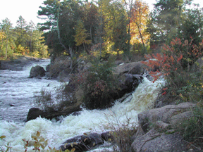
Yet today, increased withdrawals of freshwater for industrial, agricultural, and domestic use has created acute water shortages in some areas of the world. Increased pumping has caused both surface water reductions and groundwater drawdown. The resulting "water stress" has severely affected human consumption as well as crops and other natural species. These shortages are stimulating or worsening international conflicts over water, which has joined oil as a major commodity triggering or exacerbating wars.
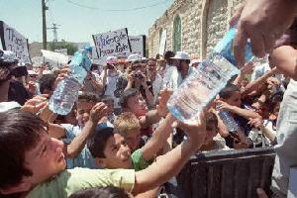
As water shortages and conflicts increase, water is increasingly being transformed into a privately owned resource, and a commodity that can be sold and traded for profit. New international trade agreements and loan policies encourage this privatization and commodification of water resources. Water companies are privatizing public water utilities around the world, and setting prices that cannot be afforded by the poor, triggering conflicts with the multinational corporations. Water bottling companies are pumping groundwater, and selling the water at prices higher than oil. Alarmed by a growing lack of safety in some municipal water supplies, many people are drinking bottled water. Yet many local residents object when companies such as Perrier try to pump out springs or rural wells.
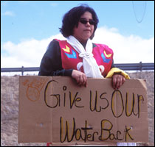
Another controversy centers on the diversion of freshwater from regions with plentiful supplies to semi-arid or desert regions. These bulk water transfers can be carried out through river diversions, pipelines, or even supertankers. The Great Lakes are at especially high risk of these types of diversions, while U.S. water policy allows smaller-scale diversions elsewhere. Water is also captured and used by dams for irrigation or power.
Solutions to the global water crisis are being discussed. There are a number of technical fixes that are too expensive for many countries to afford. All peoples can look toward traditional methods of water harvesting and groundwater replenishment as possible low-technology solutions. Yet no real solutions are possible that do not start with alternate directions in policy that put water back under public, democratic control.
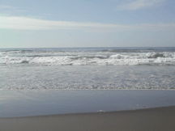
Many thanks to Julia Lehman of Bringing Instruction in Technology to Students (BITS), and our guest speakers Hiroshi and Arlene Kanno of the Concerned Citizens of Newport for their invaluable assistance. (Thanks also to Winona LaDuke, Al Gedicks, and Claire Schmidt for speaking to the class on related issues.)
Thanks to previous Geography 378 students who produced the class websites Caspian Basin Alert (Fall 2002) and Iraq & Our Energy Future (Spring 2003). Thanks also to the U.W. System's Teaching Technology Today for printing an article describing this Geography 378 project: "Class Websites Contribute to Environmental Awareness."
Geography 378 Students
Nichole Abrashinsky | Megan Kieper | John Palmbach
Brianna Binnaboose | Lance Klessig | Brett Schroeder
Adam Dicke | Kevin Korth | Michael Schwartz
Devon Disrude | Samuel Larsen | Miguel Simhon
Lindsay Entringer | Theresa Lenon | Patrick Soldan
Heather Eslinger | Adam Livermore | Britta Suppes
Jason Gosse | Matthew Murphy | Dustin Vanoverbeke
Eric Heuer | Matthew Nier | Jennifer Wilson
Michael Jolitz | Abigail Ofori-Amoah | Kally Worm

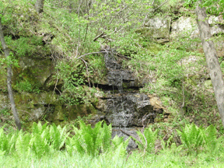
Water links
Save America's Water | Blue Gold (Maude Barlow) | Grading Drinking Water
Water Bank | Water Follies (Robert Glennon) | Corpwatch
Pure Drink or Hype? | Water Wars (Vandana Shiva) | MI Land Use Institute
Bottled Water Web | Groundwater & drinking water (EPA) | Water articles
Int'l Bottled Water Assoc. | Groundwater issues in WI | Aquifer mining (NM)
Concerned Citizens of Newport (WI) | Great Lakes water export | MN Water Alliance
Michigan Citizens for Water Conservation | Water taking in Lake Superior | Vivendi/Veolia
Save Our Springs (FL) | International Joint Commission | RWE/Thames Water
Bottled Water Blues | Great Lakes Directory | Suez
Tribal opposition to Perrier (WI/MI) | International Rivers Network | Hydronet
Polar pumping plan (WI) | Canadian Environmental Law Assoc. | Nestlé Waters
 | Water barons | Splash
This website can be most easily read in Explorer, with the Matura MT Script Capital font for titles. The opinions expressed on this website are those of the students or their research sources, not of all Geography 378 students, the instructor, or of the University of Wisconsin-Eau Claire and its departments. We hope the class website project contributes to the knowledge and debate around this growing environmental issue of global consequence.
2. Global Water
Cycle & Supplies

Matt Murphy murphymw@uwec.edu

In order to fully understand the impact of water privatization, it is imperative that we understand how rare it is to find clean, drinkable freshwater. This page aims to illustrate how little actual drinkable freshwater exists around the world, as well as to show water's importance to all cultures across the globe. By understanding the nature of the global water cycle, and its importance to all peoples, we can understand why water cannot be treated as a commodity, but only as a necessity for all life.

The Water Cycle
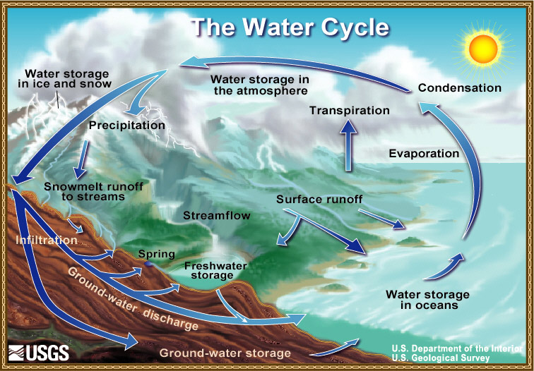
Source:Illustration by John M. Evans USGS, Colorado District (http://ga.water.usgs.gov/edu/watercyclegraphichi.html)
The water cycle is the process by which our freshwater is produced. It breaks down into several different stages. According to the Department of Atmospheric Sciences at the University of Illinios at Urbana-Champaign,"The hydrologic cycle begins with the evaporation of water from the surface of the ocean. As moist air is lifted, it cools and water vapor condenses to form clouds. Moisture is transported around the globe until it returns to the surface as precipitation. Once the water reaches the ground, one of two processes may occur: 1) some of the water may evaporate back into the atmosphere, or 2) the water may penetrate the surface and become groundwater. Groundwater either seeps its way to into the oceans, rivers, and streams, or is released back into the atmosphere through transpiration. The balance of water that remains on the earth's surface is runoff, which empties into lakes, rivers and streams and is carried back to the oceans, where the cycle begins again."
Source:Universty of Illinois WW2010 project. (http://ww2010.atmos.uiuc.edu/(Gh)/guides/mtr/hyd/smry.rxml)

Facts & Figures About the World's Freshwater
- Water covers 75% of the Earth's surface. The total amount of water on Earth remains about the same from one year to the next, as it circulates between the oceans, land and atmosphere in a cycle of evaporation and precipitation. This hydrological cycle is fundamental to the functioning of the Earth as it recycles water, and has a role in modifying and regulating the Earth's climate.
- Nearly 98% of the Earth's water is in the oceans. Freshwater makes up less than 3% of water on earth, and over two-thirds of this is tied up in polar ice caps and glaciers. Freshwater lakes and rivers make up only 0.009% of water on Earth and groundwater makes up 0.28%.
- Water is essential for all life forms. For example, it makes up 60 to 70% by weight of all living organisms and is essential for photosynthesis. The viability of all life on Earth is determined chiefly by the presence of water, which is not evenly distributed on the planet. If it were, it would cover the entire surface to a depth of 3 km (nearly five miles).
Source:BBC Science & Nature Homepage. (http://www.bbc.co.uk/nature/environment/conservationnow/global/freshwater/)
It seems that the most relative fact is that while three-quarters of the Earth's surface is covered with water, less than one percent (0.37% to be exact) of that water is drinkable. Furthermore groundwater, where we place pumps for wells, only accounts for 0.28% of freshwater across the globe.
Cultural & Religious Significance of Water
We cannot however, simply define water as a commodity to be assessed a value and sold. Water is a basic human right and something of significance to all cultures across the globe. It is considered sacred as the source of life, and as a purifying agent, in many religions. Every religion has some sort of belief or practice involving water, giving it an honored, or even sacred position in many rituals. Water is central to the religious practice of all indigenous peoples as well as to the beliefs of the major world religions.
Buddhism- Buddhist monks pour water into a bowl and place it before a dead body and other monks in attendance at a funeral.
Christianity- Water is used in baptism rites, a public declaration and acceptance of faith; an individual may be either sprinkled with water or fully immersed, or anywhere in between. Water represents purification and rejection of Sin. In the New Testament the "living water" or "water of life" represents the spirit of God, and eternal life.
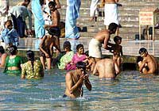
Hinduism- Water represents spiritual purification to Hindus, for whom bathing is a morning ritual. Oftentimes there are pilgrimages to one of the seven sacred rivers of India: the Ganges, Godavari, Kaveri, Narmada, Sarasvati, Sindhu and Yamuna. Water is also used in funeral rites.

Islam- For Muslims, water serves as the key means of purification, or cleansing the soul. There are three sorts of ablutions: The first and most important involves washing the whole body; it is obligatory after sex, and recommended before the Friday prayers and before touching the Koran. Secondly, before each of the five daily prayers Muslims must bathe their head, wash their hands, forearms and feet. All mosques provide a water source, usually a fountain, for this ablution. When water is scarce, followers of Islam use sand to cleanse themselves; this is the third form of ablution.
Judaism- Jews use water for ritual cleansing, to restore or maintain a state of purity. Hand-washing before and after meals is obligatory. Although ritual baths, or mikveh, were once extremely important in Jewish communities, they are less so now; they remain, however, compulsory for converts. Men attend mikveh on Fridays and before large celebrations, women before their wedding, after giving birth and after menstruation. The first book of the Bible, Genesis, tells the story of Creation and of the Great Flood. To punish humans for their disobedience, God sent a torrential rain down upon the Earth, for forty days and forty nights. Safe on an ark, Noah, his family, and two of each species of animal alone were spared. The flood washed away the sins of the world so that it could be reborn, free from impurity.
Source:International Year of Freshwater 2003

Sources
International Year of Water: http://www.wateryear2003.org
United States Geological Survey: http://ga.water.usgs.gov/edu/watercyclegraphichi.html
BBC Science & Nature Homepage: (http://www.bbc.co.uk/nature/environment/conservationnow/global/freshwater/)
Universty of Illinois WW2010 project: http://ww2010.atmos.uiuc.edu/(Gh)/guides/mtr/hyd/smry.rxml)
CBS News: http://www.cbc.ca/news/features/water/

3. Structural Adjustment Programs

Kevin Korth korthkp@uwec.edu

Developing nations have searched desperately to find a successful path to stabilizing their economies. Throughout the Periphery we have seen nations cycle through every ideology of economic reform, from socialism to capitalism, with little success in improving their economies. In recent decades, a new system of economic reform has emerged. The stated aim of Structural Adjustment Programs is to relieve these nations of multibillion dollar debts while stabilizing their economies. These programs were introduced through the World Bank, a multilateral institution that lends money to governments and government agencies for developmental projects. Countries must agree to Structural Adjustment Programs in order to qualify for World Bank and International Monetary Fund (IMF) short-term loans. Is water a natural right or should it be brought into this expanding global market?
How Structural Adjustment Programs Work
Over one billion people lack access to safe water, and nearly 2.5 billion lack safe sanitation. More than 3 million people die each year from water-based epidemics. The World Bank says it strives to help its member countries ensure that everyone has access to efficient, responsive and sustainable water and sanitation services. Eligibility for an adjustment loan requires agreement on monitorable policy and institutional reform actions, and satisfactory macroeconomic management. The World Bank contends it does not force privatization on any country, but research compiled by the International Consortium of Investigative Journalists (ICIJ) indicates that privatization does play a large role in the granting of loans.
According to the ICIJ, privatization is an umbrella that includes selling assets to a private company, tendering a water concession to a private company, or awarding management contracts to a private company. The ICIJ study examined 276 projects from 1990 to 2002 which the bank itself identified as "water supply" loans, in which at least 84 had conditions of water privatization as an essential institutional reform.
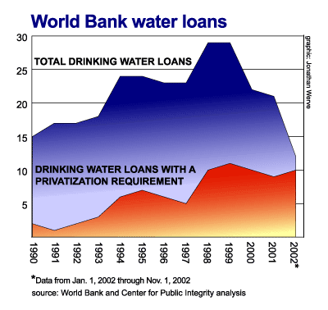
(The Center for Public Integrity)
Evidence also shows that about a decade ago the World Bank established the policy of privatization as a requirement of bank loan conditions.
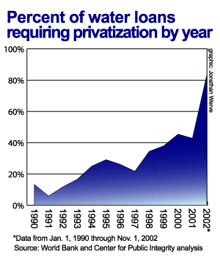
(The Center for Public Integrity)
Effects of Structural Adjustment Programs
The United Nations Declaration of Human Rights states that every human should have access to clean water.
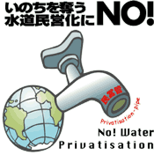
(Water for All) (Water privatizers on the defensive)
This is because like air, water is a necessity of human life. Water has also become, according to Fortune magazine, "One of the world's great business opportunities. It promises to be to the 21st century what oil was to the 20th." The vice president of the World Bank, Ismail Serageldin also relates the importance of water when he says, "The wars of the next century will be about water."
Maude Barlow writes extensively in her book Blue Gold about this issue and explains how the privatization of water resources will negatively affect the Third World while benefiting multinational corporations: "The future of one of the earth's most vital resources is being determined by those who profit from its overuse and abuse. A handful of transnational corporations, backed by the World Bank, are aggressively taking over the management of public water services in developing countries, dramatically raising the price of water to the local residents and profiting from the Third World's desperate search for solutions to the water crisis. The corporate agenda is clear: water should be treated like any other tradable good, with its use determined by market principles."
Many individuals and organizations share the belief that water is a basic human right and should not be a commodified tradable good. On the other side, corporations are benefiting from the new water trade. The three biggest corporations in this market, according to Maude Barlow and Tony Clark, Suez and Vivendi [recently renamed Veolia Environment] of France and RWE-AG of Germany, deliver water and wastewater services to almost 300 million customers in over 100 countries. Vivendi now earns over $12 billion dollars.
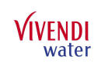
Vivedi logo Suez logo RWE logo
Argentina: Privatized Water
In 1993, the government of Argentina privatized the Buenos Aires water utility. A deal was announced between Argentina's water authority and a consortium that included the Suez group and Vivendi. A new private entity would run the water supply of the country's capital (and largest city) under the name Aguas Argentinas. The privatization was introduced ostensibly to save the country from economic ruin and deliver cleaner and cheaper water. According to a study by Dr. Malpartida's Ecology and Environment Foundation, the new company was "the biggest transfer of a water service and watershed into private control in the world," encompassing a region with over 10 million inhabitants. Water rates increased 88.2% between May 1993 and January 2002 although there was "no relationship between this rate and the consumer price index (inflation rate), which was 7.3% for the same period." In recent years, Argentina has been rocked by protests, strikes, and the resignations of presidents, all tied to resentment of World Bank/IMF "austerity measures."

Colombia: Public vs. Private Water
In 1994, Colombia drafted the Public Service Law, by which private companies or community organizations could run public utilities. The capital city of Bogotá believed that the water belongs to the people. With this ideal, they refused World Bank money and transformed its public utility into the most successful in Colombia.
Elsewhere in Colombia, cities were lining up to privatize their water supply. Cartagena, a city on the Caribbean coast, was the first to privatize by signing a concession contract in 1994 with a private firm run by multinational water companies. They established Aguas de Barcelona, which is partially owned by Suez, winning the twenty-year contract.
Back in Bogotá, the Empresa de Acueducto y Alcantarillado de Bogotá (or EAAB) strived to turnaround its near bankruptcy in 1993. In 2002 the National Planning Development of Colombia rated it the best utility in Colombia. They went from serving 78% of the population in 1993 to 95.3% in 2001.
Meanwhile, the private Cartagena water utility was profiting corporations and surrounded with controversy, including allegations of contract irregularities and a lack of transparency.
The Future
Privatization of the water supply around the world is currently a subject of hot debate. The World Bank believes that countries and cities around the world can turn to the private market to improve their water supply. Opponents argue that this policy is commodifying a good that belongs to the people. Each country and city will have decide what is best for its constituents. Will the people demand water as a basic human right, as in Bogotá, thus leaving control in the public sector, or will they look toward privatizing their water intrusting in the folks at Suez, RWE-AG, and Vivendi?

Sources
For more information:
Water Barons: http://www.icij.org/water/default.aspx
Water Privatization: The World Bank's Latest Market Fantasy: http://www.globalpolicy.org/socecon/bwi-wto/wbank/2004/01waterpriv.htm
World Bank: http://worldbank.org/

4. Trade Agreements
and Water

Jennifer Wilson wilsonje@uwec.edu

"Water is fundamental for life and health. The human right to water is indispensable for leading a healthy life in human dignity. It is a pre-requisite to the realization of all other human rights."
-The United Nations Committee on Economic, Cultural and Social Rights,
Environment News Service, November 27, 2002
-Quotations on Water
Is Water a "Good"?
A "good" is defined in a dictionary as something that has economic utility or satisfies an economic want; personal property having intrinsic value but usually excluding money, securities, and negotiable instruments; and finally something manufactured or produced for sale. According to the Harmonized Tariff Schedule of the United States, water is in fact a good. Listed as a commodity under Section IV, Chapter 22, it reads:
"Other waters, including natural or artificial mineral waters and aerated waters, not containing added sugar or other sweetening matter nor flavored; ice and snow."
Source: (Harmonized Tariff Schedule of the United States 2004 chapter 22)

Trade Laws Pertaining to "Goods"
The Canadian environmental activist Maude Barlow stated that "...In 1993, then-US Trade Representative Mickey Kantor said in a letter to a U.S. environmental group, 'When water is traded as a good, all provisions of [NAFTA] governing trade in goods apply.'" All trade organization rules and regulations share a few common points of interest: they take away basic domestic rights; they see water as a commodity and a service; and they all share the same term: “National Treatment.” National Treatment, in various clauses of these organizations, ultimately stresses that once a product, service or item of intellectual property has entered the market a nation must give others the same treatment as one's own nationals. This problem is best illustrated by the International Forum on Globalization in the document Blue Gold:
“If a Canadian company, for instance, gained the right to export Canadian water, American transnationals would have the right to help themselves to as much Canadian water as they wished.”
Source: (Water Incorporated; The Commodification Of The World's Water)

World Trade Organization
(WTO)
The World Trade Organization, was originated in 1995, set up under GATT. It was created to implement GATT (General Agreement on Tariffs and Trade), General Agreement on Trade in Services (GATS), and the Agreement on Trade-Related Aspects of Intellectual Property Rights (TRIPS). These agreements cover the major sections of trade conducted by the WTO. This trade organization contains no minimum standards, and all of the countries that are part of it work toward removing all lingering tariff and non-tariff barriers. The WTO, unlike any other international organization, has legislative and judicial power to challenge laws, policies and programs of member countries.
General Agreement on Tariffs and Trade (GATT)
According to The Text of GATT, Article XI, adopted in January of 1948,
“No prohibitions or restrictions other than duties, taxes or other charges, whether made effective through quotas, import or export licenses or other measures, shall be instituted or maintained by any contracting party on the importation of any product of the territory of any other contracting party or on the exportation or sale for export of any product destined for the territory of any other contracting party.”
This basically states that no matter what, aside from for the exceptions in Article XX sections b and g, the government is powerless to control, in any aspect, these transfers. The exceptions are stated as follows:
(b) necessary to protect human, animal or plant life or health;
(g) relating to the conservation of exhaustible natural resources if such measures are made effective in conjunction with restrictions on domestic production or consumption.
The problems with these exemptions are the facts that first, attempts to use section b have already failed when trying to protect marine animals, and second most fresh water sources are categorized as renewable.
General Agreement on Trade in Services (GATS)
GATS was implemented in 1995 and operates under the fortification of the WTO. What’s different about GATS is that it actually includes water in its "rules and regulations" consisting in sections of: sewer services, freshwater services, treatment of waste water, nature and landscape protection, construction of water pipes, waterways, tankers, groundwater assessment, irrigation, dams, bottled water, water transport services, and the like. The main purpose of this is to limit government actions with respect to services, incorporating water with them.
Agreement on Trade-Related Aspects of Intellectual Property Rights (TRIPS)
According to the Citizens Trade Campaign:
"The TRIPS agreement creates enforceable global rules on patents, copyrights and trademarks to protect inventions or artistic products, but also extends far beyond this scope. Intellectual “property” now includes the practice of patenting plant and animal forms as well as seeds. By taking such public and cultural goods out of the hands of people and communities, the private rights of corporations are promoted over the rights of local communities; and the protection of ecosystems, public health, and traditional cultures are all undermined."
There are no apparent correlations between TRIPS and water.

North American Free Trade Agreement
(NAFTA)
NAFTA, put into action in January of 1994, in essence, grants corporations more control and strength than they originally had with GATT. One of the ways that this is done is by what many refer to as the “Proportionality Rule,” which limits the amount of water that can be restricted. In Article 315 this rule is defined along these lines:
"Except as set out in Annex 315, a Party may adopt or maintain a restriction otherwise justified under Articles XI:2(a) or XX(g), (i) or (j) of the GATT with respect to the export of a good of the Party to the territory of another Party, only if:
a) the restriction does not reduce the proportion of the total export shipments of the specific good made available to that other Party relative to the total supply of that good of the Party maintaining the restriction as compared to the proportion prevailing in the most recent 36 month period for which data are available prior to the imposition of the measure, or in such other representative period on which the Parties may agree."
There are other parts to this article, but not as relevant as part a). If there is a significant deficiency of water in a NAFTA country, exports can be momentarily limited as long as they are done so in an equivalent proportion to the total supply accessible over the past three years. If one of those years has a notably higher availability of water than the other two, restrictions to this supply may not be implemented because the shortage won’t look noteworthy, when it actually is.
Even more so, NAFTA introduced Chapter 11, which protects the investors and their investments. This chapter can correlate to water in a few particular ways. If a government, whose country was part of the North American Free Trade Agreement, tried to limit the distribution of water, or even attempted to ban water exports before they hit the market, it involuntarily puts them at the mercy of its foreign investor’s rights under NAFTA. Foreign companies have most of the support in this chapter, and even changes in government policy could bring about confrontations for that country, province, or state.

Free Trade Area of the Americas
(FTAA)
The FTAA is proposed to be put into effect in the year 2005. Essentially every article and chapter that was presented in NAFTA would also appear in the FTAA, but would be extended to a broader number of nations and with a greater intention of exposing public services for privatization and deregulation in the Western Hemisphere. The Free Trade Area of the Americas would be included in the General Agreement on Trade in Services (GATS), which is now being discussed as a part of the WTO. According to the People’s Consultation on the FTAA, GATS and the FTAA would:
- Give corporations an absolute right to bid on running or purchasing all public services, including… the public water supply.
- Force governments to give contracts to the lowest bidder without considering fair labor practices, corporate safety records, or environmental responsibility.
- Let corporations challenge any laws that get in the way of their profits, like environmental, labor or consumer protection laws… the cases would be heard by a secret tribunal, with no chance of appeal.
- Let corporations ignore unprofitable areas when providing a service, even if it means not… providing water to rural or inner city areas; those areas would be served by governments on limited funds.
The FTAA has not yet gone into effect, and the best thing that you can do to oppose it is to get involved in one of the many organizations going up against it. Here are some links to various "fair trade" groups:
Anti FTAA Action
Stop the FTAA
Free Carnival Area of the Americas
Food Not Bombs FTAA
Society Issues Seek Activism
All in all, these international "free trade" organizations, such as the IMF, or the WTO, promote the private sector of the economy and neglect human and environmental rights. Once the international pump is turned on, it won't be turned off again until there isn't any left.
"Every human should have the idea of taking care of the environment, of nature, of water. So using too much or wasting water should have some kind of feeling or sense of concern. Some sort of responsibility and with that, a sense of discipline."
-The 14th Dalai Lama Tenzin Gyatso quoted in Peter Swanson's Water: The Drop of Life (2001).
-Quotations on Water
Sources
For more information:
Citizens Trade Campaign:
http://www.citizenstrade.org/wto.php
People’s Consultation on the FTAA: http://www.peoplesconsultation.org/education/background.html
NAFTA:
http://www.sice.oas.org/trade/nafta/naftatce.asp
International Forum on Globalization:
http://www.ifg.org/
Blue Gold: http://www.thirdworldtraveler.com/Water/Threat_Agreements_BG.html
Trading our water away: http://www.thealliancefordemocracy.org/html/eng/2122-AA.shtml
Harmonized Tariff Schedule of the United States (2004): http://hotdocs.usitc.gov/tariff_chapters_current/toc.html
GATT:
http://www.wto.org/english/docs_e/legal_e/gatt47_e.pdf
FTAA/2nd draft:
http://www.ftaa-alca.org/ftaadraft02/draft_e.asp
Keep up-to-date on GATS:
http://www.GATSWatch.org
Public Citizen site with up-to-date information on trade agreements: http://www.tradewatch.org
The New Economy of Water: http://www.pacinst.org/reports/new_economy_of_water.pdf
The Free Trade Area of the Americas and the Threat to Water: http://www.ifg.org/programs/ftaawater.htm

5. Industrial Water Use

Brett Schroeder schroebj@uwec.edu

Industries that produce metals, wood, paper, chemicals, gasoline, oils, and most other products all use water in some part of their production process. Industry depends on water, much like agriculture and domestic households depend on water. Industrial reliance on water makes it essential to preserve water in every aspect possible and make sure water pollution is kept at minimal levels. This page will focus on understanding what water means to industry, how much is used during production, and the negative effects of industrial water use.
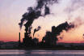

Facts & Figures
Total industrial water use in the world is about 22%, with high-income countries using 59%, and low-income countries using a minuscule 8%. These figures will rise with industrial production.
Annual water volume use by industry is increasing at an enormous rate. Annual water volume use will most likely increase from 752 km³/year in 1995 to 1,170 km³/year by the year 2025. All figures are according to the website Water Science For Schools.
According to the UN World Water Development Report, some 300-500 million tons of heavy metals, solvents, toxic sludge, and other wastes accumulate each year from industry, most of which gets into the freshwater supply. In some developing countries, 70% of industrial wastes are dumped into untreated waters where they pollute the drinking water. Clearly, there are some issues concerning freshwater supplies and industry is a major contributor. See more interesting facts and figures regarding industry and the water supply.
Major Uses
Industry is reliant on water for all levels of production. It can be used as a raw material, solvent, coolant, transport agent, and energy source. According to Environment Canada's website, many liters of water are used to produce glass, plastic, along with some fabric components. Fresh water is not just for drinking anymore.
Car washes are a great example of an industry that uses gallons and gallons of water everyday. People in developed countries use them frequently without really thinking about all of the water being used. It is the Core countries that use the majority of freshwater in industry, and the United States leads the way. It is astounding if one thinks how much water is consumed by industry. It is predicted to represent 24% of the total freshwater withdrawal worldwide by 2025.
Now that one knows some facts about industrial water use, along with its major uses, it is time to explore some of the concerns regarding freshwater use for industries.


Concerns and Conservation
We have learned that water is a necessity for all industrial production. In turn that means water must be protected, conserved, and used in a proper manner. For most industrial purposes, the water used needs to be freshwater, not salt water, because salt can corrode metal.
Another major concern about water use in industry is that the government does not regulate or enforce the standards put in place to conserve water. Standards are put in place, however they are not closely followed. According to the website CSE: Down to Earth Supplement on Water Use in Industry: "Countries across the world set water consumption standards and targets for industries to achieve, and regularly revise the standards in a bid to control water use. China, for instance, sets water targets for major water consuming industrial sectors. According to a report from the China Water Conservation Agency, the first national quotas for industrial water consumption will push companies to save as much as 6 billion cubic meters of water a year by 2005. Similar water saving targets are fixed across the developed world." To see more concerns facing the water supply in the future see CSE: Down to Earth Supplement on Water use in Industry.
Countries need governing bodies to control water use and enforce those guidelines strictly. Fresh water is needed for industries to survive, but it is also needed for humans to survive. There needs to be a conservation plan that is followed to help make freshwater accessible to all.
Sources
For more information:
Water Science For Schools: http://wwwga.usgs.gov/edu/wuin.html
CSE: Down to Earth Supplement on Water Use in Industry:http://www.cseindia.org/dte-supplement/industry20040215/fall-outs.htm
The UN World Water Development Report: http://www.unesco.org/water/wwap/facts_figures/water_industry.shtml
Photos:
www.wanganui.com/gallery/ images/industry-ndg2.jpg
www.house.gov/.../107th/ 0702/july02update.html
www.epa.gov/.../groundwater/ src/supply.htm

6. Agricultural Uses

Devon Disrude disruddj@uwec.edu

The use of water for agriculture has changed the production of crops dramatically in the 20th century. Agricultural use of water accounts for nearly 70% of the water used throughout the world, and the majority of this water is used for irrigation. During the 1970s, the construction of irrigation systems dramatically increased. Its rate of growth began to decrease in both developed and developing countries in the 1980s. An increase in irrigation development guarantees an increase in crop production in many countries. Irrigation allows the land that does not recieve enough precipitation annually to become land that can be used for productive agriculture.
On the negative side, irrigation of land causes salinization of the land that is being irrigated, mostly in arid and semi-arid regions. Irrigation of cropland can increase the possibility fertilizers and pesticides will infiltrate into the groundwater or runoff into nearby streams. Along with the irrigation of crops, the farmers that have livestock must provide clean water for the livestock to drink. With a growing world population, expected to increase by 2 billion people by the year 2030, agriculture needs to find a way to use less water or to use the water more efficiently.
Irrigation of Cropland
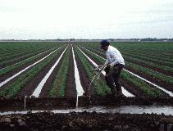
Source: Ditch Irrigation

There are several different systems that are used for irrigation purposes, including ditch irrigation, terracing, overhead irrigation, center pivot irrigation, lateral move irrigation, and drip or trickle irrigation. Irrigation of cropland has greatly increased production of food, but has also had some drawbacks due to the amount of water that is being drawn from aquifers. Some of the problems with irrigation are competition for surface water rights, depletion of underground aquifers, ground subsidence, and buildup of toxic salts on soil surfaces in regions of high evaporation rates, called salinization. These problems can be increased or be more detrimental during periods of drought. Irrigation has been increasing between 1960 and 1995, as the graph below depicts.
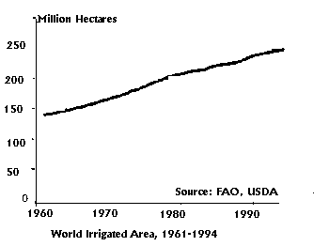
Source: Increase in water for irrigation

There are also many farms that are being heavily irrigated due to their location within an arid or semi-arid region of the world.
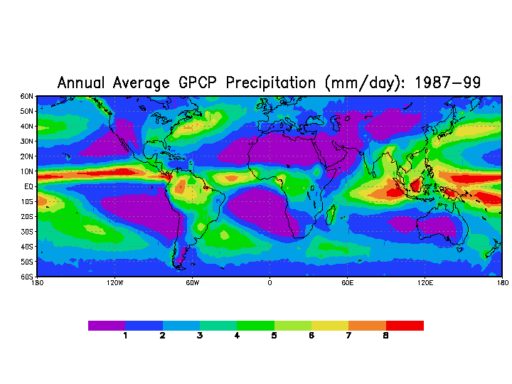
Source: Annual Average Precipitation
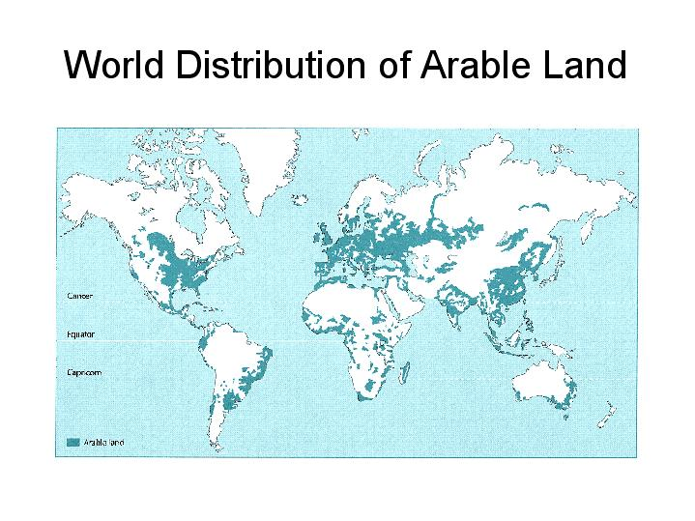
Source: Arable Land in World
Groundwater Contamination
Groundwater contamination occurs when the pesticides, livestock waste and fertilizers infiltrate through the soil and eventually reach the groundwater, which is called leaching. The problem with feritlizers is that they contain nitrates, which are very soluble in water and are very hard to remove, or cannot be removed from the water once they are in it. Leaching is more of a problem in regions that contain sandy soils. The sandy soils are very permeable, allowing the water and the nitrates, which are dissolved within the water to pass through the soil relatively fast before being absorbed by the plants. Infiltration can be a large problem for contaminating groundwater especially in regions with sandy soils.
Conclusion
Irrigation of cropland has become widely used practice throughout the world and has greatly increased the productivity of farmland. It has made it possible to farm in regions that would not be farmable without irrigation. But, with nearly 70% of the total water use throughout the world coming from irrigation for cropland, the need for newer and more efficient practices is becoming more important. Another problem with irrigated cropland is the possibility of groundwater contamination and the stricter restrictions that are going to have to be implemented on the amount of fertilizers and pesticides used to reduce the risk of the contamination.
Sources
For more information:
Freshwater: http://freshwater.unep.net/index.cfm?issue=water_irrig
Science Daily : http://www.sciencedaily.com/encyclopedia/irrigation#Ditch%20(Furrow)%20irrigation
Food and Agriculture of the United Nations: http://www.fao.org/english/newsroom/focus/2003/water.htm
Nitrate in the Groundwater: http://www.valleywater.org/Water/Water_Quality/Protecting_your_water/Nitrate_in_groundwater.shtm#1
Water for Agriculture: http://www.iwmi.cgiar.org/agriculture/
Clean Water Action Plan: http://cleanwater.gov/action/c1a.html
Agriculture: http://www3.iptv.org/exploremore/water/uses/use_agriculture.cfm
Water for Agriculture: http://webworld.unesco.org/water/ihp/publications/waterway/webpc/pag19.html

7.Domestic Use of Water

Nichole Abrashinsky abrashnm@uwec.edu

"Thousands have lived without love, not one without water."
-- W. H. Auden
Where there is water, there is life. Life exists around numerous uses of water which makes it important for survival and luxury. It is a part of our biosphere that should not be overused, ignored, or taken for granted. Because of this, water should be conserved to sustain our domestic needs for the future.

Domestic Water Use and Demands
As world population is constantly growing, the demand of water increases each and every day. The luxuries of domestic uses of water have become a necessity to people in their homes and backyards. Domestic water is normally characterized by its use inside and outside the home: washing the dishes, cooking a meal, laundry, bathing, watering the lawn or garden, and other household activities.

In a typical home in the United States, approximately 50% of water is used in the bathroom. The toilet makes up 26%, while the shower and sink use 23%. Outside of the house, 35% of water use is for lawn or garden care. Below is a picture showing more detailed information of water use inside of a home.

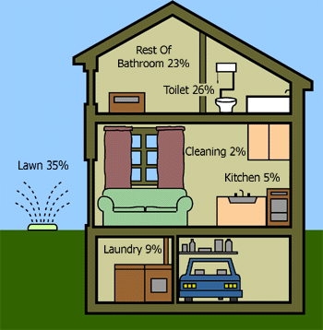
www.texasep.org/index.html

Below is a table showing specific domestic activities with normal uses and conservation uses of water. Each activity is displayed to show the differences between each. This table gives a great indication that water is a valuable resource.

Activity | Normal Use | Conservation Use
Flushing | Depends on Tank Size  5-7 gallons | Displacement bottles in tank 4 gallons
Showering | Water Running  25 gallons | Wet down; soap down 4 gallons
Bathing | Tub Full  40 gallons | Minimal water level 10-12 gallons
Brushing Teeth | Tap Running  5 gallons | Wet brush; turn water off;  rinse 1/2 gallon
Washing Hands or Face | Tap Running  2 gallons | Plug and Fill Basin 1 gallon
Drinking | Run Water to Cool  1 gallon | Keep Water in Refrigerator  8 ounces
Cleaning Vegetables | Tap Running  3 gallons | Fill Pan with Water to Clean  Vegetables  1/2 gallon
Dishwasher | Full Cycle  16 gallons | Short Cycle  7 gallons
Dishes by Hand | Tap Running  30 gallons | Wash and Rinse in Dishpan  or Sink  5 gallons
Washing Clothes | Full Cycle, Top Water Level  60 gallons | Short Cycle, Minimal Water  Level  27 gallons
Information provided by the U. S. Dept of Agriculture, Natural Resources Conservation Service.
These graphs show more detailed information about conserved and non-conserved typical single family home water use.
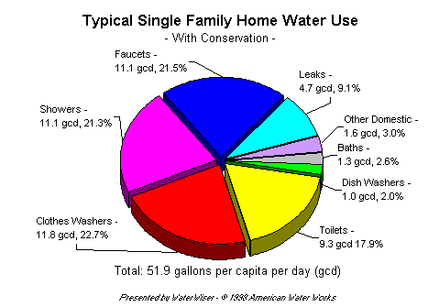

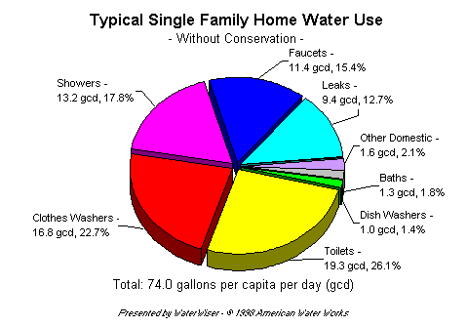

Due to these individual and personal habits, domestic use of water is increasing. “Of all the social and natural crises we humans face, the water crisis is the one that lies at the heart of our survival and that of our planet Earth," said UNESCO's director-general, Koichiro Matsuura, in a prepared statement. "No region will be spared from the impact of this crisis, which touches every facet of life, from the health of children to the ability of nations to secure food for their citizens" (Ehrenman, Mechanical Engineering).
Global consumption of water has also increased twice as much as the population during the past 20 years. According to the United Nations, the demands for access for fresh water are unattainable to more than one billion people.
This graph shows the percentage of specific countries (Asia, South America, Australia, Europe, North America, and Africa) withdraw and consumption rates between the year 1995 and 2025.
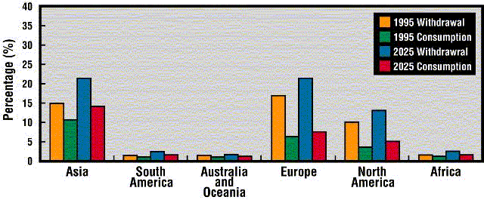

Australian Case Study
In Australia there are huge demands for water, (see Australia's Economy for more information). It is one of the driest countries, due to an extreme drought that has been occurring for the past six years. Australia is also one of the top consumers of water per person in the world. According to the figures below, the domestic uses of water for Melbourne (based on average household water consumption) are reasonably similar to those in the southwestern areas of the United States. In Melbourne, an average family uses 19% of their total water for flushing the toilet and 35% for garden and lawn watering.

Garden 35%
Bathroom 26%
Toilet 19%
Laundry 15%
Kitchen 4%
Drinking 1%

Almost 65% (156 kiloliters) of water consumed per year is used indoors. But the total water use for an average household in Melbourne, Australia is 657 liters per day (240 kiloliters per year).

As of now, most households in Australia are supplied with a clean and sufficient supply of water, but it may not stay this way for long. According to Global Education, an online source indicates that “in the next two decades, water use will increase by 40 percent, and by 2025, nearly two-thirds of the world’s population will live in regions where water supply is under stress.” These are situations that should not be taken lightly. Currently, the effort to conserve water usage throughout the city includes utilizing all available water and reducing water consumption.
Source: Melbourne Water Resources Strategy Committee, June 2001, pages 14, 17.
Water Scarcity
Water is a vital resource for the survival of all living things. Without water, life on planet Earth would not exist. According to recent studies, more than 508 million people in 31 countries face water scarcity in the world today. It is predicted that by the year 2025, the number of people dealing with water scarcity will be over 3 billion a year. If this cycle of overconsumption, pollution, and wastefulness does not subside, our water supply will be severely diminished.
This graph shows much more detail about specific countries that are, or could be, in demand for water in the future.
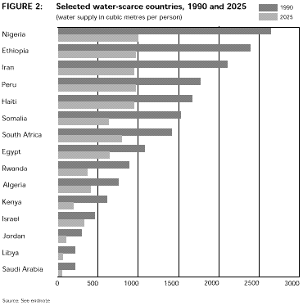

This is a short poem written by Sir Alan Herbert. He expresses the joy of water and how it is needed by all living organisms on the planet Earth. It sends out a message in that water is not always an available resource, so the need to conserve, reuse, and preserve water is the key to survival.

"Water"
by Sir Alan Herbert
The rain is plenteous but, by God's decree,
Only a third is meant for you and me;
Two-thirds are taken by the growing things
Or vanish Heavenward on vapour's wings:
Nor does it mathematically fall
With social equity on one and all.
The population's habit is to grow
In every region where the water's low:
Nature is blamed for failings that are Man's,
And well-run rivers have to change their plans.

Sources
For more information:
Australian Natural Resources Atlas
Domestic Water Conservation: A Users Guide
Mechanical Engineering
Water Requirements for Domestic Use
Water Scarcity
Water Quotes - Pausing to Think
Water Wiser
What on Earth Do You Know About Water?

8. How Groundwater
Works

Megan Kieper kieperme@uwec.edu

Groundwater is found beneath the the Earth's surface and occupies cracks and pores within rock material. More than 50% of the United States relies on groundwater for household use and 75% of all cities rely solely on groundwater. Irrigation of crops uses more groundwater than any other single application. Industrial users are the second biggest consumers of groundwater (Environment Canada). Groundwater makes up about one-third of all freshwater on the planet, although it is a mere 1% of all water on the planet. Groundwater serves a variety of purposes. Not only can groundwater be used for household, industrial and agricultural use, but it can even be used for heating. In areas that experience geothermic activity, groundwater may become heated to high temperatures and used as heating for homes.
If all the groundwater on the planet were to be spread over the earth's surface, it would result in a layer of water 55 meters (180 feet) thick. However, much of this groundwater is inaccessible and/or polluted. It may take a long time for groundwater contamination to be detectable at the surface, because groundwater moves very slowly beneath the surface. For this reason it is vital to monitor and preserve groundwater to protect future supplies from being damaged by our present-day activities.

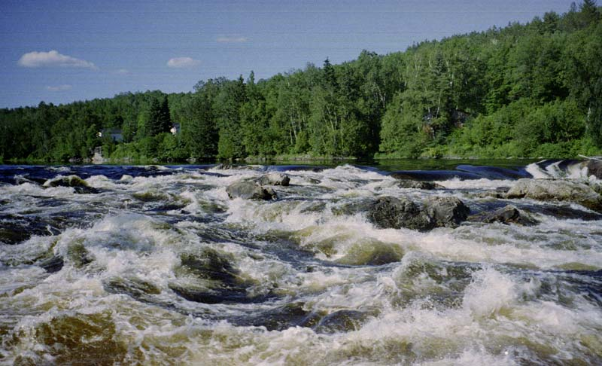
Photo from Ken Kifer's Bike page
http://www.kenkifer.com/bikepages/touring/naty2k4.htm
How does the water cycle work?
Groundwater is an important part of the hydrologic cycle. Understanding this cycle is key to understanding the unique role of groundwater.
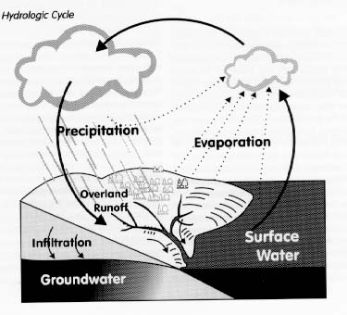
Photo from University of Michigan http://www.windows.ucar.edu/earth/images/groundwater.gif

The Hydrologic Cycle:
Step 1: Water that falls as atmospheric precipitation can do one of several things upon falling to the earth. Vegetation absorbs some of this precipitation. Some of the precipitation runs along the surface of the land until it ultimately ends up in lakes, rivers, or the ocean. The remaining precipitation infiltrates (soaks into) the earth and may become part of the groundwater supply.
Step 2: Water returns to the atmosphere through evaporation. This evaporation occurs off of surface waters and returns moisture to the atmosphere. Plants contribute to evaporation through a process called evapotranspiration, which involves water that is evaporated off plant materials.
Step 3: Moisture builds up in the atmosphere, precipitation falls to the earth's surface and the cycle continues.
Where is groundwater stored?
Groundwater is stored below the surface of the earth within a structure called an aquifer. An aquifer is made out of permeable or porous rock material and is saturated (soaked) with groundwater.
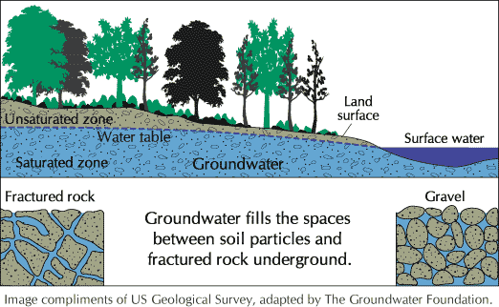
Graphic from USGS http://water.usgs.gov/ogw/
The characteristics of particular rock types determine the type of aquifer present. Unconsolidated aquifers are composed of sand and/or gravel. These types of aquifers vary in permeability. Sand and gravel are very permeable and make the best aquifers. Clay and shale are very impermeable, and do not make a good aquifers. Consolidated aquifers are composed of fractured rock material. The rocks present in these aquifers are usually granites, basalts, and limestone. Water flows through the cracks in the rocks and can be drawn out for use (USGS).
Aquifers can also be defined as confined and unconfined. Confined aquifers are rarer than unconfined aquifers, and occur when the saturated zone lies between two layers of impermeable rock. These types of aquifers result in wells that do not require pumping, or artesian wells. Unconfined aquifers are the most common and only have one layer of impermeable material beneath the saturated zone.
Below the permeable aquifer layer, there is usually an impermeable layer that the aquifer rests upon. The very top portion of the aquifer is called the water table. Rivers and lakes are fed by groundwater, and are examples of areas in which the water table is exposed (The Groundwater Foundation).

Movement of Groundwater
Water that is entering the groundwater system is called recharge water. Recharge areas occur where the watertable is below the surface of the land. Water reaches the aquifer through a process known as infiltration or percolation. The aquifer can also be considered a zone of saturation. The land above the water table is in the unsaturated zone (Environment Canada).
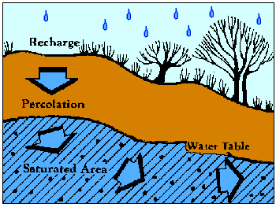
Photo courtesy of EPA http://www.epa.gov/seahome/groundwater/src/ground.htm

Areas where groundwater leaves the system are referred to as discharge areas. Discharge of groundwater occurs whenever the surface of the watertable is above the land surface. This occurs at lakes, streams, wetlands, and sometimes at areas of low elevation. The water may bubble out in springs, or seep out through soil, sand or stone.
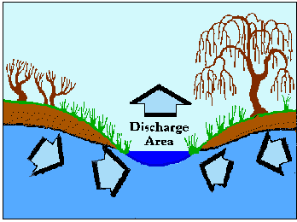
Photo courtesy of EPA http://www.epa.gov/seahome/groundwater/src/ground.htm

Water in the aquifer moves very slowly. Movement is caused by both gravity and pressure differences. Groundwater can move against gravity by moving from areas of high pressure to areas of low pressure. The rate of groundwater flow is determined by porosity and permeability. Permeability is the ease at which water moves through the rock material. Porosity is the percentage of air space within the rock material. Water moves more quickly through highly porous and permeable material than it does through less porous and permeable material. Groundwater typically moves from 35 to 1,100 feet per year, but sometimes this rate is much slower.

Sources
The Groundwater Foundation www.groundwater.org
Groundwater.com www.groundwater.com
National Groundwater Association www.ngwa.org
Environment Canada www.ec.gc.ca/water/en/nature/grdwtr/e_gdwtr.htm
US Environmental Protection Agency www.epa.gov/safewater/
United States Geological Society http://water.usgs.gov/ogw/
9. Lack of Freshwater Throughout the World

Samuel T. L. Larsen larsenst@uwec.edu

Today, one of the largest concerns around the world iis the lack of freshwater for drinking and cooking. It is estimated that over one billion people, or about one-sixth of the world's population, does not have access to fresh water; of these one billion, the vast majority are living in developing nations. Although water is one of the most common resources on the planet, only 2.5% of it can actually be consumed, and the rest is salt water. Of that 2.5%, two-thirds is confined to glaciers and permanent snow cover. Only a fraction of the world's water is liquid freshwater, and it is increasingly the subject of conflict and strife as it becomes less available.

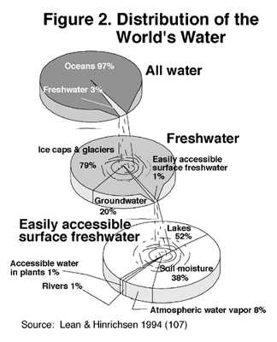
Figure 1.

Population Growth
The world's population is growing at a rate of 80 million people each year. This means that each year we need to find a way to add about 64 billion cubic meters of water to the global water supply. The two fastest-growing areas are Africa and the Middle East. The Sub-Saharan African population is growing at a rate of 2.6% people a year, and in the Middle East it is growing at a rate of 2.2%. Africa is already one of the driest continents in the world, and with this constant change its are facing water stress and water scarcity.
A country is said to experience "water stress" when annual water supplies drop below 1,700 cubic meters per person. At levels between 1,700 and 1,000 cubic meters per person, periodic or limited water shortages can be expected. When annual water supplies drop below 1,000 cubic meters per person, the country faces water scarcity.
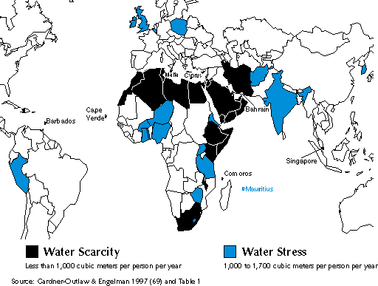
Figure 2.
As of 1999, 31 countries, with a total of 500 million people, faced either water stress or water scarcity. Estimations in the recent five years have added six more countries and almost 100 million more people. (Irrigation Business and Technology)
Demand
The global demand for fresh water has become much more of an issue than in past decades. The largest user of water in every country is agriculture. Trying to farm in hot, arid countries is difficult, if not impossible at times. Agriculture uses 70% of the world's supply, with industry coming in second with 22% of global use, and only 8% used for domestic household purposes.
Agricultural users are getting better at limiting the amount of water they withdraw. New techniques such as drip irrigation, low pressure sprinklers, and even drip walls, can capture the water from rainfall before it drains away.
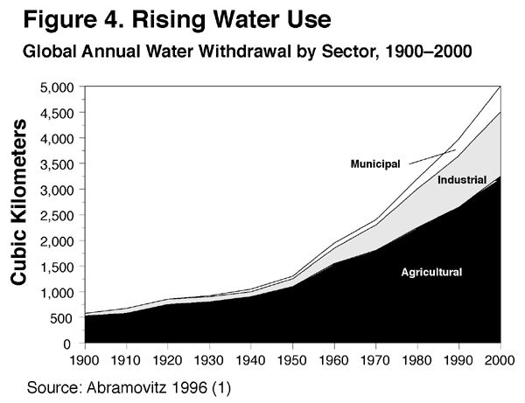
Figure 3.
Pollution
Pollution is becoming a huge and worsening factor in destroying the fresh water supply. Every day almost two million tons of waste are dumped into lakes, rivers, and streams. At present there are about 12,000 square kilometers of polluted fresh water in the world, and if trends are not slowed or reversed, the total will reach 18,000 sq km by 2050, nearly nine times the total amount currently used for irrigation. The Age (Melbourne)
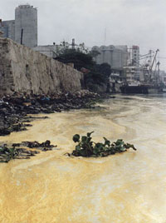
Figure 4.
Alarming Facts
- The 250 million U.S. residents living today have access to about the same amount of water as U.S. residents did 200 years ago, when the population was four million. (National Drinking Water Alliance)
- If present consumption patterns continue, two out of every three persons on Earth will live in water-stressed conditions by the year 2025. (United Nations Environment Program)
- At least 1 billion people must walk three hours or more to obtain drinking water. Nearly 2% of U.S. homes have no running water. In Mexico, 15% of the population must haul or carry water. (National Geographic Society)
- In a one-hundred-year period, an average water molecule spends 98 years in the ocean, 20 months as ice, only about two weeks in lakes and rivers, and less than a week in the atmosphere.
- By 2050, per capita water supply is predicted to fall, leaving anywhere from 2 billion to 7 billion people with water scarcity (CBC News)
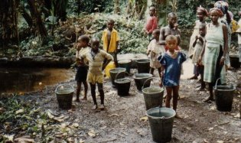

How to Help Protect Freshwater Through Household Conservation
Conserve
Limit the time you spend watering the lawn, showering, running the garbage disposal, and running faucets.
Fix leaky faucets. One drip a second can waste 2,000 gallons a year.
Buy water-efficient plumbing fixtures. If all plumbing fixtures in the United States were replaced with water-conserving fixtures, we could save 3.4 to 8.4 billion gallons of water a day.
Use moderate amounts of low phosphate cleaners and detergents. Eliminate the use of drain cleaners. Use recycled products.
Protect
Wash your car on the lawn instead of the driveway. Water that lands on an impermeable surface, such as pavement, flows through the watershed to the nearest body of water and deposits its contaminants. Your lawn, on the other hand, can trap and break down most foreign agents.
Limit the use of lawn fertilizers, and be sure to use only phosphorus-free lawn fertilizers. Most lawns already have sufficient phosphorus, and when more is added it runs through the watershed and causes algae growth in surrounding lakes.
Learn
Realize that many human activities affect water quality. Wetlands, groundwater, and waterways are destroyed by construction, polluted runoff, and spills. Population growth only intensifies these impacts.
Become an educated consumer. Buy recycled, environmentally friendly products.
Learn to recognize and become knowledgeable about aquatic nuisance species. Exotic invaders (such as Eurasian water milfoil, zebra mussels, and thousands more) cause habitat destruction, decrease biological diversity, and cause millions of dollars of damage in the United States each year.
Change
Rethink your daily habits and help reduce water pollution and water use. Bike, walk, or carpool to help reduce the production of toxic air pollutants that cause acid rain.
Turn down the water heater temperature and the home thermostat to reduce your energy usage and help curb pollutants that cause acid rain.
Finally, share your knowledge with others. Try to remember that our actions have a widespread impact on the lasting quality of freshwater resources. We can and must make a difference.
figures from: The Water Web site
Sources
The Freshwater Society
BBC News
CBC News
Solutions for a Water Short World
The Age
Common Dreams News center
For more information:
Institute of Environmental Management & Assessment
Water Scarcity and Poverty
WWF

10. Shortage Effects on Species & Crops

Eric Heuer heuerej@uwec.edu
For life to exist a few components need to be present, such as food and water. Today, future food sources are being threatened by human privatization of freshwater. Humans need food, and that food needs more food and water. Fresh water is a basic requirement for a healthy ecosystem. Such an essential resource should not be privatized for profit.

Humans often forget that other than ourselves, plants, insects, micro-organisms, and all other animals require freshwater. The basic focus for many Americans is on the almighty dollar and not on species and crops, which are vital forms of food that support all forms of life. The effects of water privatization on species and crops can already be noticed. Such effects are generally negative in a long run, and are only going to get worse as freshwater shortages increase. The bottom line is that we all need to be more conscious about how vital freshwater is to all species of living things.

Effects on Species
All species are at risk when freshwater becomes scarce. In a specific case, fish in Upper Klamath Lake and the Klamath River in southern Oregon are now threatened by low and human-induced water levels. In this example in southern Oregon, the water levels are lower than normal because farmers pump Klamath Lake and the Klamath River to irrigate their crops. The low water levels, combined with crop runoff, are now threatening the coho salmon, chinook salmon, and the already endangered sucker fish. Also, the aquatic organisms that depend on a fairly constant level of water are not able to survive in many of the retreating water level conditions. These aquatic life forms are not able to migrate to more suitable habitats. As the rivers struggle to reach the ocean, higher levels of salt will be able to push further upstream. In such situations, much of the aquatic life is lost and a greater threat to freshwater presents itself. source:(http://eces.org/archive/ec/population/klamath.shtml)
Another important area to consider is how the depletion of wetlands can harm species. In many regions of the world animals and other organisms rely on wetlands for shelter and water. In area where water becomes privatized, such wetlands often become dried out. When wetlands dry up many species are no longer able to survive, while others migrate to areas suitable for animal life.
Effects on Crops
Agriculture is the largest consumer of freshwater in the world. In the U.S., 42 percent of the total amount of freshwater available is used for agriculture. About 98 percent of that amount is used to irrigate crops. The other 2 percent is used to raise livestock, poultry, and fish. In rural settings, many farmers rely on access to freshwater through river systems. What once was a resource near the farms is slowly disappearing, created a crisis that could potentially ruin crops and force farmers to relocate operations for locations that provide larger yields. There have been cases where rural farmers actually needed to buy water to irrigate crops, because freshwater levels have fallen so low. Sometimes, irrigation hs led to salinization of the soil. In such cases, the soil becomes too saturated with salt. Heavily saliniated croplands, once rich for farming, now prove usless for growing crops.source: (http://www.learner.org/powerofplace/themes16.html)
Farming is nearly all controlled by big business. Small farming operations are closing everyday because they cannot keep up with the low price demand that big agribusiness places on them. Once farmers cannot rely on natural sources of water, small farms will be virtually non-existent. Once that happens, most agriculture will be standardized; resulting in fewer and more expensive products for the consumer. The end result for consumers is that crops will be harvested by big businesses that also control freshwater resources. Consumers will be paying more for their water and their food. source: (http://www.ncrlc.com/WaterEthic-webpage03.html)

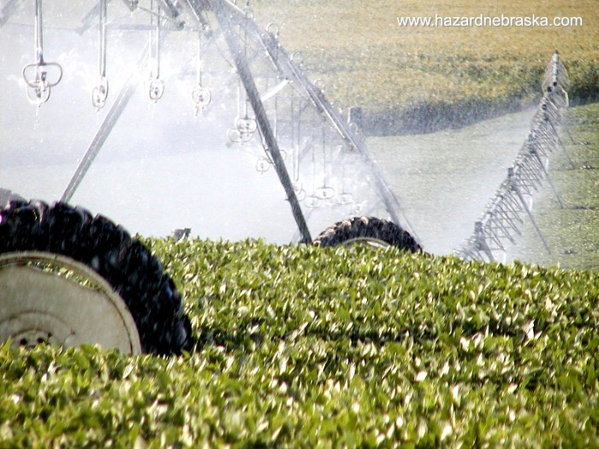
Source: Hazard, Nebraska

Sources
Culture Change: Photo
http://www.culturechange.org/e-letter-water.html
Earth Crash:
http://eces.org/archive/ec/population/klamath.shtml
Hazard, Nebraska:
http://www.nctc.net/~hazard/photo/
NCRLC:
http://www.ncrlc.com/WaterEthic-webpage02.html
Urban and Rural Contrasts:
http://www.learner.org/powerofplace/themes16.html

11. Groundwater Drawdown
Kally Worm wormka@uwec.edu

Groundwater is the second largest reserve of freshwater on earth. It also makes up 40% of the freshwater used in the U.S. alone. Groundwater is found within underground aquifers in the "zone of saturation". A zone of saturation is located where water fills in all of the spaces that are in the lower layers of soil. The water table is located at the top of the zone of saturation. These aquifers need to be recharged by rainwater and other water sources. (See How Groundwater Works). The recharge rate is slow. In many areas groundwater is being removed from the aquifer faster than it can be replenished.
When groundwater is depleted, the effects on the landscape and the people are drastic. "Cones of depression" can be formed if too much water is drawn out of a water table without letting it recharge. A cone of depression is where the water table sinks in an area that has been heavily pumped, creating a large area that has sunken. "Sinkholes" may also form when an underground cavern or channel collapses and creates a crater in the earth’s surface.
Another danger is that aquifers that are located near coastlines can experience saltwater intrusion, where saltwater mixes with fresh water from the aquifer, rendering the water unusable. In the end, heavy pumping of groundwater depletes aquifers until there is little or no fresh water available to those who depend upon it.

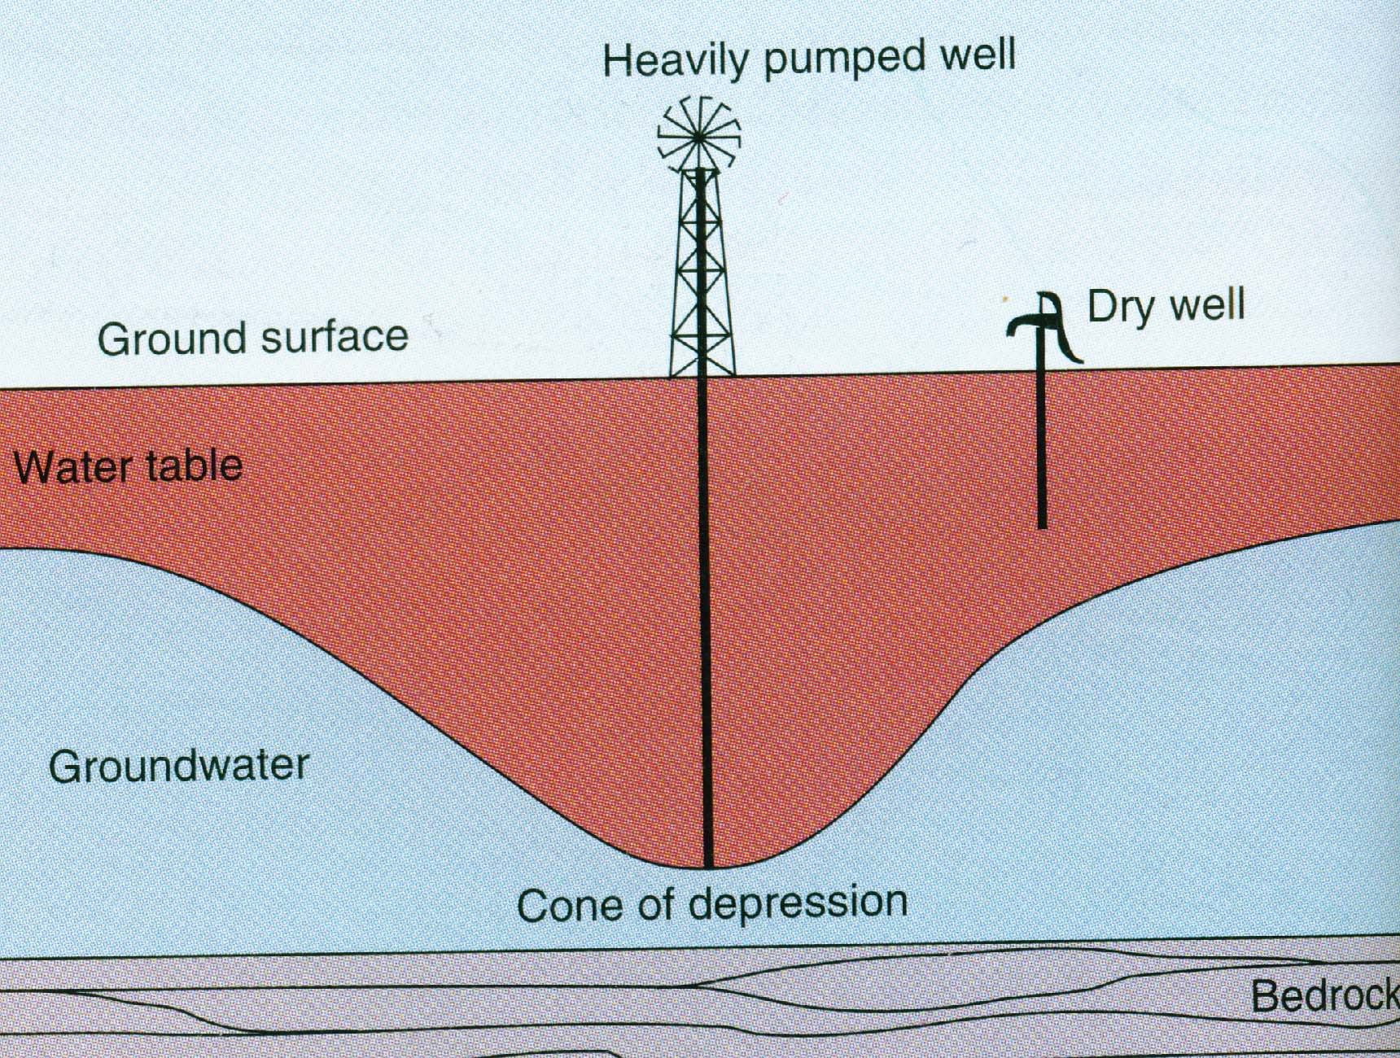
Pictorial view of a cone of depression. (Cunningham, William P. et. al., “Environmental Science, 7th edition, McGraw Hill 2003.)
Ogallala Aquifer in the Great Plains
Even though we know the dangers of heavily pumping water from aquifers, some regions are still dealing with these consequences. In the U.S. Great Plains, the Ogallala Aquifer is a prime example of groundwater depletion. This aquifer provides water for South Dakota, Nebraska, Colorado, Wyoming, Kansas, Oklahoma, Texas, and New Mexico. It spans an area of 800 miles from north to south, and 400 hundred miles from east to west.
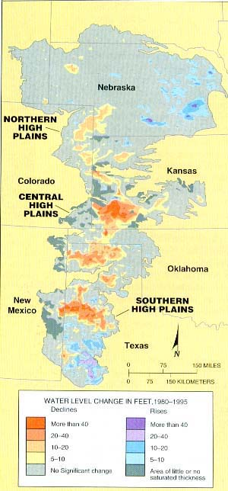
Water level changes in the Ogallala Aquifer (Cunningham, William P. et. al., “Environmental Science, 7th edition, McGraw Hill 2003.)

It was first tapped in 1911 when a farmer dug a well by hand for irrigation purposes. In the 1950s there were approximately 80 wells a year that were being dug to tap the aquifer in Colorado alone. There were some restrictions placed on digging wells to tap the Ogallala Aquifer, but these limitations did not stop farms and cities from depleting the aquifer. This aquifer supplies 70% of the water used daily in Kansas.

The water pumped from Ogallala Aquifer is used mostly for irrigation purposes. The land in the Great Plains is semi-arid and the water that is available evaporates quickly. Due to the need for greater amounts of water for irrigation, the aquifer is being depleted because the recharging process cannot keep up with the withdrawal of water. Since people had started to rely on the Ogallala Aquifer for irrigation of their fields, 6% of the aquifer has dropped to an unusable level that can no longer be pumped. If irrigation continues to draw water from the aquifer at the same rate, about 6% of the aquifer will be used up every 25 years. One estimate states that the aquifer is being depleted at a rate of approximately 12 billion cubic meters per year. The biggest problem facing people who use the Ogallala Aquifer is that they do not know how long the water supply will last. (Overview of Ogallala Aquifer)

Mexico City Groundwater Depletion
Mexico City may be one of the worst examples of groundwater depletion. Mexico City was built on an old lakebed that is surrounded by mountains. It does not have access to a nearby surface water source, so the city must rely on the underground aquifer for all of the people’s water needs, along with some water pumped across the mountains at a very high cost. There have been other options that the city has looked at to bring in water from the outside. Since the valley is at a high elevation, approximately 2,000 meters above sea level, importing water into the city is too expensive to be a realistic alternative. The city’s 15.6 million people rely on the only viable water source, the underground aquifer.
The Mexico City Aquifer has been depleted since the early 1900s. One study showed that from 1986 to 1992 the aquifer lowered anywhere from 6 to 10 meters in heavily pumped areas. This massive depletion of the aquifer has caused multiple problems for Mexico City. One major problem is that severe land subsidence has occurred. Land subsidence occurs when porous formations that once held water collapse, which results in the surface layer settling. This often occurs where cities were built on unconsolidated land such as river deltas or lakebeds. Some areas of Mexico City are rapidly sinking. These areas, such as the central section of the metropolitan area, have fallen as much as 8.5 meters. This has caused damage to many of the buildings as well as ancient monuments that are located in those sections. The monuments as well as buildings are sinking at angles, causing damage to their infrastructures. The subsidence is also damaging the sewer system. This could potentially cause the untreated sewage to mix with the fresh water in the aquifer. More than 95% of the hazardous waste generated by companies is dumped directly into the municipal sewage system. If the waste mixes with the fresh water in the aquifer it could render the only water supply to the city unusable until it is cleaned up. This cleanup process would be slow and expensive.
Even though the aquifer is being depleted rapidly, demand for water in the city is increasing. Not everyone is provided with water on a day-to-day basis. The rapid population influx from rural areas is causing the supply of water to be challenging for the city. Even though this challenge is hard to overcome, Mexico is still using less water than other developed countries. This means that the demand for adequate water is not about to be fulfilled anytime soon. (People and Planet)

Other Groundwater Depletion Problems

Even though we often hear mostly about the Ogallala Aquifer and the present conditions of Mexico City, groundwater is being depleted at high rates elsewhere in the world. About one-third of the global population depends on water from groundwater supplies. India, China, and North Africa are also feeling the effects of groundwater depletion. In some areas of India, the water tables have dropped as much as 70 centimeters (approximately 25 inches). Up to 25% of India’s agriculture may be threatened by the depletion of groundwater resources. In areas of northern China, the water table has been dropping as fast as 1.5 meters a year for the last ten years.

Water tables have been drastically reduced all over the world, especially in areas that rely heavily on agriculture for income. Many cities in North Africa, as well as the Middle East, are experiencing harsh water shortages. In Iran, villages are being evacuated because wells are running dry and there is no water supply to support the population of the village. One estimate reported that the water table had dropped by 8 meters in 2001 in parts of Iran. In Yemen, on the Arabian Peninsula, the water tables have been falling on average two meters per year across the country. It has been predicted that the capital of Yemen will run out of its water supply within the next ten years.
Groundwater depletions have led to the inability of the Yellow River in China to reach the ocean for months at a time. The longest dry-spell has been 200 consecutive days, during which time the river did not flow into the ocean. Even though many water disasters have been manifested as surface water depletions, such as the failure of the Colorado River in the U.S. or the Indus River in Pakistan to reach the ocean every day, these disasters are a result of groundwater depletion. These groundwater depletions affect everyone’s lives. The water supplies to many cities are being drastically reduced. The water that farmers depend on to irrigate their crops are being depleted. The depletion of aquifers does not allow the surface waters to be recharged and they are shrinking as well. Water is a commodity that will have a profound effect on the world within the next decade, drastically changing the way in which we view water as a resource. (People and Planet)

Sources
For more information on this topic:
People and Planet
Earth Policy Institute
Ogallala Aquifer Depletion
History of Ogallala Aquifer
Ogallala Aquifer Depletion in Kansas
Overview of Ogallala Aquifer
Christopherson, Robert W., “Geosystems, 5th edition”. Prentice Hall, 2003.
Cunningham. William P. et.al., “Environmental Science, 7th edition”. McGraw Hill, 2003.

12. Surface Water Drawdown

Theresa Lenon lenontm@uwec.edu

Surface water drawdown is strongly linked to groundwater drawdown. Groundwater and surface water both affect and interact with each other. A baseflow stream, for example, is a stream that is fed by springs from groundwater. Lakes and rivers fed by groundwater no longer receive water when the groundwater levels become too low. Surface water drawdown is often caused by diverting water and keeping it from reaching its natural destination. Dams for irrigation, hydropower, or flood control can cause surface water levels to drop.

Aral Sea
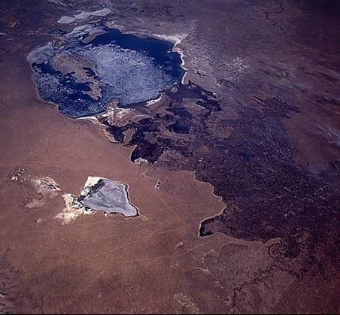

One example of catastrophic surface water drawdown is the Aral Sea, located in Central Asia between Kazakhstan and Uzbekistan. The Aral Sea is fed by the Amu Darya and the Syr Darya rivers. In the past 40 years, large amounts of water have been taken from these rivers for irrigation of millions of acres of cotton and rice crops in Soviet Central Asia. This water withdrawal has caused the Aral Sea to shrink in size and water amount by more than half. The level of the sea was lowered by 17 meters. The Aral Sea went from being the fourth largest inland body of water to being the eighth largest. More than 27,000 square kilometers that were once covered with water became exposed.
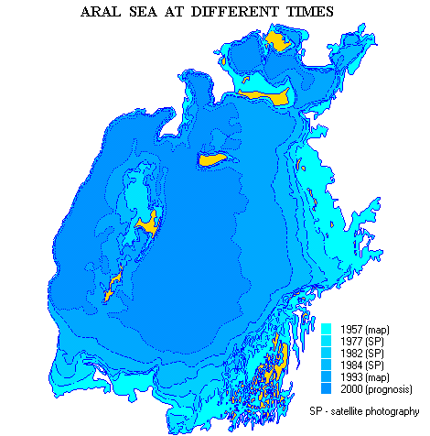
source: http://www.grida.no/aral/aralsea/english/arsea/arsea.htm
With the reduction in the amount of water the salinity of the sea increased from 10% to 23% and higher. This salinity has had devastating effects on the local fishing industry whose boats are now stranded miles inland from the coast. In the areas where the water receded, dust made of salt and chemicals from fertilizers and pesticides was left. This toxic dust blew away and was scattered over hundreds of square miles. In the areas where the sea once existed a new desert has appeared.
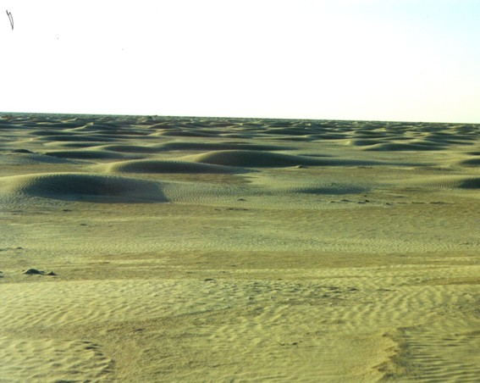
Surce: http://www.uni-bielefeld.de/biologie/Oekologie/aralsee.html

The Yellow River
The Yellow River (also called the Huang He) originates in the Qinghai Province and makes its way more than 3,000 miles across China to the Yellow Sea. The fertile area around the Yellow River is the cradle of Chinese civilization. Millions of people rely on the river for agricultural, industrial, and domestic uses. During the winter the river is small and silt-laden, but during the summer it becomes swift and cause serious flooding. Many areas in the arid western parts of China rely heavily on the river to irrigate their crops. The river has many dams, to provide water to people, for hydroelectric power, and also to prevent catastrophic flooding.
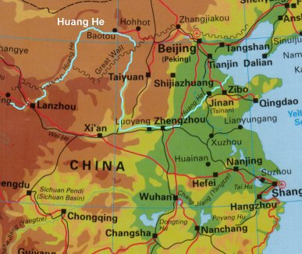
Source: http://www.kented.org.uk/ngfl/rivers/Feature%20Articles/huanghe.htm
Because of dams and diversions of the river, in 1972 for the first time in history the Yellow River failed to reach the sea. The problem continues to grow worse as use continues to increase and more dams are built upriver. In 1997 the mouth of the river was dry for over 200 days. Many of the river’s tributaries are now dry.
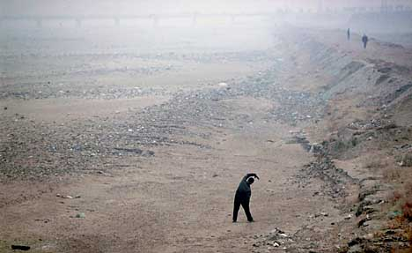
Source: http://www.sfgate.com/cgi-bin/article.cgi?f=/chronicle/archive/2002/03/04/MN50621.DTL
The Yellow River is not the only river in China that has this problem. Many dams are built or are planned to be built on other major rivers such as the Yangtze (or Chang). In 2000, China announced tht it would build canals to divert water from the Yangtze to the Yellow River. As water use continues to increase the amount of water in these rivers will decrease.

The Colorado River
In the arid Southwest of the United States several large cities such as Las Vegas and Phoenix have grown beyond the capacity of groundwater resources to support them. Despite the arid climate there is enough water for the growing populations, and you can find swimming pools, green lawns, and decorative water fountains. The reason these cities have had an adequate supply of water in the desert is the Colorado River. The Colorado River provides water to nearly 25 million people in Arizona, California, Colorado, Wyoming, Nevada, New Mexico and Utah.
Uses of Water in Colorado
Water Use | % of total used
Municipal | 4.4
Industrial | 1.0
Irrigation | 91.6
Livestock | 0.4
Other | 2.6
data from: http://waterknowledge.colostate.edu/withdrawals.htm
The Colorado River originates in the mountains of Colorado and makes it way across the Southwest U.S. and through Mexico to the Pacific Ocean. Because of the large amounts of water drawn from the river however, little water finds its way to the ocean. a treaty signed in 1944 requires the U.S. to allow a certain amount of water to reach Mexico, but almost all of this is used before it reaches the ocean.
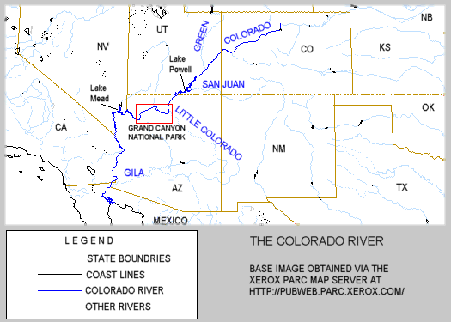
Source: http://www.kaibab.org/misc/gc_coriv.htm
The Colorado River is the location of the largest dam in the United States, the Hoover Dam, which was built in 1935. The river also has many other dams, including the controversial Glen Canyon Dam which was completed in 1963. These dams have altered the ecology of the Colorado River, causing many fish species to die off. With the creation of these dams large reservoirs are created, such as Lake Powell which is behind the Glen Canyon Dam. The water in these reservoirs evaporates more quickly than it would normally, causing reduced water levels and high levels of salinity in the downstream river. Due to recent dry conditions, Lake Powell is the lowest it has been in 30 years, making the salinity problems worse.
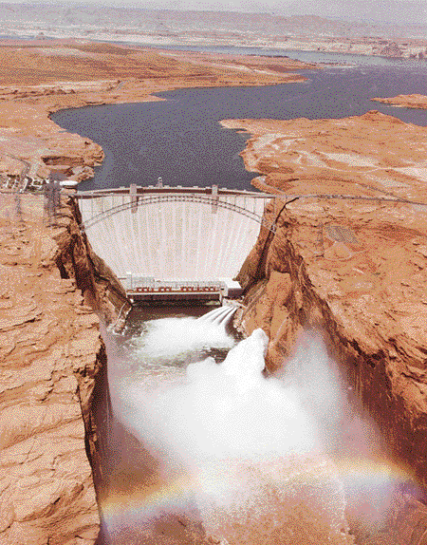
Source: http://www.kaibab.org/misc/gc_coriv.htm
Sources
For more information on this topic:
Aral Sea http://www.grida.no/aral/aralsea/english/arsea/arsea.htm
USGS Earthshots http://edcwww.cr.usgs.gov/earthshots/slow/Aral/Aral
Combating desertification and rehabilitation of the salt deserts in the region at the Aral Sea http://www.uni-bielefeld.de/biologie/Oekologie/aralsee.html
The Huang He http://www.kented.org.uk/ngfl/rivers/Feature%20Articles/huanghe.htm
The Columbia Encyclopedia http://www.bartleby.com/65/hu/HuangHe.html
SFGate.com http://www.sfgate.com/cgi-bin/article.cgi?f=/chronicle/archive/2002/03/04/MN50621.DTL
Yellow River Homepage http://www.cis.umassd.edu/~gleung/
The Colorado River: Whose Water is it Anyway? http://www.udel.edu/inst/problems/colorado/
CRWUA http://www.crwua.org/colorado_river/overview.htm
Colorado Water Knowledge http://waterknowledge.colostate.edu/
Environmental News Network http://www.enn.com/news/2004-05-04/s_23434.asp
KVOA http://www.kvoa.com/Global/story.asp?S=1829915&nav=HMO5Mk1v
Grand Canyon Explorer http://www.kaibab.org/misc/gc_coriv.htm

13. Water Companies
& Water Pricing
Adam Livermore livermaj@uwec.edu

Do you ever wonder how water companies make money? Why is water so expensive when water itself does not cost anything? The reason why communities pay water companies is because the companies can deliver the water, and the government has handed a previously public water utility over to them. The companies are also responsible for treating and cleaning up polluted water, water distribution and supply, sewage and sewage treatment, river purification, flood prevention and some aspects of coastal protection. We pay water companies to ensure that the water that is distributed to our homes and other buildings is safe to drink. Supplying water is a huge business, especially in heavily populated areas. The more we waste water and the more polluted natural supplies get, the harder water companies will work to sell us clean water, which means higher water bills. Eco-schools
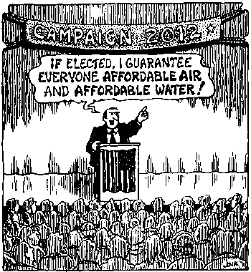

Municipal Water Pricing
Water pricing varies from country to country, and depends largely on whether the water company is privatized or state-owned. Also, water rates are generally higher in countries with severe water scarcity (such as Algeria, Sudan, and Israel) and institutionally developed water economies (such as Australia and Israel). The industrial and power sectors within a country usually pay the highest water rates and receive a higher, more costly level of service throughout the year, as do domestic users. Agriculture pays the least, but also receives the lowest level of service. Within each sector and country, there can also be a wide variation in costs, as domestic users buying water from private vendors pay much more than those connected to municipal systems. Farmers receiving irrigation from public canals also pay far less than those receiving irrigation from private wells.
According to the World Bank Group, monthly utility water bills typically around the world are about 2 percent of household income. The utility water bill excludes payments to water vendors, which can be substantial in some locations. In Egypt the monthly utility water bill is as low as $1, while in Ramallah (West Bank) it is close to $20.
Municipal water use is metered in most countries, but Egypt and Lebanon do not use water meters in most cities. These two countries levy only a flat-rate tariff that is independent of the level of water use and provides no incentive for conservation. Sewage tariffs throughout the region tend to be even lower and typically are only a fraction of water tariffs. According to the Green Lane, water consumption usually drops 18-25% after a water meter is installed. For more information: World Bank website
Here is a break down of water cost in Europe from the International Office for Water: http://www.oieau.fr/anglais/gest_eau/part_d.htm
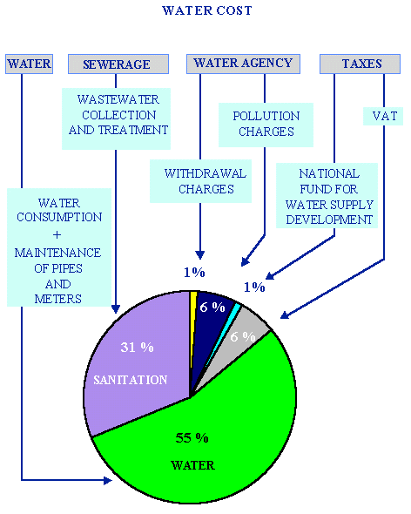

Corporate Water Giants
The problem with water companies is that since water is such a big business today, the huge transnational corporations can control the price of water. There are three major transnational corporations in the world today: the French transnational Vivendi, the German energy conglomerate RWE, and the French firm Suez. Vivendi and RWE are water giants that have control of almost 40 percent of the existing water market share. Veolia Environnement was formerly called Vivendi Environnement and owned by Vivendi Universal. Vivendi has long history of corporate corruption, including bribery convictions, class action suits, massive debt, etc. The company's opponents say it is concerned with monopolistic profits rather than providing people with water. Currently Veolia’s focus is on the markets of the United States, Europe, and Asia. For more information: Vivendi/Veolia
RWE, the other major corporate giant, also has an awful record. It is known for pollution in England and Wales in the early 2000s. RWE is a German conglomerate that has fully acquired Thames Water from England, which is responsible for the pollution mentioned above. This company's opponents say it would rather risk public health and pay a few fines to save money than to prevent pollution that is easily in their power to control. RWE is also acquiring American Water Works (through Thames Water), the largest U.S. public water utility, with 16 million customers in 29 states and three Canadian provinces. RWE makes more than $50 billion annually and continues to expand. For more information: RWE/Thames Water

Solutions in Australia to High Water Demand
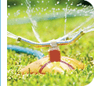
In Sydney, Australia, the New South Wales state government is considering changing its water pricing system to avoid having to put in a new dam. The Utilities Minister, Frank Sartor, said, "We need to develop a system that better reflects our need to conserve as much water as possible." The first option the government provided was to increase the water price for everyone. However this was seen as unfair because it did not punish the water wasters. The second and third option create a pricing system that stays the same up to a certain level (400 milliliters a year) and then have to pay a tax that is nearly double. The incentive to reduce water consumption is quite significant and could encourage people to invest in recycled water. (See New water pricing to penalise water guzzlers) Recycled water is a service recently created by Sydney Water to use waste water that has been treated for household use. The Rouse Hill Recycled Water Area is part of a co-ordinated water cycle management program designed to help protect the Hawksbury Nepean River. The water that is treated goes through an intense water filtration system, and when it is finished it cannot be distinguished from regular drinking water. However it is not used for consumption. Houses that use recycled water have separate water pipes installed so the water can be used for purposes such as watering the lawn and toilet water. The cost is about one-third the cost of regular water, but plumbing with recycled water is more expensive than for a normal house. There is also a recycled water service charge and a recycled water usage charge. This system is based on environmental as well as economic sustainability. For more information: Rouse Hill
Improving Water Management in India
The key to using water effectively lies in effective management of water resources. Combining better water treatment policies and water use reduction is an important goal for a sustainable future. The Center for Science and Environment poses these solutions for India’s water problems:
Improve process technology: Clean and advanced process technologies can help industry reduce its water demand. For instance, by replacing the conventional bleaching process with totally chlorine bleaching process, pulp and paper companies can almost close their water cycle. But these changes can be costly.
Reuse process water: This involves reusing water in a series, in an open system, for two or more successive but different purposes. This enables use of poor quality water for more than one purpose.
Recirculate process water: Indefinite reuse of same water after treatment for the same purpose. Makeup water is to be used only to replace unavoidable losses. This is far cheaper than installing new process technology and recent technological development has made sure that it can be used by any type of industry.
Rainwater harvesting: This helps industries meet a substantial part of their annual water requirement even as demand on local sources is minimized. (See Traditional water harvesting)
There are enough technologies to solve all water problems, and the prices of these technologies are gradually decreasing. In a nutshell, it quite feasible today for an Indian industry to substantially reduce its water consumption and wastewater discharge by putting efficient systems for recycling and reusing the process water. But for this to happen government policy needs to be overhauled. For more information: Down to Earth Extra

Conclusion
In order to reduce our dependence on huge foreign water corporations, it is imperative that we strive to find better ways to locally utilize our water supplies. The proposed water system in Australia is a great example of how to create an economically and ecologically sustainable solution to reduce water consumption.

Sources
For more information:
Eco Schools: http://www.eco-schools.org.uk/water/bigpic.asp
Public Citizen : http://www.citizen.org/cmep/Water/
Center for Science and Environment: http://www.cseindia.org
Article, New Pricing to penalise water guzzlers: http://www.smh.com.au/articles/2003/12/18/1071337099722.html
World Bank Group
14. Water Privatization Conflicts

Dustin VanOverbeke vanovedr@uwec.edu


In her book Water Wars, the Indian author Vandana Shiva lists nine principles underpinning water democracy. At least two of these principles are directly compromised by the privatization of water. Point number four states that “Water must be free for sustenance needs. Since nature gives water to us free of cost, buying and selling it for profit violates our inherent right to nature's gift and denies the poor of their human rights.” When private companies try to make large profits through high water prices, it denies the poor the inalienable right to the most necessary substance for life. Inaccordance with this fact, point number seven states, “Water is a commons. . . It cannot be owned as private property and sold as a commodity.” How can one justify claiming water as their own through contractual agreement while letting another human being go thirsty? Water is a commons because it is the basis of all life. Water rights are natural rights and thus are usufructuary rights, meaning that water can be used, but not owned. As far fetched as water ownership may seem, it is happening at an increasing rate around the globe.
http://www.asahi.com/english/asianet/hatsu/eng_hatsu030222b.html
Currently there is a rush to privatize water services around the world. The World Bank and International Monetary Fund (IMF) are pushing for the privatization of water services by European and U.S.-based companies. They are pushing privatization through stipulations in trade agreements and loan conditions to developing countries. These privatization programs started in the early 1990’s and have since emerged in India, Bolivia, Chile, Argentina, Nigeria, Mexico, Malaysia, Australia, and the Philippines, to name a few. In Chile, the World Bank imposed a loan condition to guarantee a 33 percent profit margin to the French company Suez Lyonnaise des Eaux while the company insisted on a margin of 35 percent.
This privatization of services is only the first step toward the privatization of all aspects of water. Through this new globalization and privatization of water resources, there is an effort to replace collective ownership of water sources with corporate control. This effort is being met with increasing opposition. Supporters of privatization say that it has a great track record of success, increasing the efficiency, quality, reliability and affordability of services to the population.
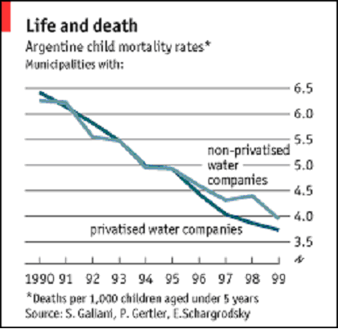
www.rppi.org/ privatizingwatersaves.html
Yet the industry has a track record of hazards and failures. For example, private companies most often violate standards of operation, and engage in price fixing without many consequences. This leads to water stress among the poor populations of these areas, causing people to drink water that is often very contaminated and hazardous to their health (even though case studies have shown that privatized water can be very contaminated as well).
Rising Prices and Deteriorating Water Quality
Australia - In 1998, the water in Sydney, was contaminated with high levels of giardia and cryptosporidium shortly after its water was overtaken by Suez Lyonnaise des Eaux.
Canada - At least seven people died as a result of E. coli bacteria in Walkerton, Ontario, after water testing had been privatized by A&L Labs. The company treated the test results as "confidential intellectual property" and did not make them public.
Morocco - Consumers saw the price of water increase threefold after the water service was privatized in Casablanca.
Argentina - When a Suez Lyonnaise des Eaux subsidiary purchased the state-run water company Obras Sanitarias de la Nacion, water rates doubled but water quality deteriorated. The company was forced to leave the country when residents refused to pay their bills.
Britain - Water and sewage bills increased 67 percent between 1989 and 1995. The rate at which people's services were disconnected rose by 177 percent.
New Zealand - Citizens took to the streets to protest the commercialization of water.
South Africa - Water became inaccessible, unaffordable, and unsafe after the water supply was privatized by Suez Lyonnaise des Eaux in Johannesburg. Cholera infections became widespread and thousands of people were disconnected from their supply of water.
Sydney Water Scare Leads To Accusations, Suggestions http://www.clo2.com/reading/waternews/sydney_report.html
Water Privatization: Will You Trust the Water That comes From Your Taps?
www.socialjustice.org/subsites/privatization/pdf/waterprivate.pdf
Water Wars
http://www.thirdworldtraveler.com/Vandana_Shiva/Water_Wars_VShiva.html
CBC News: Walkerton report highlights
http://www.cbc.ca/news/features/walkerton_report.html
Corpwatch: Argentina Water Privatization Scheme Runs Dry
http://www.globalpolicy.org/socecon/bwi-wto/wbank/2004/0226argwater.htm
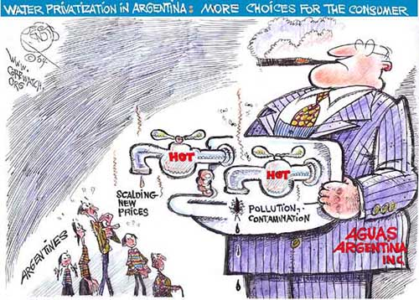http://www.corpwatch.org/issues/PID.jsp?articleid=10088
As is already evident, once these private water giants take over water services, prices skyrocket. After privatization, customer fees in France increased 150 percent while the water quality declined. In a French government report, it was revealed that over 5.2 million people had received “bacterially unacceptable water”. In Subic Bay, a former U.S. naval base in the Philippines, Biwater increased water rates by 400 percent. Water rates in England increased by 450 percent while company profits soared by 692 percent. CEO salaries for the private corporations behind the water supply increased by an astonishing 708 percent. As one can expect with such high price fixing, service disconnection increased by 50 percent. Meanwhile, the British Medical Association condemned water privatization for its health effects because dysentery increased six-fold. Many of these examples of the failures of water privatization are occurring in developed countries, but the most severe effects have been on the developing world. The high rises in pricing along with deteriorating water quality because of water privatization has led to much public scrutiny and uprisings by affected communities around the world.
Water Wars
http://www.thirdworldtraveler.com/Vandana_Shiva/Water_Wars_VShiva.html
Paying for privatization: higher prices, lower employment
www.psiru.org/reports/2000-03-W-Hprice.doc
Bechtel in Cochabamba, Bolivia
Probably the most well known example of the global conflict over water privatization is the case of Cochabamba, Bolivia. It is a shining example of the conflict over the privatization of water services, a victory for the people opposing privatization, and the persistence of the water giants to make money any way they can. Cochabamba lies in a semidesert region of Bolivia, making water a scarce and precious resource. However, in 1999 the World Bank recommended privatization of Cochabamba's municipal water supply company, Servicio Municipal del Agua Potable y Alcantarillado (SENIAPA). "Bank officials directly threatened to withhold $600 million in international debt relief if Bolivia didn't privatize Cochabamba's public water system." http://www.alternet.org/story.html?StoryID=14525 This was to be done through a concession to one of Bechtel’s subsidiaries - International Water. Bechtel is a U.S. corporation based in San Francisco. This corporate giant is not even welcome in its hometown of San Francisco. In June, 2002 the Board of Supervisors in San Francisco voted to cancel a $45 million program management contract awarded to Bechtel for the reconstruction of the Hetch Hetchy public water system. This vote took place after an investigation by the San Francisco Bay Guardian, a local alternative weekly newspaper, exposed that at least $5 million dollars of nearly $8 million payed out to Bechtel for its first year of service was a complete waste of money. In one case, Bechtel took a city database of projects, resorted the information, changed the data into a different format, and sold it back to the city for almost $500,000.
Bechtel vs. Bolivia: The Bolivian Water Revolt
http://www.democracyctr.org/bechtel/
Bolivia’s Water War Victory
http://www.thirdworldtraveler.com/South_America/Bolivia_WaterWarVictory.html
Bechtel's Water Wars
http://www.corpwatch.org/issues/PID.jsp?articleid=6670
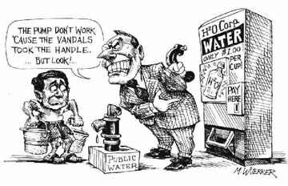
http://www.oilempire.us/water.html
In response to the World Bank recommendation, the Bolivian Congress passed the Drinking Water and Sanitation Law in October 1999, allowing privatization and ending government subsidies to municipal utilities. Soon after International Water took over the water services in Cochabamba, the monthly water bill reached $20 in a city where the minimum wage is less than $100 a month. These increases forced some of the poorest families in to literally choose between food and water ($20 is nearly the cost of feeding a family of five for two weeks). For more information on the these price hikes, see http://www.democracyctr.org/bechtel/waterbills/index.htm In response to these price increases, an alliance of the citizens of Cochabamba called La Coordinadora de Defensa del Agua y de la Vida (The Coalition in Defense of Water and Life) was formed in January 2000. Through mass mobilization, the alliance shut down the cityfor four days. Within a month of this, millions of Bolivians marched to Cochabamba and held a held a general strike, stopping all transportation. The protesters then issued the Cochabamba Declaration, which called for the protection of universal water rights for all citizens.
Bolivia’s Water War Victory
http://www.thirdworldtraveler.com/South_America/Bolivia_WaterWarVictory.html
Bechtel vs. Bolivia: The Bolivian Water Revolt http://www.democracyctr.org/bechtel/
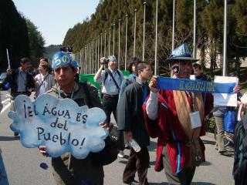
www.americas.org/.../ WaterCartel2.htm
In response to this, the Bolivian government promised to reverse the price hike. They never did. So, in February 2000, La Coordinadora organized a peaceful march demanding the retraction of the Drinking Water and Sanitation Law, the termination of the water contract, the participation of citizens in creating a water resource law, and the cancellation of ordinances allowing privatization. Slogans such as "Water Is God's Gift and Not A Merchandise" and "Water Is Life" were used by the protesters. These demands were strongly rejected by the government. The following April, the government declared martial law to try and silence the water protests. Activists were arrested, protesters were killed, and the media was censored. After only a day of martial law, three protesters had been killed, including a 17-year old boy who was shot in the head by soldiers in Cochabamba. Over 30 people had been injured through conflicts with the military and the leaders had been jailed (some were flown to a remote location in the jungle of Bolivia).
The people finally won on April 10, 2000 when Aguas del Tunari and Bechtel left Bolivia and the government was forced to revoke its water privatization legislation. The water company Servico Municipal del Aqua Potable y Alcantarillado (SEMAPO) along with the debts, was handed over to the workers and the people. In the summer of 2000, La Coordinadora held public hearings to start democratic planning and management. However, the Bolivian government and Bechtel continued to harass and threaten activists of La Coordinadora, trying their best to undermine the process. In November 2001, Bechtel filed a lawsuit against Bolivia, demanding $25 million in compensation for its lost opportunity for future profits.
Currently, this lawsuit is being heard by the International Center for the Settlement of Investment Disputes (ICSID), an international tribunal housed at the World Bank in Washington DC, that holds all of its meetings in private. Bechtel was able to file the case with ICSD under a Bilateral Investment Treaty (BIT) between the Netherlands and Bolivia. Even though Bechtel is a U.S. corporation, its subsidiary founded a presence in the Netherlands in order to exploit this treaty. Because of the secrecy of the hearings, the Center for International Environmental Law and Earthjustice filed a request in August 2002 to open these proceedings to the public of Bolivia. However, in February 2003 the ICSD sided with Bechtel, announcing that it would not allow the media or public to have any part in or even witness the meetings. Not only is the World Bank forcing its programs and ideas on the people of Bolivia, but it is also preventing the affected people from participating in a matter that directly affects their lives. As of May 2004, there has been no verdict on the lawsuit.
Bechtel Strikes Back at Bolivia
http://www.alternet.org/story.html?StoryID=14525
URGENT ACTION: supports demands that Bechtel drop suit against Bolivia
http://www.nadir.org/nadir/initiativ/agp/free/imf/bolivia/txt/2002/0420bechtel.htm
Bechtel vs. Bolivia: Bechtel’s legal action against Bolivia http://www.democracyctr.org/bechtel/bechtellegalaction.htm
Bechtel in the new Iraq
Today, Bechtel is spreading its water privatization elsewhere, aided by war. Within a month after the 2003 invasion of Iraq, Bechtel acquired a $680 million contract for “rebuilding” Iraq. As Vandana Shiva writes in her article Bechtel And Blood For Water: War As An Excuse For Enlarging Corporate Rule, “The U.S. led war first bombed out Iraq's hospitals, bridges, water works, and now U.S. corporations are harvesting profits from 'reconstructing' a society after its deliberate destruction. Blood was not just shed for oil, but also for control over water and other vital services. . . war has become a convenient excuse for enlarging corporate rule. If W.T.O. is not enough, use war.”
George Shultz was Secretary of State under Ronald Reagan and previously was the president of Bechtel. He is now a board member and senior counselor for the corporation. He was chairman of the pro-war Committee for the Liberation of Iraq and wrote in a op-ed article in the Washington Post September 2002 that “A strong foundation exists for immediate military action against Hussein and for a multilateral effort to rebuild Iraq after he is gone."
Because Bechtel is a privately held company, without public stock trading, it does not have to reveal many of its operations. Bechtel is responsible for over 19,000 projects in 140 countries on all continents, and is involved in over 200 water and wastewater treatment plants around the world. It was involved in the Dabhol plant in India with Enron, and is now involved in water privatization of Coimbatore/Tirrupur as part of a consortium with Mahindra and Mahindra, United International North West Water. The contract has not yet been made public, as is the case with other privatization contracts.
Conclusion
The rush to privatize water continues unencumbered, despite its unpopularity among residents worldwide who are affected by it. Countries faced with large debts are forced by the World Bank and IMF to privatize water . Water deregulation is a common demand of the World Bank and IMF as part of their loan conditions. In 2000, out of 40 IMF loans distributed through the International Finance Corporation, 12 had requirements of partial or full privatization of water supplies. They also insisted on the creation of policies to stimulate “full cost recovery” and the elimination of subsidies. African governments, such as Ghana, increasingly give in to pressures for water privatization. In Ghana, the World Bank and IMF policies forced the sale of water at market rate, requiring the poor to spend up to 50 percent of their earnings on water purchases. As Vandana Shiva writes in Water Wars, “The water crisis is the most pervasive, most severe, and most invisible dimension of the ecological devastation of the earth.”
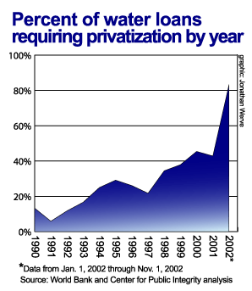
http://www.icij.org/dtaweb/water/PrintReady.aspx?AID=2
Sources
For more information:
Overall Sources
Yellowtimes: Water privatization in Africa
http://www.yellowtimes.org/article.php?sid=369
Water Privatization: Issues & Debates
http://www.citizen.org/cmep/Water/articles.cfm?ID=10842
CBCnews: Water For Profit
http://www.cbc.ca/news/features/water/
Argentina Water Privatization Scheme Runs Dry
http://www.corpwatch.org/issues/PID.jsp?articleid=10088
Water Wars
http://www.thirdworldtraveler.com/Vandana_Shiva/Water_Wars_VShiva.html
Sydney Water Scare Leads To Accusations, Suggestions http://www.clo2.com/reading/waternews/sydney_report.html
Water Privatization: Will You Trust the Water That comes From Your Taps?
www.socialjustice.org/subsites/privatization/pdf/waterprivate.pdf
CBC News: Walkerton report highlights
http://www.cbc.ca/news/features/walkerton_report.html
Water for profit: contamination, riots, rate increases, scandals. From Atlanta to Manila, cities are confronting the true cost of water privatization - the price of water
http://articles.findarticles.com/p/articles/mi_m1329/is_6_27/ai_94129863
Workers' Educational Association http://www.swales.wea.org.uk/myweb4/private%20water.htm
Corpwatch: Argentina Water Privatization Scheme Runs Dry http://www.globalpolicy.org/socecon/bwi-wto/wbank/2004/0226argwater.htm
Paying for privatization: higher prices, lower employment
www.psiru.org/reports/2000-03-W-Hprice.doc
Water privatizers on the defensive
http://www.newint.org/features/kyoto/020603.htm
Minnesota Water Alliance (opposing corporate 99-year leases on public water utilities in multiple cities) http://www.mnwater.org
Bechtel and Bolivia
Bechtel vs. Bolivia: The Bolivian Water Revolt
http://www.democracyctr.org/bechtel/
Bolivia’s Water War Victory
http://www.thirdworldtraveler.com/South_America/Bolivia_WaterWarVictory.html
Bechtel Strikes Back at Bolivia
http://www.alternet.org/story.html?StoryID=14525
Bechtel Wins Iraq War Contracts
http://www.corpwatch.org/issues/PID.jsp?articleid=6532
URGENT ACTION: supports demands that Bechtel drop suit against Bolivia
http://www.nadir.org/nadir/initiativ/agp/free/imf/bolivia/txt/2002/0420bechtel.htm
Bechtel vs. Bolivia: Bechtel’s legal action against Bolivia http://www.democracyctr.org/bechtel/bechtellegalaction.htm
Bechtel's Water Wars
http://www.corpwatch.org/issues/PID.jsp?articleid=6670
Bechtel And Blood For Water: War As An Excuse For Enlarging Corporate Rule
http://www.globalpolicy.org/security/issues/iraq/after/2003/0512bechtelrule.htm
Water Privatization in India
Water Privatization in India by Dr. Vandana Shiva
http://www.citizen.org/cmep/Water/cmep_Water/reports/india/articles.cfm?ID=8109
CorpWatch India: French Firms Spearhead Water Privatization
http://www.waternunc.com/gb/CorpWatchIndia02_2002.htm
Communities Reject Coca-Cola in India
http://www.corpwatch.org/issues/PID.jsp?articleid=7508
India Resource Center
http://www.corpwatchindia.org/
The Dabhol Project in India
Enron's ghost haunts India
http://www.atimes.com/atimes/South_Asia/EK14Df01.html
Enron: History of Human Rights Abuse in India
http://www.hrw.org/press/2002/01/enron_012302.htm
The Enron Corporation: Corporate Complicity in Human Rights Violations
http://www.hrw.org/reports/1999/enron/
Shiva, Vandana. 2002. Water Wars: Privatization, Pollution, and Profit. South End Press. 158 pgs.

15. Bottled Water Industry

Lance Klessig klessill@uwec.edu
This webpage will focus on the bottled water industry around the world, and how public attitudes toward bottled water have changed over the course of the past decade. Areas of interest include global distribution, bottled water industries, price margins, targeted areas of water bottling industries, global public opinion and acceptance of bottled water, and possible health benefits/drawbacks of bottled water.
In general, the global bottled water industry has become very profitable in the past ten years. Huge multinational companies currently make billions of dollars on water they simply extract from the ground, slap a label on and sell at competitive prices. Examples of these companies includ: Aquafina (Pepsi), Dasani (Coke), Perrier (Nestle), Evian, and Fiji Water among hundreds of others. A short list of bottled water companies within the U.S. can be found at Bottled Water Web and a list of Canadian bottled water producers can be located at Canadian Bottled Water Association.
Bottled Water Consumption
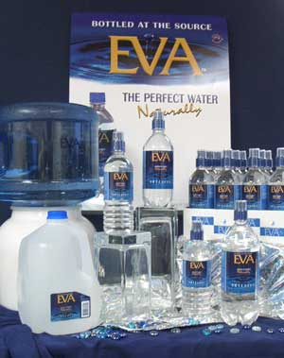
Eva
Bottled water consumption has grown exponentially over the past ten to fifteen years. This growth has taken place globally, but particularly in Europe and North America. The bottled water industry has literally created its own water culture. For example, when one enters a gas station, grocery store or a restaurant in any country of the world, one is bound to find at least a few different brands of bottled water. Bottled water is somewhat less likely to be found in developing countries, where public water is least safe to drink. Many government programs regularly disperse bottled water for various reasons. Distributing small bottles of water is much easier than distributing large bulk storages of water. Also contamination from large water storage containers is much more likely than from single 12-20 ounce bottles of water.
Many countries have become very oriented toward bottled water. According to a 2001 World Wildlife Fund survey, individuals around the globe consume some 89 billion liters of bottle water annually, worth roughly $22 million. Citizens of the U.S. alone consume about 13 billions liters of bottled water. A 2000 report conducted by Yankelovich Partneers of the Rockefeller University discovered that 2.3 eight-ounce servings of the total 6.1 servings of water that are consumed daily are bottled water in the U.S. Bottled Water Consumption
So which areas of our world are consuming the largest amounts of bottle water? Splash's website provides a wealth of knowledge regarding who, what type, regulations and an overview of the market. Below is a graph of 1999 Bottled Water Consumption in liters per person, courtesy of Splash's Freshwater Newsletter. Surprisingly, Western Europe consumes almost 50% of the world's bottled water. Many claim that this is due to European culture, since the continent has had very polluted waters due to agriculture and industry dating back to the Industrial Revolution.
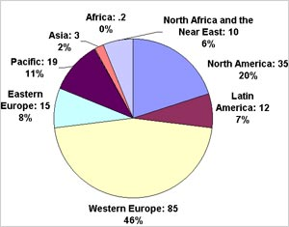
Splash
Splash also states that roughly 59% of bottled water that is consumed is purified, while the 41% is spring or mineral water. Most bottled water (about 75%) originates from protected sources such as underground aquifers and springs. Increases in bottled water consumption is also a major issue. Below is a graph that explores the increase from 1999-2001 for eight different regions globally.
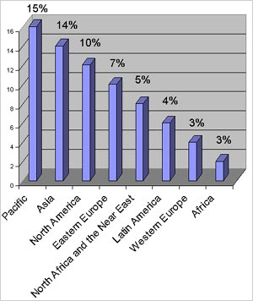
Graph compliments of World Wildlife Survey found at Splash

Health Benefits and Drawbacks
Although there are relatively few regulations on what bottled water can contain, people have very differing opinions on possible benefits and drawbacks of bottled water. Currently there are multiple studies showing numerous bottled water brands containing harmful substances. According to a four-year scientific study by the Natural Resources Defense Council, over a third of the tested brands contain contaminants such as arsenic and carcinogenic compounds. This study of 103 different brands encompassing over 1,000 bottles showed that one-third of the water in these bottles exceeded state or industry safety standards.
An earlier study by Ohio State University (found at Common Dreams News Center) found that 39 out of 57 bottled water samples did indeed have "purer" water than tap water. However, 15 samples had significantly high bacteria samples. The scientists agreed that all of the water was safe to drink, but the study clearly showed how claims of bottled water purity can be misleading. While one can evaluate the chemical contents of water, most consumers choose bottled water for its taste. A large majority of bottled water consumers drink bottled water because they believe it has better health benefits, and many consume such large quantities due to its taste. Globally most people associate bottled water with tasting better. However, when Good Morning America conducted a taste test of its studio audience, New York City tap water was chosen as the heavy favorite over the oxygenated water 02, Poland Spring and Evian (Environmental News Network).
Some global agencies such as the World Health Organization have neutral feelings regarding possible health benefits or drawbacks from the consumption of bottled water. On WHO's website they claim that many European consumers believe that natural mineral waters have medicinal or other health properties. WHO respects these beliefs, but has been unable to find convincing evidence to support the mineral water consumption benefits. There have been few quality studies regarding health effects of drinking bottled water. Many researchers believe that the benefits of bottled water are based mainly on a common ideology.
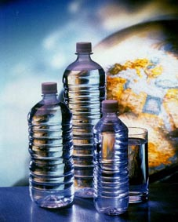
Australian Bottled Water Institute
Public Opinion and Acceptance
Globally almost every country is accepting the "bottled water culture." Millions of people get parts or all of their daily water values from bottled water. A study done by Green Nature suggests that over half of Americans drink bottled water, spending 240-10,000 times more than tap water. At the University of Wisconsin-Eau Claire, where I attend college, the "bottled water culture" definitely is in full swing. One cannot glance at a random student or faculty member book bag without finding a bottle of water stowed inside. Drinking bottled water is essentially a part of our culture today. We can look at any local, national or international sporting event and see the prevalence of bottled water. Apparently regular tap water in a bottle or cup has slowly begun to be looked down upon. Although many individuals will carry a reusable water bottle such as a Nalgene, most bottled water containers are thrown away after just one use. This may be due to the convenience of bottled water, as it is almost more readily available than tap water.
David Ozonoff, of the Environmental Health Department at Boston University, claims that the bottled water versus tap water debate boils down to a mentality issue. He states, " I think the problem today is that turning on your tap is an act of faith, and I'm not sure that that act of faith is particularly well-placed." If you drink from the tap, there are several recent studies you should know about because they may change the way you think about your water.
I grew up in Central Wisconsin surrounded by very high quality groundwater. With small creeks and a Class A trout stream running through my famly's property, I always felt safe drinking the surface water. I have been raised on high-quality tap water from underground aquifers and test after test has proven our water is safe for consumption. I do understand why more urban residents are more prone to drinking bottled water, but I do agree with Mr. Ozonoff that it is largely a mentality issue. After traveling extensively in over 15 countries in Asia and Europe, drinking water from a tap or bottle is essentially the same thing. I believe many people just view "regular" tap water as not having the best taste or question its source. In reality however, all water flows regularly threw the hydrologic cycle in only a short number of years, so source has very little bearing after the purification processes. See the related link How Groundwater Works for more information.
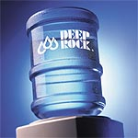
Deep Rock Water
Company Price Margins
The bottled water culture's recent explosion in the last decade is due to many corporations' advertising efforts to promote the need to drink "healthy" bottled water rather than tap water. Multinational companies across the globe are racking in billions of dollars with very little effort. The taking of "free" water and making huge sums of money is a response to very loose restrictions on water withdrawal. In areas with few or no restrictions companies are able to sink high-capacity withdrawal wells and later implement bottled water plants wherever they please. In 2001 according to Jeffrey Hammon, bottled water industry revenues in the U.S. alone grew by over 13%. According to research and consulting done by the Beverage Marketing Corporation, the global bottled water industry has exploded to over $35 billion. Americans alone paid $7.7 billion for bottled water in 2002. In 2001, for example globally bottled water companies produced over 130,000 million liters of water. This produced roughly 35,000 million dollars in revenue for the world's thousands of bottled water companies in 2001. For more information see the International Council of Bottled Water Association's website.

Targeted Areas for Bottling Operations
Corporations primarily target just a few areas to implement new bottling facilities. Each country varies where they allow new facilities to be located. In general most communities fight against corporations taking over local springs and over pumping of groundwater, according to Alliance for Democracy. Huge companies seek this water to fuel the demand for bottled water because regular tap water or municipal water is deemed poor quality. The corporations then make huge profits on water they paid nothing or very little for from Mother Nature.
Some countries and concerned citizens are bringing water bottling plants to a halt. According to Ratna Bhushan of the Hindu Business Line, in New Delhi, India the Bureau of Indian Standards (BIS) has clamped down on some of the water bottling companies within their region. BIS shut down the production of over 200 bottling plants in India in early 2004 because the plants did not submit test reports or had unsatisfactory performance. Some of these plants included Bisleri, Coca-Cola's Kinly and Kingfisher.
Hiroshi and Arlene Kanno have had similar battles with trying to prevent Perrier from building a plant that would pump 500 gallons a minute from the Town of Newport in central Wisconsin. The Concerned Citizens of Newport won the battle even after the company tried to bribe the community, hired lobbyists to further its plans, and even had the support of the governor. These two examples are just mere glimpses of what companies will try to make millions from having a new bottling plant put into operation. Perrier moved its bottling plans to Michigan, where it was defeated in 2003. For more information on bottled water issues between citizens and corporate giants see the related webpage Bottled Water Conflicts.
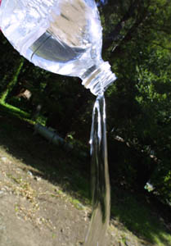
Metro Active

Global Bottled Water Companies
Worldwide there are thousands of companies bottling water for profit. Many of these corporations have grown exponentially. Almost all of these corporations make phenomenal amounts of money on a resource they pay very little for. I believe it a shame that we have quantified water in so many areas of the world. One only has to look at industry leaders such as Thames Water, Perrier, Vivendi, Suez, Pepsi and Coca-Cola to see how their profit margins have been on a steady increase over the last decade, in their bottled water divisions. Bottled water companies fight not only concerned citizens within local areas, but also fight each other in hopes of being the first to establish their own bottling plants.
German energy conglomerate RWE and French transnational Vivendi currently are the two largest water corporations globally. These giants control almost 40% of the existing water market shares as they are ranked 51st and 53rd among Fortune's Global 500 List. Vivendi alone operates in over 100 countries while the third largest bottling water giant, Suez, operates in more than 130 countries. Suez and Vivendi combined annual revenues push $70 billion. (Public Citizen)
Global bottled water companies have been criticized for their methods. For example, in Massachusetts and New Hampshire, after American Water Works had been sold to German based RWE, the managers of Nashua's water company Pennichuck decided to post the local company for sale. Then in April 2004, Pennichuck announced that it had received a $106 million purchase offer from Philadelphia Suburban. This company is the second largest investor-owned water utility in the United States. Not surprisingly Vivendi, the huge French conglomerate and one of the world's leading bottled water producers, owned 17% of Philadelphia Suburban. Now the citizens of the greater area of Nashua, New Hampshire are extremely concerned with who will own their public water supply. See American Friends Service Committee for more information on this and other related stories. This example just goes to show how these huge multimillionaire global bottled water corporations will try and get into any place of the water market to further extend their economic domination.
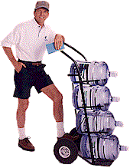
Culligan
Conclusion
The global bottled water industry is in a very powerful position, but is also under increased scrutiny and criticism. I believe that bottling companies have far too much control and are relatively uncontrolled in most places globally. What will happen when our bottled water consumption reaches the projected 50 billion liters by 2008? What will happen when that figure doubles or triples in five or ten years after 2008? I believe that bottled water consumers need to severely limit our bottled water consumption, and alert these huge multinational bottled water corporations of our disapproval of their practices. The citizens of every nation in the world need to stop purchasing bottled water and replace these containers with more durable and reusable containers, such as those made by Nalgene, and make our tap water of higher quality so we can rely on it for our drinking supply.
Sources
Alliance for Democracy
American Friends Service Committee
Australian Bottled Water Institute
Bottled Drinking Water, Health and Purity
Bottled Water Web
Brandchannel.com
Canadian Bottled Water Association
Canadian Springs Water Company
Common Dreams News Center
Culligan
Deep Rock Water
Environmental News Network
European Bottled Watercooler Association
Eva
Evian
Fiji Water
International Bottled Water Association Website
International Council of Bottled Water Associations
Hartford News Advocate
Health Canada
Hindu Business Line
Natural Resources Defense Council
Nestle Waters
Public Citizen
Pure Earth
Splash
World Health Organization

16. Bottled Water Conflicts

Mike Schwartz schwarmj@uwec.edu

Bottled water companies often seek out rural areas with clean natural springs to bottle and sell to consumers. Unfortunately, they often pay no heed to the local residents or the environment they live in. While most small bottlers take the water as it naturally bubbles up, many large bottlers pump out the groundwater and springs with high-capacity wells. These wells can cause groundwater drawdown, drying up area residents' wells (see Groundwater Drawdown). Today, many residents are fighting back and winning. Using a variety of methods, including legislative changes, local referenda, and boycotting, these groups have managed to say "no" to multinational water corporations.

Perrier in São Lourenço, Brazil
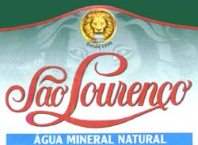
Photo Source: (http://www.aguastudoazul.com.br/sao%20lourenco.jpg)
"The Circuito das Águas region of Brazil contains one of the most important Brazilian national parks, the Itatiaia Park, known for its famous mountain peak, the Agulhas Negras (Black Needles). The mineral water sources are concentrated in 'water parks' distributed among 4 small towns: São Lourenço, Caxambu, Cambuquira, and Lambari. Towns were founded around these water parks in the 19th century, when the water sources and their medicinal properties were discovered." Franklin Frederick, an advocate of the International Free Water Academy, Brazil also described some personal experiences. "About 3 years ago many people in São Lourenço...began to notice a change in the taste of the mineral waters inside the Water Park, and one of the most famous water sources there, the Magnesiana, dried up and stopped flowing. Water usually needs hundreds of years inside the earth to be slowly enriched by minerals. If it is pumped in quantities greater than nature can replace it, its mineral content will gradually decrease, bringing the change in taste that we were noticing." (1)
Nestlé produces purified water labeled 'Pure Life.' The company violated all laws in the bottling of mineral water, when their production process produced common water by reverse osmosis. This process changed the natural composition of the mineral and healing waters. The huge amount of water that is pumped nonstop to meet the industry demand is lowering piezometric levels of the aquifers, diminishing flow and has used up one of the fountains, (the magnesian water) to below replenishable levels. The peculiar and discernible tastes of the waters of the different fountains are gone, and tourism was affected by all these conditions. (2)
In the article, Water as a Multidimensional Entity, Frederick went on to describe action taken by some of the locals. "... We created the Water Citizenship Movement and collected information about production of Pure Life. We discovered that Nestlé/Perrier was pumping huge amounts of water in the park from a well 150 m deep. The water was then demineralized and transformed into Pure Life table water. As the Brazilian constitution does not allow mineral water to be demineralized, we brought our findings to the attention of the public prosecutor of the State Public Ministry in São Lourenço, who began an official investigation of Nestlé/Perrier's activities in São Lourenço. This led to charges against the company at the end of 2001, and a federal investigation of Nestlé/Perrier. Meantime, we organized citizen protests against the company and collected 3000 signatures on a petition." (1)

Towns of Newport and New Haven, Wisconsin vs. Perrier

In 2000, Perrier informed the residents of two townships near Wisconsin Dells that they had a plan to begin continuous pumping of 500 gallons per minute of Big Spring into bottles (3). The company promised that pumping would have no effect on the local lakes and streams, and that it would bring jobs and money to the local economy. Many local people started asking "Who needs this?" says Hiroshi Kanno, a local resident. Many of the local residents are retirees who did not need jobs or large trucks rumbling by. Residents got together, putting up signs along roads reading "Go Away Perrier!". The towns even held referendums, voting 4-1 and 3-1 against letting Perrier pump the water. Perrier came back, giving the town $20,000, and launched a public relations offensive; the people of New Haven stepped up their community organizing. After the town chairman accepted the money, the residents held a recall, voting 263-92 against the chairman. Once the new chairman was in charge the people gave the money back to Perrier (4).
The majority voice of the residents was not enough. Governor Tommy Thompson and the Wisconsin Department of Natural Resources (DNR) gave Perrier the permits it needed to pump. A group called Concerned Citizens of Newport (CCN) filed a lawsuit against the Wisconsin Department of Commerce and DNR on a number of grounds, claiming that the DNR violated its duty to protect the Public Trust, the DNR violated WEPA (Wisconsin Environmental Protection Agency) by not adequately identifying and mitigating significant environmental impacts, and by dividing Perrier’s proposed water bottling operations into segments, among other objections (5). After a year, a judge decided that the DNR had not gathered enough data to show there would be no significant impact on the environment.
"In September 2002, Perrier announced that it would not seek to renew its drilling permits in Wisconsin. The CEO of Perrier was quoted as saying that his Wisconsin experience was the worst his company had ever had, and that the people of Wisconsin do not appreciate a good business. Perrier has since turned its sights towards Michigan." (6)

Michigan Stops Functional Bottling Plant
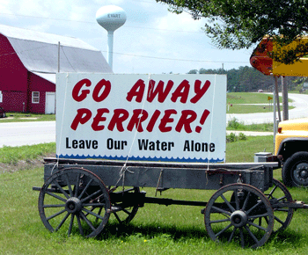
Photo Source: (http://www.garringer.net/foam/archives/Images/Go-Away-Perrier.gif)
"... In 2001 Perrier, which has since been bought by Nestle Waters North America [NWNA], was welcomed with open arms by then-Michigan Gov. John Engler, who allowed the company to open up a plant for a licensing fee of less than $100 per year and offered millions in tax breaks to boot. Construction started on the plant even before all the necessary permits had been obtained. For the past year and a half, the plant has been pumping 100 to 300 gallons per minute out of an aquifer on a hunting preserve in Mecosta County and piping the water 11 miles away to a bottling plant in Stanwood, where it is prepared for shipping and sale around the Midwest as Nestle's Ice Mountain brand." (7)
"Shortly after the pumping plan was announced, a grassroots movement of local residents and activists coalesced to oppose the plan, on the grounds that not only would the pumping have harmful effects on the environment and quality of life for residents, but it would also set a chilling precedent in selling off the area's natural resources to a multinational company. This coalition has used both legal and direct action approaches to raise awareness of the issue and try to stop the pumping plan. Among other things, the group Sweetwater Alliance, which has coordinated much of the grassroots opposition, staged a 'canoe-in' along one of the streams fed by the spring." (7)
"In the fall of 2001 the group Michigan Citizens for Water Conservation (MCWC) along with four individual local residents filed a lawsuit in Mecosta County Circuit Court seeking to prevent the pumping, arguing that it was not a legally defined 'reasonable use' of water and violated state and federal regulations regarding water rights." (7)
In late November 2003, Mecosta County Circuit Court Judge Lawrence C. Root ruled against NWNA, forcing the company to shut down four high- capacity springwater wells. This renders its already operational 700,000 sq. ft. bottling facility in Stanwood useless. In the ruling, the judge noted “Defendant Nestle was cautioned that it was proceeding in building a bottling plant at its own risk should I decide plaintiffs’ claims have merit such that there might be no water to be bottled in the plant.” (8) Such a ruling will likely make way for new groundwater legislation, as promised in 2002 by Governor-elect Jennifer Granholm.
Crystal Springs, Florida
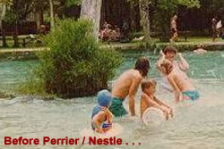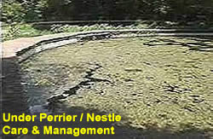
Photo Source: (http://www.saveoursprings.com)
Another ongoing struggle against bottled water has been happening in Crystal Springs, Florida. Crystal Springs flows directly into the Hillsborough River, which is the main drinking supply for the city of Tampa. For 20 years, owners of the spring, the Thomas family, maintained the spring and kept it open to the public while developing a lucrative deal to sell water and truck it to the Zephyrhills bottling facility. "When Perrier/Nestle purchased the Zephyrhills Water Company in 1987, things began to change. To accommodate Perrier's increasing demand for water, Bob Thomas suggested they install a PVC pipe in the heart of the spring to pump water underground to the bottling plant. By the early 1990s, Perrier's plans for the spring broadened to include larger steel pipes and pumps to upgrade their operation." (9)
In 1996, Bob Thomas, President of Crystal Springs Recreation Preserve, locked the gate and closed the spring to the public. This was justified in a public announcement saying he planned to conduct scientific research. Others argue the reason was to keep Perrier's abuse from public view. The closure prompted outrage and a united community effort to "Save Our Springs." (9)
In a letter, the Southwest Florida Water Management District, known as Swiftmud, cited Bob Thomas for allowing Zephyrhills Spring Water Co. to overdraw its allotment from the springs during July and August, 2000. Figures show that the company took 5,000 gallons per day too much in July and 3,000 a day too much in August. Thomas said the violation was an honest mistake that stemmed from calculating the daily intake of water on a calendar-year average rather than a 12-month rolling average. Terri Wolfe, leader of the Save Our Springs coalition said, "I don't believe it was an accident...I think his permit should be revoked. We're in a crisis here. The river is dying. This is Tampa's water he is screwing with." (10). Thomas is struggling to get new permits that would allow the water company to boost its daily withdrawals from the springs on his Two Rivers Ranch. One request, for up to 1.8-million gallons a day, (from 301,000 per day) was denied in February 2000 after Swiftmud found that such a dramatic increase would deplete Tampa's drinking supply. (10)
In 2002, Thomas was granted a 30,000-gallon per day increase permit. As part of the deal, approved in April, Thomas was allowed to take 30,000 gallons a day above his current allowance (301,000 gallons per day) if he found a suitable replacement source outside of the Hillsborough River Basin. Now, tanker trucks carrying thousands of gallons of well water are rumbling from Dade City to Crystal Springs and dumping it into the headwaters of the Hillsborough River. The water is coming from farmer Buddy Rowland's property near Dade City. (11)
In 2003, Thomas announced plans of opening up a long-promised nature center on the grounds, serving as a "living laboratory'' for students to learn about the environment and why the spring is so important to Florida's ecosystem. Save Our Springs, Inc. President Terri Wolfe, remains skeptical about Thomas's motives. Although she is glad that the springs will be reopened to some degree, she believes Thomas is doing it to look better in the eyes of the officials who issue permits to pump more water. (12)
Sources
(1) Water as a Multidimensional Entity
(2) Conflict Between São Lourenço Community and Nestlé
(3) Hightower, Jim. "The Grassroots Rebellion" The Nation. Sept. 2-9, 2002
(4) Lopez, Steve. "And Nary a Drop for You" Time. Sept. 25, 2000
(5) http://www.saveamericaswater.com/ccn/102000.html
(6) When the Grassroots said No (Way)
(7) Bottled Water Blues
(8) Nestle Decision a Bipartisan Challenge
(9) Crystal Springs History
(10) Rancher Cited for Letting Too Much Water be Taken
(11) Water Deal Puts Larger Tap On Crystal Springs
(12) It's Spring Time For Nature Center?

For more information:
FightingBob.com: When the Grassroots said No (Way)
Save America's Water: http://www.saveamericaswater.com
Concerned Citizens of Newport, WI: http://www.saveamericaswater.com/ccn/
Michigan Citizens for Water Conservation: http://www.savemiwater.org
Save Our Springs (FL): http://www.saveoursprings
17. Municipal Water Safety & Drinking Water Safety

Lindsay Entringer entrinlm@uwec.edu

Although three-quarters of the Earth's surface is water, only one percent is available for human consumption. As everyone knows, clean water is essential to life. That is why it is important to know about your municipal water supply. Water that comes from municipal wells is considered very safe, because it is tested more than two times per day. Many contaminants can easily get into water and be detrimental to people's health. It is crucial to remove these wastes so we stay healthy. Unfortunately, some areas of the world are not able to afford treatment for their water, and have to put people at risk of getting sick from drinking contaminanted water. Public water and treatment varies from place to place, so it is important to talk with your local water utility and health department regarding the safety of household and community tap water. This is especially important for immunocompromised individuals who may react differently to contaminants.

Keeping Drinking Water Safe
For many years it has been known that chlorine does an amazing job of bringing "dirty" water to a safe drinking standard. Water can be life-threatening if it carries water-borne disease. When chlorine was discovered in 1908, it made a huge difference in purifying drinking water. Why is chlorine essential? According to the Chlorine and Drinking Water: Here's to your health chlorine is just as important to water as water is to us. Public health officials around the country believe that this is true. However, no purification system is perfect, and chlorine can have byproducts which can be harmful.
One such byproduct, trihalomethanes (THMs), forms when chlorine reacts with organic materials such as the remains of leaves or soil in water. Some epidemiological studies have suggested a possible link between THMs and an increased risk for bladder and colorectal cancer. More studies need to be done on these or there is debate over these issues, and you can find more information on the Chlorine Knowledge website. The chart below shows The Santa Clara Valley Water District's Water Quality for an eight-month period. It does not exceed of the EPA maximum contaminant level (shown in red).
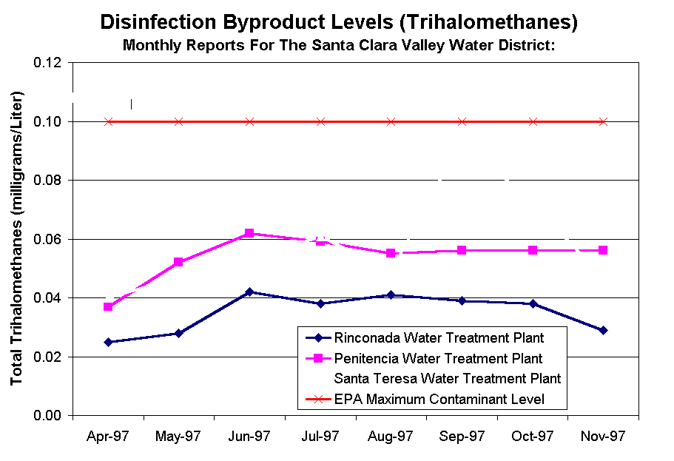

Drinking Water Concerns

Since water is so capable of dissolving contaminants, there is no way of getting "pure" water (Drinking Water Contaminants). There are many solvents that can be in your water, such as lead, that may affect you and your family, especially children and pregnant women who are at high risk of contamination. There are inorganic compounds and of course organic compounds.
Inorganic Compounds: relating or belonging to the class of compounds not having a carbon basis, such as hydrochloric and sulfuric acids.
Organic Compounds: any compound of carbon and another element.
The materials suspended in water serve a health risk because these can cause diseases. Pathogens are disease-causing organisms, and some of these organisms can come from other sources besides drinking water. There are bacteria, such as cholera, thyphoid fever, and E. coli. In the article Tap Water at Risk, the Houston Chronicle notes that there were 3,641 water purification sites that violated the health standards for fecal contamination.
There are also protozoans that can cause many problems if ingested. Cryptosporidium parvum and Giardia lamblia are two very common parasites, which can give humans cryptosporidiosis and giardiasis respectively. The picture below is a picture of the infective stage of the parasite C. parvum called the oocysts (Wilkes University). The infective stage for G. lamblia is the cyst stage found in fecal matter shown in the second picture (Bugs on the Web).
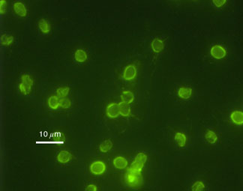

Outbreaks Throughout the World
These two diseases are the most prevalent throughout the world and are considered cosmopolitan, which means they have had world wide distribution. Cryptosporidium became well publicized during the massive outbreak in Milwaukee in 1993 (CIC Guideline for Crypto). It was found to be spread by drinking water that was contaminanted with the oocysts. Unfortunately the water was not purified according to Federal standards. After a few days, 400,000 people came down with diarrhea, weight loss, and abdominal cramping.. People who were immunocompromised (such as HiV/AIDS patients) were at increased health risks. In the end, residents had to boil water for quite a few weeks until the problem was fixed, and in the end over 100 people died from this outbreak. A Giardia outbreak occured in Sydney, Australia (in a privatized utility system), but was not as severe as Milwaukee's and was taken care of through increased water safety and treatment.
Water Safety Around the World
U.S./Canada
The United States and other industrialized countries have good monitoring of the municipal water supplies and are usually able to catch contaminants. If you have your own well, you may want to read up on how to monitor your drinking water for safety (Cancer Research Center website). If you are not sure if your water is safe, find out what you can do or drink water from another source. Unfortunately, U.S. citizens' money is being put into buying bottled water, rather than guaranteeing safe water for Americans and others in the world.
Australia/New Zealand
Australia is a country much like the United States, and has many municipal water safety facilities that monitors what is in the water every day. If there is an outbreak agencies are able to clean it with chemicals (Drinking Water Guidelines for Australia).
Third World Countries
Water problems in the "Third World" (Periphery and Semi-Periphery) countries are much more devastating and dangerous to people's health. Most of the time local rivers, streams and lakes are the source of drinking water. This is very dangerous for people because they have a much higher risk of being contaminated by bacteria and parasites. Just stepping into a lake with fecal contamination is dangerous. Imagine having to drink that water because the economy is too poor to provide safe drinking water, or the community is too far from a source of safe water. The question for many countries who cannot afford water safety facilities is, "Municipal services: basic human right or economic good?"
China's rapid economic growth, industrialization, and urbanization -- accompanied by inadequate infrastructure investment and management capacity -- have all contributed to widespread problems of water scarcity and water pollution throughout the country (China). Many Chinese try to boil their water, but unfortunately this does not work for many toxins. Much fecal contamination has occurred in China and other Asian countries, which makes risks of parasites and bacteria very high.
Water Safety
Water safety is a concern for countries all over the world. It is important to understand what is being put into the water you drink. It is crucial to know who to contact and what you should know about water from the city, your own well, and other countries. There is a continual struggle in "Third World" countries today. They are still hoping to have access to safe water, but privatization is making this more expensive.
Sources
For more information, contact your local municipal water safety council in your town/city for accuarate information or questions.
Australia Water Safety Guidelines: http://www.nhmrc.health.gov.au/publicat/pdf/eh19.pdf
Cancer Reasearch Center: http://www.fhcrc.org/clinical/ltfu/patient/water_safety.html
Cholorine and Drinking Water: Here's to Your Health: http://c3.org/chlorines_everyday_uses/before.html
Chlorine Knowledge: http://c3.org/chlorines_everyday_uses/before.html
Cryptosporidium Guidlines: http://aegis.com/pubs/atn/1995/atn22706.html
Drinking Water Contaminants: http://www.cyber-nook.com/water/contam.html
Municipal Services in South Africa Article/China: http://web.idrc.ca/en/ev-5490-201-1-DO_TOPIC.html
Parasite Pictures: stat.med.utah.edu/parasitology/glambim.html
Santa Clara Water District: http://www.scvwd.dst.ca.us/
Tap Water: http://www.chron.com/content/houston/interactive/special/water/06/water/series.html
Wilkes University: http://wilkes.edu/~eqc/crypto.htm
Environmental Science; AGlobal Concern Text Book. Cunningham W.P., Cunningham M., Saigo, B. McGraw-Hill Publications. Copyright 2003. http://www.mhhe.com/environmentalscience/

18. Water Wars and
International Conflict

Abigail Ofori-Amoah oforiaa@uwec.edu
For centuries war and conflict has been tied to the protection of water resources. With the risk of water shortages around the world becoming more and more of an issue, water has become the fuel of certain conflicts in many regions around the world. “Water Wars” are becoming inevitable in the world's future as the misuse of water resources continues among countries that share the same water source. International law has proven itself inadequate in defending the equal use of shared water supplies in some parts of the world (Darwish, Middle East Water Wars). The rapid population increase has greatly affected the amount of water readily available to many people.
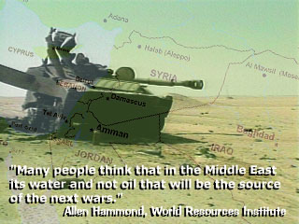
Water as a resource is very comparable to oil; it is essential to all daily human activities. Water is becoming a very valuable commodity, yet freshwater resources are unevenly distributed among developing countries. This scarcity in water has triggered desperation in countries that already have little access to water, let alone reliable water supplies. This desperation usually cannot be resolved by negotiations. If governments or rebels want water badly enough, they resort to force to obtain it. Water has very rarely been the main ingredient in international conflicts, but it is often factored into the problem due to its economic importance. (Peter Gledick, Water Conflict Chronology)
"Conflicts over water arise form the fact that under conditions of increasing scarcity, competition levels also increase.” Anthony Turton

The Potential Causes
There has been much speculation over what causes conflicts over water. The conflicts arise over who has the power to control water and therefore control the economy and population. By breaking it down into categories, we can begin to understand the causes. Conflicts can be caused by water use which includes military, industrial, agricultural, domestic and political uses. Through the military and political uses, conflicts can be exacerbated by the use of water systems as a weapon and as a political goal. In relation to industrial and agricultural uses conflicts may arise from the overuse and degradation of water resources, and the insufficient amount that is left over for communities.
Conflicts can further be a result of pollution affecting the quality of the water supply. The military is already most likely the number one producer of wastes in the world, and the leftover chemical and weapons used in times of war can have an effect on water supplies. Wastes from industries and agriculture can contaminate groundwater resources if not disposed of properly, and cause frustration for those who must travel to obtain sufficient daily water supplies. This lack of water quality can cause a conflict to arise regarding the distribution of water. Not having water evenly distributed among people and countries creates an imbalance among those who share supplies, particularly in developing countries (Cause of Conflicts, Haftendorn).
The increase of urbanization has increased the demand for water. However the supply cannot take care of the demand. With the problem of uneven water distribution future conflicts can occur. As societies become more developed they tend to use more resources such as water (Klare).

Regions of Conflicts
Many regions around the world deal with shortages of water. However, some areas deal more with conflicts over inadequate water supplies and disputes over shared water supplies. In regions where countries compete for access to water, the relations between the countries are likely to be unstable. In regions where water supply is scarce, combat sometimes seems to be the only way to resolve the problem. It is estimated that there are 1,250 square kilometers of freshwater remaining in the world’s semi-arid and arid regions and this supply is not evenly distributed among two or more countries sharing the same water source. Severe water scarcity is strongest in the Middle East and Northern Africa. The need for water in these regions is essential for food production used in irrigation farming (Klare).
Water systems usually arise in one country and pass through others before reaching the sea or oceans. The rivers and lakes that come off these larger water systems are typically shared by more than one country. The states where these systems originated tend to try and gain the most control over the water. This is the case along river systems like the Nile, the Tigris-Euphrates, and the Jordan River (Klare).

The Middle East
Middle East conflicts are usually tied in the media to religion or oil, but water has become a major factor in recent disputes. In prominent watersheds such as the Jordan River Basin and the Tigris-Euphrates Basin, water supplies can be critical especially when they are being shared among multiple countries. These rivers play a very important role in the agriculture and economic development of these states.
Jordan River Basin
The area of the Jordan River Basin, including parts of Lebanon, Syria, Israel, Jordan, and the West Bank, is primarily an arid region. The river originates in Lebanon and has a total average flow of 1,200 million cubic meters per year. This river system consists of the Jordan and Yarmuk River, which flows from Syria. With the arid climate and low precipitation in this region, water has become the most valuable resource (Klare). Most countries in the Jordan River Basin are among some of the poorest countries in the region. Groundwater aquifers are the principle source for water supplies to the states that rely on the Jordan River. Water use varies throughout the region. Israel uses the greatest amount of water available in the basin, and next in line is Jordan. The Israeli-occupied West Bank uses the smallest amount. The daily amount of water per person in the Jordan River Basin is the lowest in the world (Water Scarcity in Jordan River Basin).
The patterns of water use, overuse, and political territorial issues are resulting in disagreement over water distribution. The increase in population (both through natural increase and Israeli settlements) has led to significant challenges in managing limited water supplies. Without the existence of a legitimate water sharing agreement, the countries of Syria and Israel have taken over the water supplies. The construction of reservoirs on the Yarmuk River has caused the reduction of discharge into the Jordan River (The Jordan River Basin).
The Mountain Aquifer underneath the West Bank is a point of contention between Israelis and Palestinians. Issues include the domination of groundwater supplies by the Israeli state and settlers, and the walling off of Palestinian access to water supplies. Compared to Israeli settlers Palestinians are charged three times the cost for water that comes from under the West Bank (Villiers).
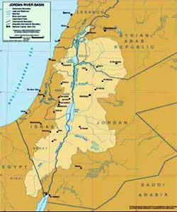 | 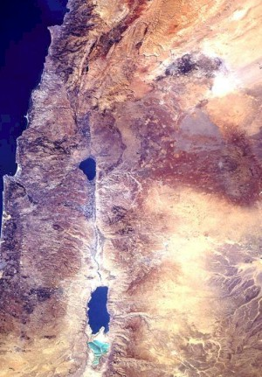
Map and Satellite picture of the Jordan River Basin
The Tigris-Euphrates Basin
The scarcity of water supplies in the river basin of ancient Mesopotamia has long fed disagreement among neighboring nations. The Tigris and Euphrates rivers originate in Turkey, and their watershed covers a much larger area than the Jordan River basin. The river system is shared by several countries and ethnic groups who regularly disagree on water issues. Like the Jordan River Valley, rising population in these areas is heavily affecting the availability of water. The Tigris and Euphrates are especially important to Syria and Iraq. Syria obtains approximately 85 percent of the renewable water supply while Iraq obtains 100 percent from the combination of both rivers (Klare).
The Turks (and the Kurds who live in southeastern Turkey) are less dependent on the rivers, yet they still have plans for irrigation schemes to increase their utilization of both rivers. Along the Tigris and Euphrates rivers, conflict arises from north to south. The downstream states of Iraq and Syria depend heavily on these two rivers for their water supply. Dams along the rivers installed by Turkey have prevented some of the water from flowing downstream to these warmer, drier countries.(Haftendorn). All three countries (but mainly Turkey) have constructed dams on the rivers for purposes of agriculture, hydroelectric power and industrialization.
Turkey and Syria have increased hostilities towards one another over the use of the Euphrates River. Turkey’s plans to utilize its portion of the Euphrates have affected the share going to Syria for irrigation purposes. Hostilities between Syria and Iraq escalated due to the filling of Lake Assad by Syria, resulting to the reduction of downstream flow in the 1970’s. Iraqi’s began accusing Syria of holding back water supplies. Among all three countries, the water supply conflict is equated with their national security (Tigris Euphrates Dispute).
Tigris-Euphrates River
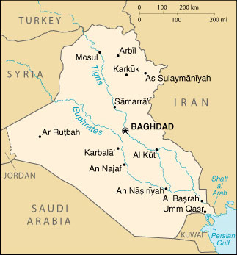

Warfare in Iraq
The 1991 Gulf War brought on water crisis in Iraq due to the bombing of water treatment facilities in Iraq by the U.S., triggering water shortages in the country. Out of the seven major water pumping stations, four were destroyed. The targeting of sewage and water treatment plants contributed to the mass contamination of the Trigris River, and triggered many waterborne diseases. The bombing during the 2003 Iraq invasion agian targeted civilian infrastructure, and left many southern Iraqis with little or no access to water in the first weeks of the occupation. (See Iraq water crisis.)
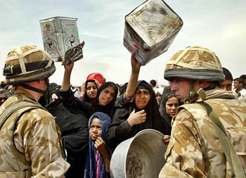
Iraqi women waiting for incoming water supplies while confronted by British troops

Africa
In many parts of Africa, water shortages are a part of everyday life. Many countries share one water resource for the use both of their populations. A large percentage of these countries are very dependant on the weather to provide proper irrigation to the agricultural industry, since water resources are so scarce.The major areas being shared among countries are the Nile River, Volta River, Zambezi River, and the Niger Basin. Conflicts rage from the privatization of the water resources to the many people displaced by dams along the rivers, and the unequal distribution of water supplies amongst neighboring countries.With the growing demand for water resources, conflicts seems almost inevitable, especially with many African governments' history of poor management of resources and inadequate conflict resolution mechanisms.
The Nile River Basin
The Nile is the longest river in the world, stretching for 4,130 miles. The Nile River for centuries has been the source of sustaining human life in Egypt and Sudan. The Nile’s tributaries, lakes, and rivers collect and disperse water in nine African countries before it reaches the Mediterranean Sea. The Egyptians have used military force to ensure their control over the headwaters of the Nile, because the country has no other water source. Sudan, Ethiopia, and Uganda have constructed various river projects to increase their annual water withdrawals, affecting Egyptian control over the Nile (Klare). However, in some cases national governments have agreed to share water that flows between their countries. For example, the leaders of Uganda, Sudan and Egypt signed a pact to share the waters of the Nile River. Such solutions can potentially prevent water shortage and head off conflict.
Nile River
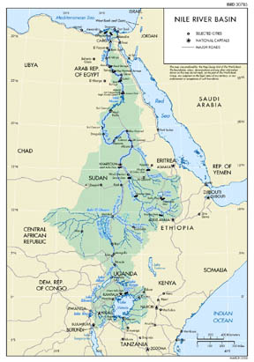

Volta River Basin
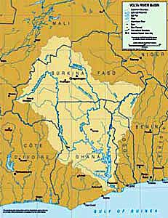

Niger River Basin
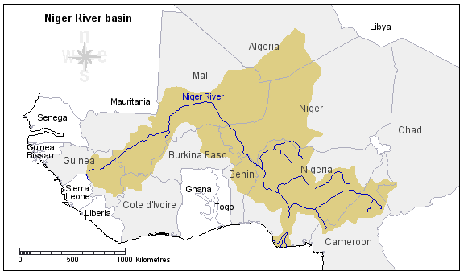

Zambezi Water Basin
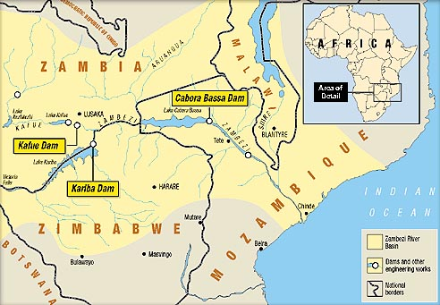

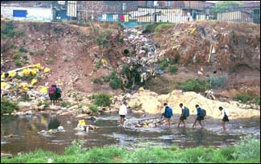
School children crossing contaminated river source

Asia
South Asian countries deal with conflict over the sharing of river water supplies both in downstream and upstream regions. The distribution of water resources throughout Southeast and Central Asia is increasingly becoming a political issue, with the tensions amounting over the control of water supplies (Biliouri). The idea of shared water supply has not been easily understood by the nations of this region. The growing populations come with the increase in demand and could be a catalyst for conflict to arise out of the ethnic and political disputes (Water and Conflict).
In India and China water shortages pose both a social and economic threat. Throughout India, Pakistan, Nepal, and Bangladesh, water shortages are increasingly triggering conflict. Although the freshwater resources are abundant, they are not well distributed to drier regions in dire need of water. With the immense amount of pollution being dumped in the freshwater supply, clean water is becoming scarce to the mass of people and tensions can easily escalate.
The Indus River Basin has been an area of conflict between India and Pakistan. Spanning 1,800 miles, the river and its tributaries together make up one of the largest irrigation canals in the world. The basin provides water to millions of people in northwestern India and Pakistan. Dams and canals built in order to provide hydropower and irrigation ha dried up stretches of the Indus River. Water projects have further caused the displacement of people and have contributed to the destruction of the ecosystem in the Indus plain.
The divisions of the river basin waters have created friction among the countries of South Asia, and among their states and provinces. Accusations of overdrawing made by each central region or province has resulted in the lack of water supplies to coastal regions of Pakistan (Controversy over Indus River Water). The Ganges River has long been disputed over by India and Bangladesh. The two regions share a common river system, formed by the joining of the Bhagirathi and the Alaknanda.
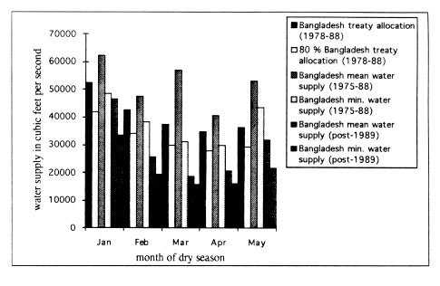
Water Supply in Bangladesh

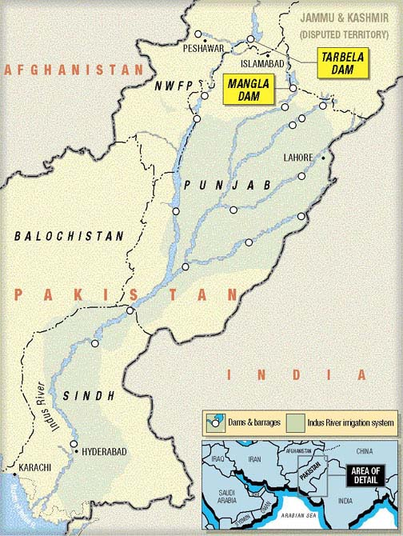
Map of the Indus River Basin

Ganges River System:
The Ganges River possesses strong economic and religious importance. The Ganges River as a water source has been strongly disputed between India and Bangladesh. With increasing demands of water in Calcutta for industrial and domestic use, and irrigation use in the Indian state of West Bengal, water conflicts between the two countries have increased. With large amounts of pollution in this river system, the available water is unsanitary and can increase illness, as well as trigger mass migration.
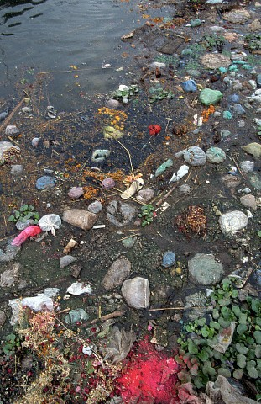
Ganges River pollution makes it an unsanitary water resource

Sources
For more information:
Conflict and Natural Resources
Green Nature
Global Policy Forum
International Freshwater Conflict
Potential for Water Wars
Sea-River New Letter
Science in Africa
The Emerging Water Wars
The Water Page
Water and Conflict
Water Conflict and Cooperation
Charrier, Bertard, Shlomi Dinar, Fiona Curtin. Water, Conflict Resolution and Environmental Sustainability in Middle East. [Internet] http://www.gci.ch/GreenCrossPrograms/waterres/water/waterconflictresolution.html 27 April 2004
Darwish, Adel. Analysis: Middle East water wars. [Internet] BBC News http://www.newvote.bbc.co.uk 27 April 2004
Gleick, Peter. World Conflict Chronology. [Internet] The World Water. 27 April 2004
Haftnedorn, Helga. Water and International Conflict. [Internet] http://www.ciaonet.org 27 April 2004
Klare, Michale T. Resource Wars: The New Landscape of Global Conflict.Owl Books New York 2001
Turton, Anthony. Water and Conflict in an African Context [Internet] http://www.accord.org 27 April 2004
Villiers, Marq De Water: The Fate of our most Precious Resource. Mariner Books Boston New York 2000
.
19. Irrigation Dams
Michael Jolitz jolitzmw@uwec.edu
Irrigation uses enormous amounts of water, and often wastes water. In the United States alone, 41% of water use is for irrigation. The dams that hold this water for irrigation pose many environmental problems that degrade the water supply. The purpose of this page is to show the benefits and environmental problems associated with irrigation dams, and whether they fulfill their purpose.
Erosion and Silt
The build-up of silt behind dams is reducing their water storage capacity according to the United Nations. Storage facilities are losing an average of 1% of their storage capacity annually. Scientists also think that global climate change will increase the severity of storms and worsen erosion. Many scientists believe that removal of sediment from behind dams should be a regular occurrence.
The UN Environment Program says that 60% of the water that is used for irrigation is wasted or used inefficiently, and that 50% or more of the water that is used in cities is lost through leaks and poor management.
Kariba Dam in Zambia
The building of the Kariba Dam in Zambia has created many environmental problems. The Kariba Dam is used for power generation and irrigation for industrial and institutional water supply. The towns around the area have grown considerably in recent years. This growth has caused the demand for food to rise greatly, putting pressure on the surrounding land. More and more land has to be cultivated to support the people in this area. Overgrazing and loss of soil fertility are adding to the depletion of soil.
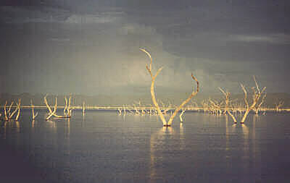
Kariba Dam
The photo shows a large area of cultivatible land that was flooded by the Kariba Dam. The land was flooded and thousands of people resettled. A operation called Operation Noah was launched to save many of the animals that were trapped during the flooding. The dam also had a effect on the Tsetse fly population. The Tsetse fly carries the parasite Trypanosomiasis, which causes sleeping sickness, a debilitating disease for cattle and humans. There was an attempt to try to eradicate the Tsetse by spaying the insecticide DDT. This toxic chemical has reduced the species of birds and fish in the area. It has also been found in the breast milk of nursing mothers.

Information on Kariba Dam was taken mostly from http://www.bized.ac.uk.
Narmada Dams in India
One of the world's foremost controversies around dams is underway in India, where dams are being built on the Narmada River. One of the main global environmental/ human rights groups that fights these dams is the International Rivers Network. India has a Narmada Valley Development Program which involves the construction of 3,000 dams and would flood thousands of acres of forest and agricultural land. India's goverment says that the project would provide water to 40 million people and irrigate over 1.8 million hectares. There would be continuous irrigation here that would degrade the fertile agricultural soils. This program will also displace approximately 1.5 million people. The people that oppose this project often place themselves in danger of arrest and detention. There have been many documentations of abuse and excessive force used against opponents of the dam, even though most protests are peaceful demonstrations.
One of the dams on the Narmada named Sardar Sarovar was opposed because it would displace almost half a million people. Another is the Maheshwar Dam which would submerge some of the richest agricultural lands in the area.
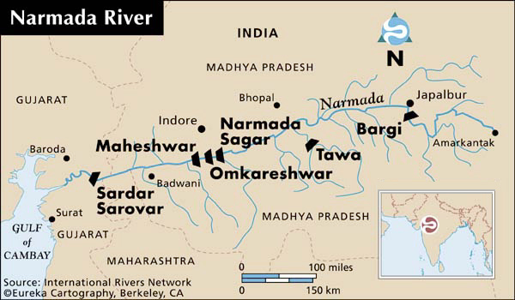

The map above shows a few locations on the Narmada River where some of the larger dams are planned. A good place to go to read more about this project is the International Rivers Network website.
Manitoba Hydro dams in Canada
Manitoba Hydro is an example of a utility that has exploited water for hydroelectricity rather than mainly for irrigation, but the resulting problems are similar to irrigation dams. The demand for electricity is growing at a great rate and utility companies make hydroelectric power seem friendly to the environment. The Unplug Manitoba Hydro website said, "Over the last 25 years, thousands of square miles of northern forests, rivers and lakes have been flooded or made inaccessible. And now, a toxic soup of drowned trees and other vegetation lies rotting—submerged along with native communities' hopes, dreams and traditional livelihood."
The Pimickamak (Cross Lake) Cree Nation lives near the control gate that releases water. The water fluctuations from this gate cause continual bank and island erosion. The debris disrupts travel by boat and snowmobile, and makes it difficult for trappers and fishermen to feed their families, and continue practicing traditional Cree culture. This crisis has caused the Cree to have some of the highest rates of suicide of any Aboriginal reserve in Canada. Its unemployment rate is also around 95%.
The changes at this site have destroyed wildlife habitat, mammal and bird populations and aquatic plant and animal species. There has been flooding here which causes permafrost to thaw, this in turn increases shoreline erosion and siltation into the reservoir at Cross Lake. High water levels submerge vegetation, which decomposes and produces methane. Methane is a greenhouse gas that is contributing to global warming. The amounts that are produced rival those produced by fossil fuels. The decomposition process also has caused mercury from rocks and soil, to transform into the highly toxic organic methylmercury.
Most of this information about Manitoba Hydro came from Unplug Manitoba Hydro.
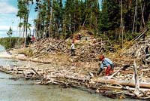
Shoreline at Cross Lake

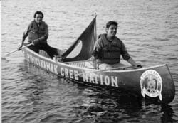
Pimickamak Cree

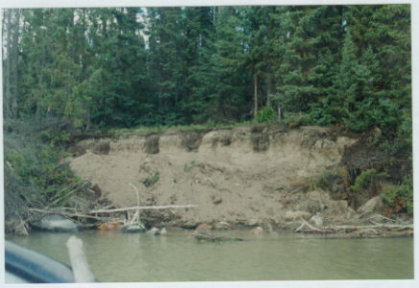
Just Energy
Erosion from the water of a reservoir in Manitoba has exposed five graves on Indian Lake in Manitoba.
Other Problems

In Australia, salinity in irrigation water is a major problem. The site National Action Plan for Salinity listed these problems related to salinity and drinking water:
• More than $130 million of agricultural production is lost annually from salinity.
• More than $6 million is spent every year on building maintenance related to salinity in South Australia.
• Salinity causes $9 million damage annually to roads and highways in southwestern New South Wales.
• The area of salt affected land in Western Australia is increasing at a rate of one football field per hour.
• If salinity is not effectively managed within 20 years, the salt content in Adelaide’s drinking water may exceed World Health Organization standards for desirable drinking water in two of every five days.
• Increased salinity could cause the extinction of approximately 450 species of native flora and 250 species of invertebrate water fauna in the Western Australian wheat belt. Salinity of drinking water occurs when irrigation water soaks through the soil area where the plant roots grow, adding to the existing water. The irrigation water causes the underground water table to rise, bringing salt to the surface. When the irrigated area dries and the underground water table recedes, salt is left on the surface soil. The salinity increases each time the water is irrigated.
The Three Gorges Dam in China has many problems that environmentalists assert will decrease water quality. The Three Gorges Dam is being built built for irrigation, flood control, and hydroelectric power. There are concerns that the reservoir will collect industrial pollution, farm runoff, and sewage that regularly runs downstream. Levels of E.coli bacteria have risen as the reservoir has began to fill. There are claims that the water here will be too polluted for drinking water. This is expected to also have a disastrous effect on many terrestrial plants and animals. There will be loss of biodiversity on land and in the water.
The Pa Sak Jolasid Dam Project is an irrigation project in Thailand. Its water detention level is 960 million cubic meters, taking up a total area of 45,647 acres, covering parts of Lop Buri and Saraburi Provinces. The main impact will be people being relocated and not being reimbursed for their land.
In Russia, irrigation for farmlands has lowered the Volga River's flow, and limited its ability to regenerate. Water extraction has also reduced the water level of the Caspian Sea.
Conclusion

Following the construction of many dams there are many problems that degrade our water supply and many people's lifestyles. It may not be in your backyard but it may affect you in some way that you are just not noticing. For example, a proposed transmission line in northwestern Wisconsin would transport electricity transported by Manitoba Hydro. These situations are just a few out of hundreds of examples of destruction and contamination of landscapes and lifestyles from dams. Make yourself aware by accessing more information about some of these problems.

"Throughout the history of literature, the guy who poisons the well
has been the worst of all villains..."
-- Author unknown --

Sources
For more information:
Current Issues Affecting World Water Supply
Removing Dams in California
Dams and Development
River Revival
River Alliance of Wisconsin
Cracking Dams
Panda.org
International Rivers Network
Environmental Impacts of Dams
World Commision on Dams
BBC News
National Action Plan For Salinity

20. Bulk Water Transfers
Adam Dicke dickeac@uwec.edu
The need for freshwater has led to overuse of limited resources in places like the Western United States. In 1941, the Los Angeles Department of Water and Power diverted water from Mono Basin streams to Los Angeles through the L.A. Aqueduct. Excessive diversions of these streams took place until 1989. The reason that the diversions were stopped was because stream ecosystems deteriorated due to lack of water. Air quality became so poor (due to the exposed riverbed) that the Clean Air Act became the only reason that the diversion of water was stopped.
A central user of freshwater is agriculture. In areas that do not have large amounts of freshwater available for use, irrigation is used to water the crops. The 230-mile Klamath River, which flows from Oregon to the Pacific Ocean in California, supplies irrigation water to about 200,000 acres of farmland through the federal Klamath Reclamation Project. A California state report in 2003 showed that the Bush Administration allowed too much water to be diverted to farms in that area. The result was that 33,000 fish died on the lower river in Fall 2002.
The problem of water shortages is not confined only to North America, it is a problem all around the world. In China, roughly 20% of the world's population lives. The problem is that only 7% of the massive country's land is arable. Lian Jixiang, head of his village in Shandong says, “When it rains, we throw plastic sheets on the ground to catch it as it falls – we won’t let a single drop go to waste.” While much of southern China is a fast-developing economic region, northern China is characterized by a harsh landscape with little water. The Chinese government has a plan to change this situation, and this plan makes the Three Gorges Dam look miniscule. The plan calls for pumping water from the south to the north by redirecting streams from the Yangtze (Chang) to the shrinking Yellow (Huang) River. The three canals, two of which are 1,000 miles long, cross some of the Earth's highest plains. Hundreds of thousands of people would be displaced, but the new source of water would serve at least 39 major cities and 50 million people. source: Ecology Asia
The Great Lakes of North America contain 20% of the world’s freshwater supply and 95% of North America’s supply of surface water. Canada's major watersheds contain approximately 9% of the world's freshwater supply and 20% of the world's total freshwater resources. Less well known is the fact that only 1% of the Great Lakes water is renewed annually by precipitation, surface runoff, and groundwater in-flow. That is only about the top thirty inches, the rest was placed there by glaciers. Nowhere else in the world is there another group of freshwater lakes that compare in size and importance to that of the Great Lakes. In addition, the Great Lakes contain unique freshwater aquatic and coastal environments that are found nowhere else in the world. The Great Lakes are a resource for both Canada and the United States to regulate. Various regions within the United States, as well as other world regions have continually coveted this essential supply of freshwater. While there may only be proposals on the table, only strong action against transfer and diversion of Great Lake' water will stop the attempts at taking this water.
The stakes in this issue are high. The availability of water is one of the most significant factors in planning for the future. Water is an element that is essential for the survival of all living things - plants, animals and humans. Will governments act to protect this supply of life-giving water and ensure its long-term sustainability? Those involved in the water-use management debate agree that effective and practical laws for regulation of water withdrawal are needed to effectively manage this precious resource. We, as citizens, must decide what will be done with this most precious resource.
Definitions
Boundary waters: Waterways that have a border running through them, such as the shared waters along the Canada-U.S. border. The principal boundary waters are the Great Lakes. The Upper Saint John River between New Brunswick and Maine is an example of a boundary river.
Bulk Water Transfer: The removal and transfer of water out of its basin of origin by man-made diversions, tanker ships or trucks, and pipelines. Such removals have the probability, directly or cumulatively, to harm the health of a drainage basin. Small-scale removal, such as for bottled water usage, is not considered a bulk transfer, but can provide a precedent for the future. Water transfers are not necessarily exported out of the province or country, but are "exported" from the basin of origin. Transfers do not include small-scale water removal, such as water in small portable containers.
Watershed: Originally, "watershed" denoted the imaginary line, or drainage divide, separating the waters flowing into different rivers or river basins, and is still often used in this context. Today, it is known as a land area that drains into a common watercourse or waterbody. Examples of major watersheds in Canada include the Atlantic (including the Great Lakes and St. Lawrence River), Hudson Bay, Pacific and Arctic. For example, the Great Lakes Drainage Basin is not restricted to the lakes themselves, but includes the many rivers and their tributaries that ultimately flow into the lakes.
Water Diversion- The hyperdictionary gives three meanings to the word diversion: The direction of water in a stream away from its natural course, the draft of water from one channel to another, or the interception of runoff by something which discharges it through unnatural channels.
Water Export: The taking of water and shipping it to other countries for profit – whether in bottles, by tanker or pipeline, or by diverting rivers and building canals.
source: http://www.ec.gc.ca/press/bulk_water_b_e.htm
Common Methods of Water Transfer
Tanker Trucks- Trucks used for water transport are equipped with a storage tank much like those used to haul milk, gasoline or any other liquid. The trucks vary from area to area, since the trucks are often produced locally. In more remote areas, some trucks are equipped with portable pumps to extract the water from the source and these pumps can also be used to distribute the water to the end user. The water is transported from the point of origin to where it will be used. Oftentimes there are no treatment facilities available to the end users, so the water is taken from the nearest natural source. In many parts of the world, water is trucked to areas that have no conventional method of water supply, or are facing a shortage emergency.
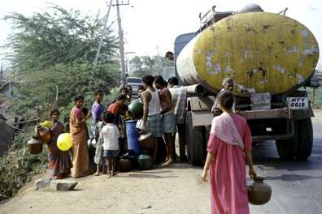
source: http://www.nri.org/WSS-IWRM/Photos/India/tanker.jpg
Pipelines- Also vary from area to area. Water can be transported through pipelines through the use of gravity or it can be pumped through the pipeline. The drawback to the pumping of water is the great cost involved. The costs include construction, operation and maintenance. When pipelines stretch hundreds or thousands of miles over varying terrain, it is very costly to make sure the system is working properly. Smaller pipelines are more readily available when employed in-point-of-use applications. These pipelines can provide enough water for an individual, or enough for bulk needs.
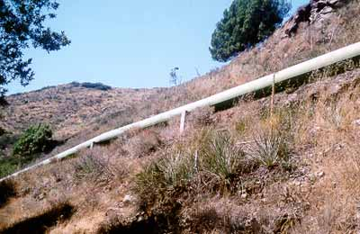
source: http://polyland.lib.calpoly.edu/topics/soils/maptour/images/pipeline.jpg
Aqueducts- A system of canals that brings water from a river, a reservoir or a body of water to a holding facility. Aqueducts are ideal for areas that have a high demand for water, like those areas with high population density or areas with high concentration of agriculture. Terrain that is fairly flat is best suited to aqueducts so gravity can be used to deliver the water to the end user. There are many factors that must be taken into consideration before a system like this can even be regarded as a possibility, such as water demands, topography, storage facilities and methods of distribution.
source: Organization of American States
Colorado River Aqueduct
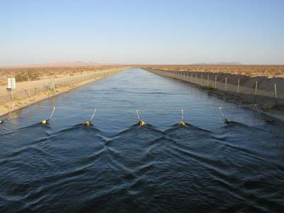
source: discoverawatershed.org
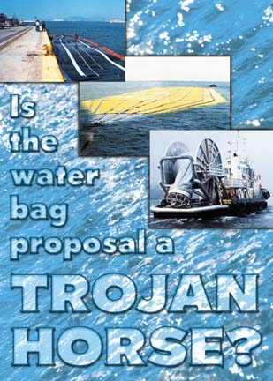
source: North Coast Journal
Waterbags- Are not currently a common method of water transport, but a method that is drawing attention as the costs of other methods skyrocket. More than one company has begun to develop a system that could transport freshwater in gigantic bags to anywhere in the world. These companies claim that their bags could be utilized in a natural disaster situation to bring in life-saving freshwater. The downside to the bags is that it will become easier to transport water out of areas that will be already overburdened with water withdrawals.
Currently the bags are shaped like those used on U.S. farms to store hay or other crops. They are about 200 yards long and contain about 35,000 tons of water. The bags are made of a polyester fabric which is coated with plastic and are 2 mm (.08 inches) thick. Jan-Otto Reimers of Nordic Water Supply compares the bags to that of seatbelts in an automobile. There are risks involved with this method of transportation. Bags have been lost at sea and the bags have been known to rip when being drained of water. The bags are now equipped with homing beacons, so collisions can be avoided and lost bags can be found. At this point, waterbags are not very profitable. In the first half of 2001, Nordic Water Supply lost over $1.5 million transporting water from Turkey to Cyprus. It is looking to expand to other parts of the world in order to make the business more profitable.
Source: http://www.planetark.com/dailynewsstory.cfm/newsid/13449/story.htm
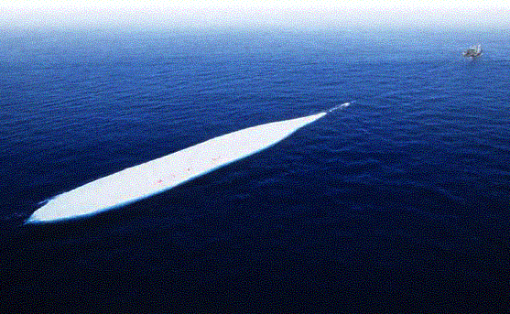
The Great Lakes Basin
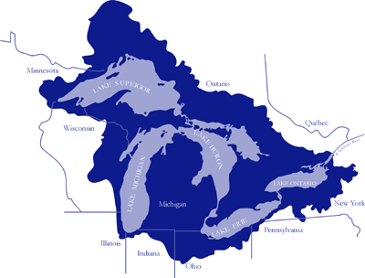
source: http://www.glin.net/teach/geog/intro/basinmap.gif
River basins are often classified by topography. Smaller basins normally lie within territorial boundaries. On the other hand, most larger basins cross one or more boundaries. The Mackenzie River basin contains seven provincial and territorial boundaries, as well as federal lands, and involves three provinces, two territories, and the federal government in its management. Some smaller basins also extend beyond a national border, such as the Saint John River basin. The Great Lakes are an example of a very large boundary basin.
Impacts of the Great Lakes
Total Volume of Great Lakes...........6 Quadrillion gallons of water. If all the water of the Great Lakes were to be spread out over the U.S., the country would be under 9.5 feet under water.
Drinking Water...........................................Provides water for 40 million people.
Other Use..................................56 Billion gallons per day for municipal, agricultural and industrial use
Fish.............250 different species of fish, many native only to these 5 lakes
Sport Fishing....................a $4 Billion dollar industry is supported by the Great Lakes.
Shoreline....................over 10,000 miles of shoreline, 1,000 of which are the international border.
The wide-ranging effects of the Great Lakes are almost unfathomable. They provide power and cooling water for countless numbers of people and businesses throughout Canada and the United States. The three main cargoes of the Great Lakes are iron ore, coal, and grain. All told, the Great Lakes are the passageway for over 200 million tons of goods to the open seas. In the 1990's over half of the total trade between the U.S. and Canada was done with the Great Lakes states. That is over $55 billion dollars pumped into the economy of the Midwest per year.

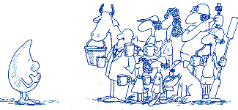
Since the Great Lakes Basin encompasses 20% of the world's freshwater supply there are many different viewpoints of what should be done with this water. One proposal is to ship Great Lakes water to several areas in the U.S., particularly to the arid Southwest. If global climate change takes place as scientists predict, demands for freshwater will become a matter of greater importance. The Great Lakes watershed, which is home to 9 million Canadians and 35 million Americans, is experiencing its lowest level in 15 years, a statistic that cannot be ignored. The EPA predicts that by the end of the century, the level of the Great Lakes will drop anywhere from 1.5 to 8 feet, without water transfers and diversions figured in to the equation.
Large-scale diversion of Great Lakes and Canada's Arctic waters have been discussed for several decades. The U.S. Environmental Protection Agency (EPA) has overseen various proposals for transferring Great Lakes water since the 1950's. The proposals have often been made by big business because of the opportunity to profit from water diversion. The proposed states where water would be shipped to have included Nebraska, Kansas, Oklahoma and Texas (due to the intense use of the Ogallala Aquifer). The EPA has also dealt with proposals to use Great Lakes water for rapidly growing areas like Phoenix and Las Vegas. According to the U.S. Census Bureau, the top five fastest-growing cities in the U.S. from 2000 to 2002 were all in Arizona and Nevada. With this great influx of people to an area with no substantial supply of freshwater, the security of freshwater supplies of Canada and the U.S. are in question. (See Great Lakes water conflicts)
The management of water is a shared responsibility between the federal, provincial, state and tribal governments, and each have an important role to play in protecting the Great Lake's freshwater resources. All levels of government must have a role to play in instituting a permanent ban of bulk water removal and transfers, including removal for export purposes. This will require immense cooperation between the United States and Canada. These resources can not be left unregulated or they will end up being sold to the highest bidder.
source: http://www.glerl.noaa.gov/pr/ourlakes/facts.html
U.S. Water Diversion Policies
The Water Resource Development Act regulates the current system for withdrawals of water from the Great Lakes. The withdrawal of water outside of the Great Lakes Basin is prohibited unless all eight Great Lakes governors consent. On the other hand, all in-Basin water withdrawals are handled in various ways.
Indiana- State law does not allow water to be taken from within the Great Lakes Basin for use outside of the basin. However, Indiana does not require a permit for any water withdrawals, whether it is groundwater or surface water. Since permits are not required for withdrawal, the state has had difficulties in judging whether withdrawals might be diverted out of basin.
Illinois- Since Illinois has large requirements for water, due to population density and other factors, it is legally restricted in the amount of water it can take from Lake Michigan. Conservation systems are taken into consideration when issuing permits. Illinois has thus developed a permit process to distribute its portion of Lake Michigan water. The first priority is to maintain minimum flows in the sanitation system, the ship canal and certain residential areas.
Michigan- The state does not regulate water withdrawals. Withdrawal reports are required for large water users, but that is the extent of the regulations.
Minnesota- Minnesota requires a water use permit from any user withdrawing more than 1 million gallons per year. If interbasin water diversion takes place in the amount of 2 million gallons per day or more regulation is tighter. The user must then receive permission from the state legislature, which requires an environmental assessment. If more than 5 million gallons are needed on a daily basis, approval of the other Great Lakes states are needed.
New York- All withdrawals from the Great Lakes Basin that surpass 100,000 gallons per day over 30 days require registration with the state. As in Minnesota, withdrawals of more than 5 million gallons per day require approval of the Great Lakes states. Any interbasin diversions from the Great Lakes call for approval by the governor and the state legislature.
Ohio- Anyone who has an operation with the ability to withdraw more than 100,000 gallons per day has to register with the Ohio Department of Natural Resources. Also, if the state designates an area as a groundwater stress area, additional permits are required to withdraw from these areas.
Pennsylvania- Has no system in place for the requirement of permits or notification of water withdrawals.
Wisconsin- Any withdrawals of over 100,000 gallons per day over 30 days must be reported. Permits are required only if total water usage in an area is greater than 2 million gallons per day over 30 days. Usage of over 5 million gallons per day requires agreement with the other Great Lakes states. In May 2004, Governor Doyle signed a bill that regulates high-capacity well withdrawals. Under the legislation, a high capacity well that may have a significant adverse effect on water supply in a "groundwater protection area" will undergo a higher standard of environmental review before approval is granted.
Source: http://www.nemw.org/glwater_divert.htm
The time to decide the future of the Great Lakes is at hand. As water shortages become more prevelant, both here in North America and around the world, this vast resource of freshwater will be highly coveted. We must raise the awareness of the situation and push for tight regulation of the Great Lakes water withdrawals. If we as citizens do nothing about this problem, the water that we take for granted will be swept out from under our feet.
Sources
For more information:
Ecology Asia- http://www.ecologyasia.com
Great Lakes Environmental Research Laboratory- http://www.glerl.noaa.gov/
Great Lakes Water Diversion- http://www.nemw.org/glwater_divert.htm
Impacts of Climate Change in the United States- http://www.climatehotmap.org/impacts/greatlakes.html
North Coast Journal- http://www.northcoastjournal.com/020603/cover0206.html
Organization of American States- http://www.oas.org/usde/publications/Unit/oea59e/ch17.htm
Planet Ark- http://www.planetark.com/dailynewsstory.cfm/newsid/13449/story.htm
Sierra Club Conservation Policies- http://www.sierraclub.org/policy/conservation/commodification.asp
The U.S. Census Bureau-http://www.census.gov/Press-Release/www/2003/cb03-106.html
The United States Environmental Protection Agency Website- http://www.epa.gov/grtlakes/
Water-How We Share It- http://www.ec.gc.ca/water/en/info/pubs/primer/e_prim07.htm

21. Water Pipelines
Britta Suppes suppesbj@uwec.edu
With diminishing water supplies and rapid human population growth, communities and countries are being prompted to investigate alternative water resources. Water pipelines have been a proposed, but controversial option. These massive pipelines pump water from a large source and transfer it across a great distance to areas in need. This webpage will investigate the positives and negatives of water pipelines, the conflicts they introduce, potential pipeline projects, and existing pipelines worldwide.

Purpose of Water Pipelines
The purpose of water pipelines is to transport surface water or groundwater from one area to another without causing erosion and reducing the chance of evaporation. Water pipelines are large in diameter and can supply water to communities and industries over both short and long distances. Pipelines can be installed underground or above ground. They can be used to bring in freshwater, or to transport and dispose of wastewater.
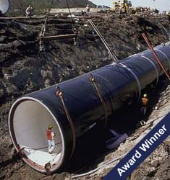
Water pipeline installation

Water Shortages: Pipelines as a solution?
With the world population reaching 6 billion and counting, the need for water is growing. Only 2.4% of all water on Earth is freshwater, and less than 1% of all freshwater is available for human use. There is no question that water is absolutely necessary for human survival. However, over one billion people on Earth already do not have access to a clean water supply. With a growing population, this number will drastically increase, especially as we continue to abuse, pollute, and deplete our current supplies.
Water pipelines provide a solution to areas lacking a continual and sustainable water source. These massive pipelines can transfer water quickly and effectively, avoiding evaporation which can occur in an open water transfer or diversion. With the incredible power of these pipelines, water can be extracted from deep within the earth through well pumping. Also, water can be directly taken from a surface water source. Water is transported through the pipelines with pumps and the natural force of gravity.
In the not too distant future, arid lands that are rapidly being developed will not be able to sustain their people or their land use practices. With 65% of all water use going towards irrigation, even more water will be needed for irrigation as growing regional populations will require increased agricultural production. Areas such as the southwestern U.S. are facing huge water shortages as urban sprawl continues to encroach on the desert. Water pipelines could transfer water to these areas to increase sustainability.

Water Pipeline Drawbacks
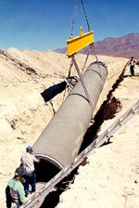
Despite the need for water to be diverted through pipelines to different areas, there are several drawbacks that accompany water pipelines. First, the actual construction of a major water pipeline is extremely expensive. With manufacturing, labor, and installation, pipeline projects can cost billions of dollars. In addition, maintenance must be done every day in order to keep the pipeline working effectively. Pipelines need to be monitored continually and water quality must be constantly checked. Because of the great distances that major water pipelines can cover, maintenance fees are extreme. Las Vegas Valley Pipeline Installation
The construction of water pipelines is also very taxing on the land. Thousands of miles of massive pipes can disrupt ecosystems, ruin scenery, and act as an obstruction. Underground pipelines require huge trenches to be dug, also disrupting the land.
The most pressingconflict related to massive water pipelines concerns the source from which the water is being taken. Whether it be from an aquifer, a reservoir, or a watershed basin, the diverted water is being taken away from an ecosystem in which it is needed. The pumping of water out of these sources can cause severe damage, such as water level drawdowns, which can affect coastlines, aquatic life, plant life, and economic activity. The water replenishment rate is not fast enough to rejuvenate water sources that are being reduced through large-scale transfer.
Legal conflict also arises in bulk water transfer proposals. The issues of water privatization is brought to a head: whose water is it anyways? What about waters on international borders? How can you own, buy, or sell a resource that is a human right and necessary for all life forms to survive?

Potential Pipeline Projects
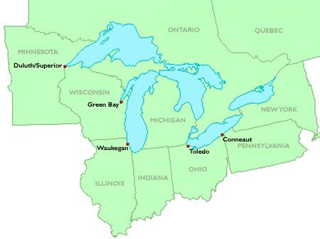
The Great Lakes Basin
The Great Lakes Basin is vast source of water, containing 20% of the world's surface freshwater, and 95% of U.S. surface freshwater. Pipelines have been discussed and proposed to share the water from this massive watershed to both nearby cities and suburbs, and also extending thousands of miles west and southwest. In the 1980's, there were proposals to pipe Great Lakes water to the southwest, but were dismissed due to the costliness, difficult logistics, and strong objections from Great Lake states. As water continues to be overused and depleted in the western and southwestern states through agricultural, industrial, and domestic uses, potential pipeline proposals are not out of the question. The lakes contain enough water to supply millions of people with water.

In northeastern Wisconsin, Exxon's proposed Crandon Mine, one of North America's largest zinc and copper deposits, has spurred much controversy within the state, due to potential toxic waste production, disposal, and contamination. The region's groundwater, the Wolf River, and the Mole Lake Chippewa wild rice beds could all be polluted with toxic mining wastes. In 1995-98, a 40-mile wastewater pipeline was proposed to transport treated waste water from the Crandon Mine west to the Wisconsin River near Rhinelander. This plan was proposed by Exxon to cut costs because the Wisconsin River does not have as many regulations as the Wolf River. According to the governors of the Great Lakes states, this diversion of wastewater would have been violating federal law (Water Resource Development Act of 1986) by transferring water from the Great Lakes Basin into the Mississippi Watershed. This "interbasin transfer" would occur due to the large amount of water needed from the groundwater of the Wolf River Watershed to transport wastewater 40 miles to the Wisconsin River. This water transfer would continue for approximately 30 years, tampering with the natural division of water within these major watersheds. In 2003, the Crandon Mine was defeated by local residents.

Current Water Pipeline Projects
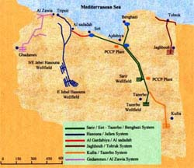Libya Pipeline Map
In Libya, a country dominated by the Sahara Desert, water is scarce. A large aquifer was found deep beneath the Sahara Desert, holding a volume of water almost equal to that of the Black Sea. With the growing population of Libya's coastal cities, the demand for fresh water is increasing. In 1983, the Great Man Made River Project was proposed to pump and divert water from the massive aquifer laying underneath the Libyan Sahara. The proposed project was to be the biggest underground pipeline network on earth, costing $27 billion, with some considering it the "8th wonder of the world." Over 1,300 wells have been drilled down into the large aquifer, some extending 500 meters (1641 feet) deep. Water is supplied to the coast over a network of 3,500 km (2174 miles) of pipeline. Over 5 million tons of cement was used to create the 75-ton pipeline sections. Besides maintenance and a few catastrophic pipeline bursts, the GMMRP has adequately brought water to the Libyan people. Construction continues to add on new legs of the pipeline network. The biggest problem is that the aquifer does not have a recharge source, and will eventually be completely exhausted. Libya Pipeline
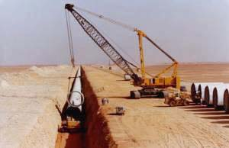

In southwestern South Dakota, southwestern Minnesota, and northwestern Iowa, construction on a 400-mile water pipeline is about to be underway. The Lewis and Clark Rural Water System consists of five reservoirs and seven pump stations, supplying and delivering over 27.2 million gallons of water per day to communities within the tri-state area. The water will be extracted from a series of wells along the Missouri River and will supply over 200,000 people with high quality drinking water. The cost of this project is estimated at about $360 million and will take 10 to 12 years to complete. In a region that has struggled with water quality and availability problems due to shallow wells, drought, and aquifer contamination, this project is an exciting prospect. Pipeline construction will, however, cut across wetlands, farmlands, and private property within the three states, posing several environmental concerns. Also, wildlife groups are concerned with potentially loud noise levels created by well drilling and pumping.
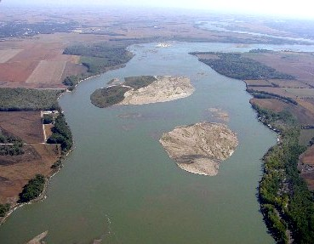The Missouri River

Sources
For more information on this topic:
HDR: Lewis and Clark Rural Water System http://www.hdrinc.com/information/default.asp?PageID=1711&ParentID=2L15
Lewis and Clark Rural Water System http://www.lcrws.org/index.html
Wisconsin Resources Protection Council http://www.wrpc.net/reports.html
The Great Man Made River Project: http://www.gmrp.org/index_en.html:
The Great Lakes Directory: http://www.greatlakesdirectory.org
Canadian Environmental Law Association: http://www.cela.ca/Intervenor/23_2/23_2selling.htm
UNESCO: The Great Man Made River Project http://www.unesco.org/water/ihp/prizes/great_man/gmmrp.shtml
Barlow, Maude. Blue Gold: the Battle Against Corporate Theft of the World's Water. McLelland and Stewart, 2002.

22. Water Supertankers

Miguel Simhon simhonm@uwec.edu
The world supply of freshwater is abundant, and capable to meet human demands for many years. Yet regional water scarcity is becoming a major concern today. International water marketing is one method for improving the distribution problem, by transporting water to those areas experiencing shortages from places with a water surplus.
Countries such as Argentina, Chile, Mexico, and the United States are already involved in water markets. Transportation of bulk water outside political boundaries, which is very rare (with bottled water as an exception), is already taking place in certain areas. Austria and Turkey export water to Mediterranean countries, and Israel sells water to areas with extreme water scarcity problems. The Bahamas and Cyprus are other countries that import water from outside sources.
If enough customers can pay, corporations are willing to send vast amounts of water across the ocean. Massive pipelines, supertankers, and giant sealed water bags, that carry freshwater long distances for commercial sale, are being used. The World Bank says, "One way or another, water will soon be moved around the world as oil is now." The mass movement of bulk water could have catastrophic environmental impacts. Some proposed projects would reverse the flow of mighty rivers in Canada's north, the environmental impact of which would be greater than China's Three Gorges Dam (Who Owns Water, 2002).
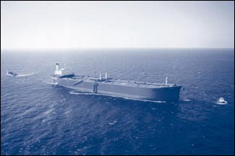
Exporting bulk water by supertanker, especially from North America, is increasing. Water shipments are sent in huge supertankers, like the tankers used to ship oil. Supertankers can transport both water and oil. “As Canadian water specialist Richard Bocking explains, their tankers would empty oil on one leg of the trip and carry water home on the return voyage. The first tanker shipment of water out of the United States, says the assistant general manager of Anchorage Water and Wastewater Utility in Alaska, may have been in a tanker leased by the Japanese trading conglomerate Mitsubishi. In 1995, this Mitsubishi-leased tanker shipping petroleum by-products overseas loaded a couple million gallons of water from Eklutna, Alaska, for transport back to Japan.” (The Global Trade in Water)

Environmental Implications
Supertankers shipping bulk water would likely operate year-round, along the Pacific coast. They would move on tight schedules through untrustworthy seas and could leave serious ecological damage. “These huge tankers,” says Bocking, “would wind their way through tortuous coastal waterways, maneuvering around islands and reefs in an area where no well-developed marine traffic management system exists . . . Pods of killer whales move regularly through these waters. Along with commercial and sports fisheries, spawning for almost the entire commercial oyster industry of coastal B.C. is located here.” For Bocking, the danger lies in the fact that the massive fuel tanks of these supertankers “are full of bunker C fuel, the worst possible grade of oil in environmental terms. With currents, winds, rocks, and reefs intersecting with tight ship schedules, the stage is set for tragedy on a grand scale.” (The Global Trade in Water)
Bulk water exports are also an ecological threat. Ecosystems would be disrupted, the natural habitat would be damaged, biodiversity would be reduced, and aquifers and underground water system will get dry because of the draining of bulk water from lake and river basins. Also, supertankers would especially deplete water supplies along ocean coasts, since they cannot venture inland.
Case Study: Turkish water exports to Israel

Another example of water marketing through supertankers is from Turkey to Israel. Israel will be buying (for the next twenty years) 50 million cubic meters of water annually from Turkey. The water will be extracted from the Manavgat River. The Manavgat River can export 180 mcm of water using tankers. Turkey hopes that the Manavgat River project will eventually supply water to other eastern Mediterranean countries such as Syria, Jordan, and Greece, who also suffer from water shortages. But right now, they are no customers for Turkish water other than Israel. As a result, Turkey's expectations from Israel regarding previous trading commitments have intensified. On July 23, 2003, the Jerusalem Post reported that "Turkey threatened to call off military deals with Israel if the water deal was not signed, and at one time there was even concern in Jerusalem that Israeli firms would be frozen out of lucrative tenders in a massive development program in southeastern Turkey if the water deal was not finalized."

The Manavgat River basin is secure and all necessary measures will be taken to guarantee the safety and quality of water. A pipeline would be the most desirable way of bringing water from Turkey to Israel, but it is impossible politically because a pipeline would have to pass through Syria, which is an adversary of Israel.
Purpose-built supertankers will be used to send the Turkish water to Israel. Even though the Turkish water would satisfy less than 5 percent of Israel's water needs, the water will be used for emergencies such as droughts. Israel has three immediate options to meet the problem of increasing water demand and irregular water supply. It can import water from Turkey, at a cost of 80 cents per cubic meter, it could desalinate seawater, at a cost of 52-55 cents per cubic meter, or recycle used water via wastewater processing plants, for 35 cents per cubic meter.

Recycling wastewater is the option with the lowest cost. “Israeli water-processing plants have been operating for thirty years in the Haifa area and in Dan, south of Tel Aviv. The volume of recycled water is estimated at 270 mcm a year, and could reach 620 mcm by 2020” (Turkish Water to Israel, 2003 ). The problem with the recycled water is that it is not considered drinking-water quality and is used by Israel only for industrial purposes.
Seawater desalination is done on a limited and local scale in Israel. Again, it can be cost-effective, but the desired drinking quality has not been reached and has environmental consequences such as leaving salt residue. “According to Shlomi Dinar, a Johns Hopkins University-based expert on international water issues, brackish water from boreholes is another viable option, as it can reach drinking quality when desalinated. At a cost of 33-42 cents per cubic meter, brackish water is relatively inexpensive to desalinate. However, Israel can at best procure 50 mcm drinking water annually through this method, and the country therefore has to look elsewhere to quench its thirst” (Turkish Water to Israel, 2003).

“Some Israeli officials have long been skeptical of importing water from Turkey. Israel's Ministry of Finance, for example, has been opposed to it on grounds of cost. The Israeli Water Commission has been lukewarm at best to the idea, generally preferring desalination and recycling. According to rumors in 2002, Israeli Prime Minister Ariel Sharon said at the time that Israel would not buy water from Turkey since it would cost Israel less to desalinate its own water -- instead offering Turkey $147 million compensation in installments for the investment it had already made in the water export project. Turkish officials refused the offer and repeated Ankara's position that the project was also a political matter. Now Israeli officials say the water desalination projects will continue and the imported water from Turkey will serve as an additional source for emergencies such as droughts” (Turkish Water to Israel, 2003).

Corporations Using Supertankers

If international water markets further develop, Canada would be a central subject of focus, with 20 percent of the world's freshwater. Canada could export huge quantities of freshwater around the world. Another huge focus would be Alaska. Corporations will be the ones responsible for transporting bulk amount of water to customers.

Western Canada Water, Snow Cap Water, White Bear Water, and Multinational Resources were all companies who were planning to transport water by supertankers along the Pacific coast. Yet, they were banned by British Columbia in 1993. “One project was to involve a Texas company prepared to pay for a fleet of 12 to 16 of the world’s largest supertankers (500,000 deadweight tons) to operate around the clock. Under one contract, the annual volume to be shipped to California was equivalent to the total annual water consumption of the City of Vancouver in Canada.”(Who Owns Water, 2002) But the export ban may be reversed, and open the floodgates for bulk water shipments by supertanker down the Pacific Coast again, due to a change of provincial government in British Columbia.

Global H2O is another Canadian-based company, which has signed a 30-year agreement to export 18.2 billion U.S. gallons (about 69 billion liters) of glacial water per year from Alaska to China. Global has formed a “strategic alliance” with the Signet Shipping Group, a U.S. company based in Houston, Texas, which has a fleet of supertankers in order to transport the bulk water to China. Each Signet supertanker (50,000 deadweight tons) is expected to carry over 330 million liters (about 87 million US gallons). Global also has a contract with Singapore. “But to supply Singapore on a regular basis,” said Global’s CEO Fred Paley in June 1998, “we are looking at converting single-hull supertankers which the oil industry will be decommissioning” (International Water Marketing, 2001).

World Water S.A. is another company that has a fleet of supertankers. This company includes Japan’s NYK Line (Nippon Yusen Kaisha), the world’s largest shipping company, operating over seven hundred vessels.

Both companies can use supertankers to ship Alaskan fresh water supplies to China and the Middle East, but they are not allowed to transport bulk water to Los Angeles or San Diego due to the Jones Act.

Conclusion
Water exports are related to the issue of to how water is viewed, either as a commodity or as a basic human right. Both extremes are difficult to analyze, since water tends to lead to wasteful and inefficient use if we disregard the monetary attributes. On the other hand, the increase in water’s economic value can result in exploitation by those concerned only with profiting from others' deficiencies. Supertankers can be very beneficial when exporting water to those countries in need, but it can be harmful to the environment.Corporations and different countries are starting to trade globally in water, and with freshwater shortages becoming common wil become more sensitive in the years ahead.
Sources
For more information:
International Water Marketing: http://www.waterbank.com/Newsletters/nws37.html
The Global Trade in Water: http://www.thirdworldtraveler.com/Water/Global_Trade_BG.html
Who OwnsWater?:http://www.thenation.com/docprint.mhtml?i=20020902&s=barlow
Turkish Water to Israel: http://www.washingtoninstitute.org/watch/policywatch/policywatch2003/782.htm

23. Great Lakes Water Conflict

Jason Gosse gossejp@uwec.edu

The Great Lakes have always been a symbol for the states and provinces that border them. The lakes hold one-fifth of the world's freshwater, and could submerge an area the size of the United States in more than nine feet of water. The lakes are the key source of freshwater for most of the people who live in the Great Lakes Basin. Although these lakes have been polluted in the past, they provide habitat for a large number of wildlife species. The lakes make up one of the main transportation routes for moving materials through the lakes to the rest of the world.
The Great Lakes Basin
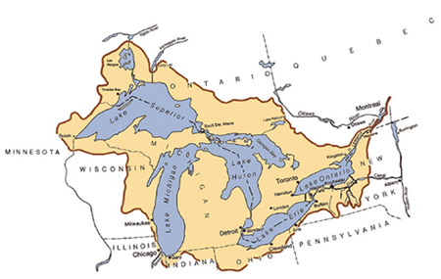(2)
Water Use in the Basin
All of the communities within the Great Lakes Basin use the Great Lakes for their daily use. These communities either take water directly out of the Great Lakes, take water from rivers that flow into the lakes, or take water out of aquifers that are replenished by the Great Lakes or the waterways that flow into them. Once this water is taken out and used as the public water supply, it is treated and sent back into the lakes. Communities are not required to replenish the water they take, because it is argued that the amount of water used in comparison to the water in the lakes is quite small. The largest city that uses water and does not return it to the lakes is Chicago. With the use of about 2.4 billion gallons a day, Chicago sends its treated water into the Mississippi River watershed.
Attempted Diversions
The Southwestern United States has recently been looking for more water to use for farmland and for municipalities. This area is growing at a fast rate and will need solutions to increase the amount of water they receive. In the 1950’s there was an attempt to take some water from the Great Lakes for use in the Southwest. The Great Recycling and Northern Development project, known as GRAND, also wanted to reverse the flow of some Canadian rivers to take water from James Bay, which would be isolated from Hudson Bay to keep out salt water, and transport it into Lake Huron. The whole matter was far too complex and costly for anyone to carry out.
In the 1980’s there was a proposal to withdraw water from the Great Lakes to recharge the Ogallala aquifer that supplies water to the Great Plains states. The U.S. Army Corps of Engineers refused to allow this project to proceed.
More recently in 1998 a company named Nova Group wanted to make a bulk water transfer from the Great Lakes and sell it to the Asian market. “On March 31, 1998 the Environment Ministry issued a five year water-taking permit to a private company, the Nova Group of Sault Ste. Marie, allowing withdrawal by tanker of up to 600 billion liters a year of Lake Superior water.”(3) This proposal for the use of water stimulated a debate over the use of Great Lakes water, and caused many people to wonder whether new laws should be passed to protect the lakes from this type of water diversion.
Another issue with use of Great Lakes water stems from the building of a Nestlé/Perrier water bottling plant in Stanwood, Michigan, 50 miles north of Grand Rapids, Michigan. The plant does not withdraw directly from the lake, but an aquifer that feeds the Muskegon River, which flows into Lake Michigan. “Ice Mountain has been permitted by the Michigan Department of Environmental Quality to withdraw up to 400 gallons a minute since May, 2002, even though Judge Root said the state had no standard to issue the permit.”(4) The judge shut down the Ice Mountain bottling plant in 2003.

Scientists have recently found that deep wells drilled near the southwestern shore of Lake Michigan are reversing the flow of the lake. As these wells are being pumped, water from Lake Michigan is recharging the aquifers that are within the Great Lakes Basin. This is making the lake flow towards the southwestern side of the lake. “Scientists admit that they do not fully understand the effects of this on fish, wildlife, and other aquatic resources. But they maintain that, because the Great Lakes hold more than six quadrillion gallons of water, the 10 million gallon per day backflow they discovered is, by itself, insignificant.”(5) These recent findings may have some impact on Wisconsin Governor Jim Doyle’s decision for Great Lakes water to be sent to Waukesha County, which lies outside of the Great Lakes Basin.
Great Lakes Population Density
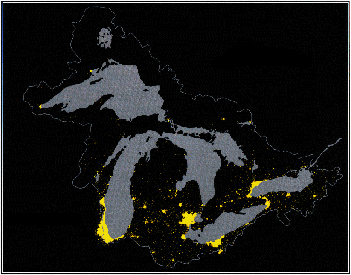(6)

Low Water Levels and Shipping
The lakes serve as transport routes for large ocean-going vessels into the interior of North America. The lakes are crucial to the industries that rely on them for shipping raw materials and finished goods within the Great Lakes region, and throughout the world. In recent years, the lakes' water levels have been declining, affecting all of the industries that rely on them for the sole means of transportation. According to an article in the September 2002 National Geographic magazine, ”For every inch of ship’s draft clearance lost to low water in the shallower channels, such as the St. Marys River between Lake Superior and Michigan-Huron, a carrier must reduce his cargo by as much as 270 tons or risk the danger of running aground.”(7) Smaller cargo loads results in a large decline in shipping profits. Water levels also have a great effect on the harbors where ships have to dock to be loaded with goods. Low water levels means that these harbors must be dredged more often, creating another economic setback in the shipping industry.

The Future of the Great Lakes
When people in the past have sought Great Lakes water, the requests were usually turned down. As the need for water throughout the world grows, people will look to this large supply of freshwater to fill their needs. The withdrawal of Great Lakes water is already being questioned for irreversible effects on the lakes, and any proposed use come under much public scrutiny. It seems that there is not currently a willingness to send the water too far from the lakes, but there needs to be clearer laws to plan for the future use of the Great Lakes’ water. Today the only laws prohibit a negative effect of U.S. water use on Canada and vise versa. The Great Lakes states’ governors have to all agree to United States use of water outside of the basin. Canada and the United States will have to both agree on the same set of guidelines to manage the lakes and to preserve them for the future.

Sources

(1) Job Office for Science Support. 5 May 2004 http://www.ofps.ucar.edu/gapp/networks/greatlakes/
(2) U.S. Environmental Protection Agency. 11 May 2004 http://www.epa.gov/glnpo/atlas/images/big12-f.gif
(3) Canadian Environmental Law Association. 4 May 2004 http://www.cela.ca/Intervenor/23_2/23_2selling.htm
(4) Great Lakes Directory. 5 May 2004 http://www.greatlakesdirectory.org/mi/121203_great_lakes.htm
(5) Michigan Land Use Institute. 5 May 2004 http://www.mlui.org/landwater/fullarticle.asp?fileid=16654
(6) Michigan Department of Environmental Quality. 11 May 2004 http://www.deq.state.mi.us/documents/deq-ogl-image104.jpg
(7) Mitchell, John G. "Down the Drain? The Incredible Shrinking Great Lakes" National Geographic Sept. 2002: 34-51.
For more information:
Great Lakes Directory: http://www.greatlakesdirectory.org/
The U.S. Environmental Protection Agency: http://www.epa.gov/glnpo/index.html
Michigan Land Institute: http://www.mlui.org
Canadian Environmental Law Association: http://www.cela.ca
International Joint Commission: http://www.ijc.org/

24. Water Policy & Conflicts

Brianna Binnebose binnebbd@uwec.edu
"When the well is dry, we learn the worth of water."
--Benjamin Franklin
Since the day human beings arrived in the Americas, water has always had an important role in their lives. Whether it was the Native Americans, the Spaniards in the Southwest, or the English in the East, ownership of water supplies became a priority. Someone has always desired to harness water to improve living standards. To alleviate conflicts over water policies, the U.S. government later instituted water policy, especially concerning the areas of surface water resource management and water pollution.
The 2000 US Census showed the population of the U.S. consistently rose during the period of 1990-2000, making it the largest population increase in U.S. history. This growth was especially prevalent in the Western U.S., where the rates have been the highest at 19.7%. This population growth is a pressing reason to resolve current water policy conflicts. Better water policies nationwide need to be made and put into action to keep pace with the growing population and growing industry market in the U.S.
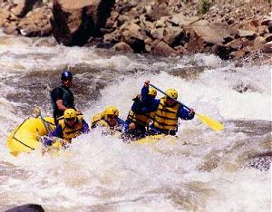 | White water rafting adventure on the Colorado River  http://www.rafting-colorado.net/whitewater-rafting.htm

From purely an aesthetic and recreational standpoint, America's waters offer some of the most beautiful and exciting forms of outdoor recreation available. In order for recreation to continue, policies concerning the proper management of water resources and pollution control are necessary to keep America's water safe and usable for generations to come.
However, conflicts continue to arise in constructing a framework of policies due to the contrasting climates of the Eastern and Western United States. The difficulty lies in a lack of understanding of integrating policies in both sides of the country, while still maintaining a fair amount of regional control. California is one state that is making the attempt, being the first to integrate both types of the traditional policies.
The Colorado River running through the Grand Canyon.  http://www.blackant.net/other/images/trip-eos2001/page20.php | 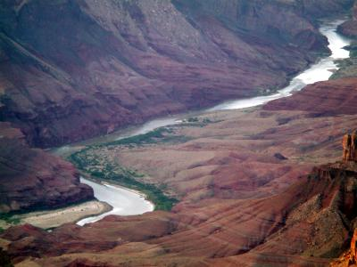

Federal Water Policy: difficulties, successes and everything else
"Throughout human history, water resources have played a critical role in the development of advanced societies. In recent years, those involved in the development and use of water resources around the world have become increasingly concerned about the unintended effects of humanity's attempts to use these precious resources. The tough realities of competition for scarce water resoucres around the world have led to diasgreements over goals and the degree to which goals can be achieved through proper mangement of water resources." --Jonathan P. Deason, Theodore M. Schad and George Willam Sherk.
Part of the reason the federal government is having so much difficulty in making and passing legislation concerning both surface water and groundwater policy is the decentralized organization of water policy. This can best be summarized in the work Water Policy in the United States: A Perspective by Jonathan P. Deason, Theodore M. Schad and George William Sherk, "With regard to institutional considerations in water resources policy development, an apparent oxymoron is true: there are both too many and too few actors." The main water policy maker, the U.S. Congress, only adds to the confusion. Within Congress, there are over a dozen Congressional committees, along with numerous subcommittees, agencies and offices in the White House. All these committees have a say in each piece of legislation, often making the process more muddled.
Water policy, management and pollution usually tends to fall under the jurisdiction of local and state governments but with major water policy acts such as the Clean Water Act (CWA), first implemented in 1948, the federal government is taking a more active role in the protection of America's water supply, as evident by the following statistics obtained by Cleanwater.gov in 1998:
In 1972, most estimates were that only 30 to 40 percent of assessed waters met water quality goals such as being safe for fishing and swimming. Today, state monitoring data indicate that between 60 to 70 percent of assessed waters meet state water quality goals.
Twenty-five years ago, wetland losses were estimated at 460,000 acres each year. Today, wetland losses are estimated to be about one-fourth of that rate.
Since 1982, soil erosion from cropland has been reduced by more than one-third, saving over a billion tons of soil each year and substantially reducing sediments, nutrients, and other pollutants that reach streams, lakes, and rivers.
Twenty five years ago, sewage treatment plants served only 85 million people. Today, the number of people who have access to adequate wastewater treatment facilities has more than doubled, to 173 million people.
Compliance with national standards for discharges from industrial facilities result in the removal of billions of pounds of pollutants from wastewater each year.
These successes in recent years have been made possible through the proper enforcement of the Clean Water Act (CWA). Amendments made to the Act in 1972 have made it the leading program of legislation, in regards to water pollution control. The CWA focuses on the areas of:
- Title I - Research and Related Programs
- Title II - Grants for Construction of Treatment Works
- Title III - Standards and Enforcement
- Title IV - Permits and Licenses
- Title V - General Provisions
- Title VI - State Water Pollution Control Revolving Funds
One of the 1972 amendments, Title II, stated that federal grants were to be given to states for construction of new and better sewage treatment plants. The states received up to 55% of the total cost, but if they were using more leading edge technology, that figure could be increased to as much as 75%. As a result, in times of budget deficits, conflicts have arisen as to the amount of federal funding states could receive for the construction of municipal sewage treatment facilities. In 1987, Congress found a way to alleviate this problem with Title V, having states match federal funds and the money is then placing the money in a revolving loan fund so the federal budget will be under less strain and states can still have the funds to construct sewage treatment plants.
The Clean Water Act is the most comprehensive piece of legislation that can be applied to both Eastern and Western U.S., unlike many other water policies, as will be illustrated later on. This nationwide application of policy covers the pollution aspect of water, not just the management of resources.

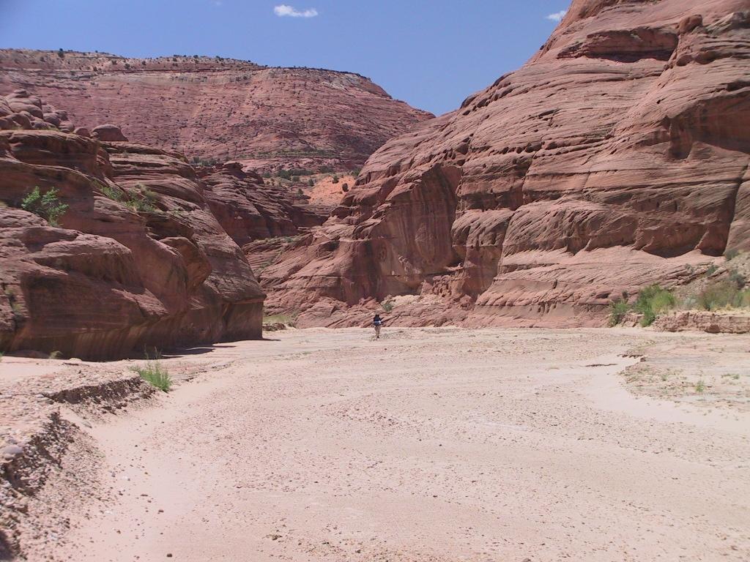 | Dried up river bed, Paria Canyon  http://www.oktrails.com/Utah/Paria_Canyon.htm
Water Policy and Conflict in the West: Past and Present
"Imagine trying to sip water through a straw from a glass across the room. That's essentially what is being proposed to quench the growing thirst of the bustling Colorado cities on the eastern slope of the Rocky Mountains." --Mary H. Cooper, CQ Researcher
Water policy in the Western United States has traditionally followed the course of the Prior Appropriation Doctrine. The doctrine began during the Gold Rush when scores of miners and settlers rushed out west in hopes of land and gold. In the semi-arid climate of the West, water itself is a resource as precious as gold, as the miners and settlers would soon discover. Miners realized that they would need water to pan and extract the gold, so the desirable stream locations were quickly snatched. For those not fortunate enough to get a spot on the water, they needed to obtain water in a different manner. Water needed to be diverted to accommodate the needs of everyone and so streams were subject to diversion in order to meet the growing demands. Water diversion would turn out to be a problem that would haunt the Western U.S. for over 100 years.

US precipitation in cm/year  http://www.ruf.rice.edu/~leeman/aNR.html | 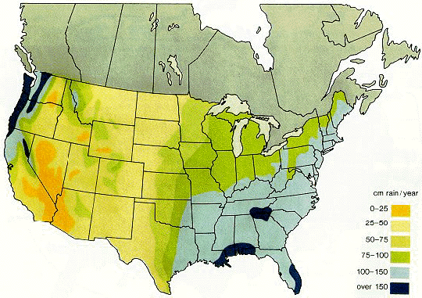
As indicated in the precipitation map above, the Western U.S. receives well below the average amount of precipitation that the Eastern U.S. receives. The West cannot rely on rainfall as a means to replenish its water reserves, so the need for adequate water management is greater. Growing populations in Western states also increase the need for water and better water management policy.
Much of the legislation concerning surface water supplies in the Western U.S. is based on the Prior Appropriation Doctrine. This doctrine is based on the old miners' mentality of "first in time, first in rights," meaning that whoever owns the land and water supply first has the greatest rights. Landowners can control the flow of the river by diverting if they so choose, regardless whether it affects others. However, this can only be done if the party choosing to divert the river is of senior status compared to the complaining party. If the complaining party is of junior status, then there is nothing it can do about the other party diverting the water. The status was established in the order of who first acquired the land rights adjacent to the river. However, traditionally these rights were only guaranteed to those who used their water regularly and in a way that was considered beneficial.
A current concern of Western water policy is the Colorado River. It provides water for over 25 million Americans and works its way through eight states until emptying into the Gulf of California in Mexico. It is also one of the most heavily diverted rivers in the country and during dry times is more like a stream than a powerful river. However, according to the US Water News, the Colorado River is listed as the most endangered river of 2004, suggesting the impacts this could potentially have on the millions of people who depend on the river.

The East, Water Policy and Conflict
"Water links us to our neighbor in a way more profound and complex than any other."--John Thorson

Eastern Tennessee valley river  http://www.state.tn.us/environment/dca/p2/p2water.php | 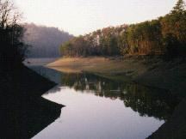
Eastern water policy traditionally follows the path of the riparian doctrine. Because of the humid climate and annual rains, free-flowing rivers are an excellent resource. Landowners can use the rivers as they see fit, as long as they do not disturb the natural flow. Under this doctrine, domestic purposes are generally the only reason landowners can remove water from the rivers. Also, unlike in the doctrine of appropriation, diversion is not a primary way of managing the water.
The climate of the Eastern U.S. is far different than that of the West, which implies a different attitude towards water resource management and in particular, the management of surface water. The much more humid East does not find itself in drought as often and comes to rely on the annual rainfall to replenish its water supply, making its attitude towards water management less stringent. "The riparian doctrine of water rights originated in lands with humid climates where precipitation easily supported agriculture and plentiful water supplies made conflicts between water users infrequent and ther legal tradition was based on English riparian use."
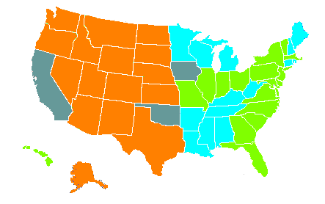 | Distribution of water policy doctrines in the U.S.  http://www.ridenbaugh.com/srba/alm/lead.htm
The above map depicts water policy doctrines in the US. The states in green follow traditional the riparian doctrine; states in orange follow the traditional prior appropriation doctrine;blue states following a modified riparian doctrine, and the gray states integrate both policies. As shown, states on the eastern side of the country favor the riparian doctrine, while the western states primarily use the prior appropriation doctrine.

Native Americans and
U.S. water policy

 | "We're looking to get the land back, and we want to restore it," says Klamath Tribes' vice-chairman, Joe Hibbs, commenting on the Klamath River Basin controversy in Oregon  http://search.csmonitor.com/durable/2001/05/24/p12s1.htm

Under the Prior Appropriation Doctrine, it would seem that the West's first inhabitants would have the strongest claim to water, but in reality the Native American tribes have had to fight for their claims in federal court.
Kib Jacobson, Native American Affairs Program Manager for the Upper Colorado region, writes in the piece, Native Americans and the Colorado River, "In the 1800s, many Western Indian tribes gave up most of their lands and agreed to settle on reservations set aside by the U.S. government as permanent homelands for the tribal people. Unfortunately, when the Indian reservations were established, Congress did not include provisions establishing Indian water rights for the reservations."
Native Americans in the Colorado River watershed also face difficulty in the use and mangement of water supplies. Water policy along the Colorado River is based the prior appropriation doctrine so one would assume that since the Native Americans were there first, they would have the most appropriation rights. Jacobson notes that after a Supreme Court decision (Winters vs United States) Congress finally granted priority rights to water to Native Americans. This led Native Americans in the Colorado River watershed to take on a more central role in water policy and especially trying to gain a foothold in the the changing of the Glen Canyon Dam operations for better management of the river environment.
Also in an effort to help tribes regain their water rights, the Department of Interior: Bureau of Reclamation, which concerns the construction and management of powerplants, dams and canals, has established a Native American Program. The federal government has a trust responsibility to the tribes, anelates to them in a government-to-government relationship.

Water Policy overall
"Water helped ancient man learn those first lessons about the rights of others and responsibility to a larger society.... It became part of the moral and mental legacy parents passed on to their children."
M. Meyer, "Water in the Hispanic Southwest"
Overall, U.S. water policy has been progressing in the direction of better water management. It is not yet perfected but with the attempt to integrate eastern adn western policies, and integrate the rights of Native Americans into these policies, it is an improvement upon the previous policies. With pressing concerns due to water contamination and population growth, water policy will continue to remain important issue in the years to come in U.S. policies.
Water rights and responsiblity are certainly important lessons for U.S. water policy to learn and practice. If they don't, future changes and improvements to water policy will be difficult. However, there is hope yet that better policies and attitudes towards water management can and will develop in the future.

Sources
Bureau of Reclamation: Native American Program . http://www.usbr.gov/native/
Chehalis River Council. http://www.crcwater.org/
Cleanwater.gov: restoring America's watersheds http://www.cleanwater.gov/
Deason, Jonathan P., Theodore M. Schad, Georege William Sherk."Water Policy in the United States: A Perspective." Water Policy 3 (2001) 175-192.
Dravnieks Apple, Daina. "Evolution of U.S. Water Policy: Emphasis on the West. Women in Natural Resources 24.3, 2003-04. http://www.cnr.uidaho.edu/winr/applewater.htm
Environmental Protection Agency: www.epa.gov
Hamming, Edward. "Water Legislation." Economic Geography 34.1 (January 1958) 42-46.
Mono Lake Website http://www.monolake.org/waterpolicy/waterlinks.htm
US Water News http://www.uswaternews.com/archives/arcpolicy/arcpolicy.html
Water Quotes - Pausing to Think: http://www.gmd4.org/quotes.html

25. Technical Fixes

Heather Eslinger eslinghm@uwec.edu
Due to the worldwide decline in freshwater availability, a need for a solution is imperative. Many experts believe they know the route that should be taken to solve the problem. As population increases so does the demand for freshwater, and despite the on-going hydrologic cycle, the replenishing rate cannot keep up with the rate of consumption. Water is being utilized for industries, agricultural uses, and the common household. This page examines the use of technology to increase the supply of freshwater. Some of the main methods that have been proposed include the towing of icebergs, seeding of clouds, and desalination.

Iceberg Towing
A longstanding proposal has been to tow icebergs from Antarctica to supply freshwater. In 1978 the idea of towing icebergs to the U.S. to provide freshwater was endorsed by the California State Senate. The plan was to have these 'iceberg trains' driven by electric propellers and powered by a floating nuclear plant (Redmond, 1993). A similar procedure had already been carried out in southern Chilean ports during the early 1900's. (Charlier, 1991). However, the extremely expensive costs, and 80% loss of volume during the towing route cast a shadow over the concept. In the late 1950's, a oceanographer named John Isaacs suggested the icebergs be brought into Los Angeles. The plan was never carried out. However, for almost the last 30 years, Terry Spragg has been working on the iceberg project. In 1991 he had planned a test run but was running into complications with funding and a lack of workers (Wohleber, 1991). Interest in iceberg towing has also been expressed by wealthy oil-rich desert countries such as Saudi Arabia.
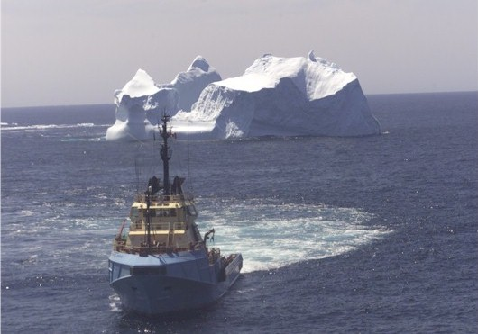
http://www.mmass.co.uk/images/HughDunlop4.jpg
Cloud Seeding
Cloud seeding is a process in which dry ice or potassium iodide particles are used to increase rainfall. Recent research has shown that hydroscopic salts have been the most successful in increasing the amount of rainfall. The chemicals are sprayed over a propane flame and float into the clouds. Although there was no scientific proof found by a national study that seed clouding works, the general public who are faced with water shortages are still willing to try it. In fact, the Denver Water Department in Colorado has spent hundreds of thousands of dollars on cloud seeding. In 2001, an estimated 66 cloud seedings took place (USA Today, 2003). Despite the current use of the cloud seeding process, many still feel that more research is essential. There is also some fear that mismanaged cloud seeding could backfire. Some South Dakota residents blame cloud seeding for a torrential rainfall and deadly floods in Rapid City in 1972.
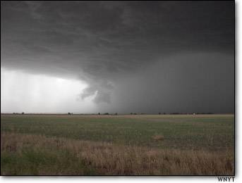
http://www.msnbc.com/local/wnyt/Images/030603_wnyt35.jpg
Desalination
Desalination is the process of removing the salt impurities and other dissolved minerals from bodies of water. When it is removed from the oceans and has a high salt content it is called "seawater." When the water that is retrieved is less salty than seawater, but has a higher salt content than fresh water it is considered to be "brackish water." Desalination may be accomplished through the use of heat (thermal) or of a semi-impermeable membrane. Thermal desalination is a process in which the salty water is heated, the evaporation collected, and then allowed to cool and condense where it as pure water. The semi-impermeable membrane, also known as Reverse Osmosis (RO), is the primary choice for the desalination of brackish water. The process involves sending the salty water through a film membrane at a pressure of 1,000 to 1,500 per square inch, resulting in one-third of the water having a low salt content.
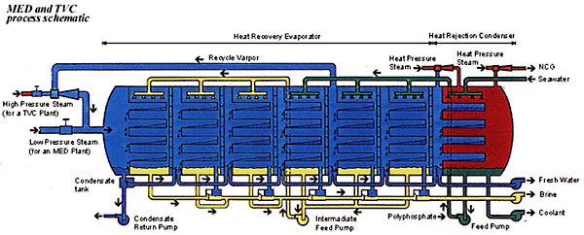

Currently about 3,500 desalination plants dot the globe, with most located in higher developed countries. It is important to remember that all countries are being faced with water depletion and only a few are able to set funds aside for desalination research and technology.
Israel has set up the Grand Water Research Institute (GWRI) which is funded by the American Technion Society. Israel, as well as neighboring countries and territories, has begun to feel the stress from the lack of water resources as populations continue to grow. Because of the over-pumping that has taken place in Israel, saltwater intrusion has occurred along the Mediterranean coast, resulting in a 20% loss of useable drinking water from the underground aquifer. The Rabin Desalination Laboratory, led by Professor Rafi Semiat and aided by Professor Emeritus David Hasson, has been set up by the GWRI to conduct research. The main objectives of this lab are to not only concentrate on reducing the high costs of (R.O.) technology, but to continue investigating techniques to raise the efficiency of all desalination methods. A promising step taken to reduce the amount of freshwater use has been to recycle wastewater through agricultural irrigation. However, the lack of freshwater is still a pressing problem.
The United States, unlike many countries, has the resources and funds to investigate and research the water depletion problem. A federal agency called the U.S. Bureau of Reclamation has a division called ‘The Water Supply, Use, and Conservation Group’ is in charge of the following technical related functions:
  - Conducting hydrologic investigations and studies including participation on matrix and negotiation teams;
  - Providing reclamation- wide technical guidance on hydrologic studies;
  - Reviewing studies and reports containing hydrologic information to ascertain technical adequacy;
  - Developing technical standards and guidelines for hydrologic analyses and studies;
  - Developing and applying improved procedures for hydrologic data collection, retrieval, and analysis;
  - Assisting other agencies and governments with technical training and conducting hydrologic investigations and studies; and
7. Conducting research into new methodology for hydrologic investigations and analysis.
The issues involved with the depletion of water will never be solved merely though a technical "fix." No matter how many technical advances are made (and resources are continuously being discovered), we cannot change our need for water. We have to share that need with many plants and animals that we depend upon, and people need to distribute water more equitably, prioritizing those who need it the most for their lives. Water is going to continue to disappear and the price of research is going to continue to be expensive. Sadly, we are going to continue to see many lesser developed countries become more deprived as the price for freshwater grows beyond their reach. Whatever the best solution is to the problem, and even if the price is attainable, the most advantageous goal would be to conserve what we already have.

Sources
For more information:
US Bureau of Reclamation
MSNBC article
Definition of Israel's Water Problems
The Stephen & Nancy Grand Water Research Institute: Israel Institute of Technology
http://www.wws.princeton.edu/cgi-
bin/byteserv.prl/~ota/disk2/1988/8842/884203.PDF
Redmond, T., and Mowrey, M., October 1993, Unnatural Disasters: The ten worst environmental ideas in U.S. history: Omni, vol. 16, issue 1.
Charlier, R.H., 1991, Water for the desert- A viewpoint: International Journal of Environmental Studies, vol. 39, p 11-35.
Wohleber, C., 1991, L.A. Thaw: Omni, vol. 13, issue 11.
West seeks help in cloud seeding: USA Today, December 2, 2003, p. 3a.
Hecht, J.L., 2002, Salty Solution: Christian Century, vol. 119, issue 13.

26. Groundwater Replenishment Methods

Matthew Nier niermm@uwec.edu

Water is a renewable resource, to a point. The current population of the world is using water at an alarming rate, and nature cannot keep up. You may think there is enough water on earth for everybody, but when you look at the numbers, the amount readily available for consumption is very little. Of the Earth's water, 97% is salt water and 3% is fresh water, but of that 3%, only 0.003% is available for human consumption. In industrialized countries, urban sprawl is increasingly paving over land, forcing rainfall to flow to surface water, rather than seeping back into underground aquifers. This is why groundwater replenishment programs are very important to the survival of the Earth and all of its inhabitants.
Artificial Recharge
Artificial recharge is a very common process to replenish groundwater. One example of artificial recharge is the use of "reclaimed municipal wastewater" through infiltration basins or direct injection. Some other examples of artificial recharge are water traps, cutwaters, drainage wells, septic tanks and effluent disposal wells, and sinkhole injection of excess surface flows.
Reclaimed Municipal Wastewater
Reclaimed municipal wastewater is defined as any surface water that is not drinkable. Obviously there are drawbacks to replenishing the groundwater with this type of water. The biggest drawback to this style of artificial recharge are the health risks. It is essential that the water go through a certain number of pretreatment steps before the water can be introduced to the groundwater. This will prevent any contamination that may occur. There are two main ways to introduce the pretreated water into the groundwater, infiltration basins and direct injection. Takashi Asano, Ph.D., P.E.
Infiltration Basin
An infiltration basin is where "recharge waters such as treated municipal wastewater percolates from spreading basins through the unsaturated groundwater zone." This form of replenishment is the oldest, most easily used, and most widely used in the world. The reason infitration basins are so popular is because they are the most efficient and require the least maintenance. This form of recharge is best in huge open areas where plant an animal life is undisturbed.Takashi Asano, Ph.D., P.E.
Direct Injection
Direct injection is where the treated water is put directly into the groundwater. Direct injection is used where the topography of the land is not suitable for large infiltration basins, such as in the Rockie Mountains. Takashi Asano, Ph.D., P.E.
It is important to remember that both these forms of recharge are not limited to reclaimed municipal wastewater. They are used by many different communities across the world along with many other forms of artificial recharge.
Water Trap
A water trap is a mini-dam used to increase infiltration. Water traps are constructed perpendicular to riverbanks at a height of 1-3 meters. Water traps are constructed every 70-100 meters and have a holding capacity between 250 and 400 meters cubed. 1.9 Artificial recharge of aquifers
Cutwaters
Cutwaters are areas of excavated land, at varying dimensions, built in "low-lying areas." Cutwaters are built in areas with very few rivers or streams and are primarily used to harvest the available surface water. Cutwaters are built on permeable ground in order to replenish the groundwater or on impermeable ground to act as reservoirs.1.9 Artificial recharge of aquifers
Drainage Wells
Drainage wells, or "suckwells" as they are sometimes referred to, are used to dispose of drainage waters. These drainage waters include agricultural runoff, industrial runoff, runoff from pavement, etc. The water is sent through a series of tubes to the well that has an area of about 16-36 square feet. 1.9 Artificial recharge of aquifers
Septic Tanks and Effluent Disposal Wells
Effluent disposal wells are "very similar to suckwells in design and construction, except that they are used in conjunction with septic tanks and are always covered." 1.9 Artificial recharge of aquifers
Sinkhole Injection of Excess Surface Flows
Water is treated before it is allowed into the groundwater. This process is primarily done with salt water. The water is continuously monitored to make sure the saline level (saltiness) is not too high. 1.9 Artificial recharge of aquifers
These types of artificial recharge styles are common throughout the world. In the Argentinian provinces of San Juan, Mendoza, and Santa Fe, infiltration basins have been installed; cutwaters are being used in the Paraguayan Chaco; and Caribbean island of Barbados is using drainage wells. The rainfall of these different comunities is not a sustainable amount. Artificial recharge is saving these communities from extinction and preserving their way of life. Even though artificial recharge seems to be a good idea, there are advantages and disadvantages you have to take into account before a community can make the decision to install one of them. 1.9 Artificial recharge of aquifers
Advantages:
  - The technology is appropriate and generally well understood by both the technicians and the general population.
  - Very few special tools are needed to dig drainage wells.
  - Because of the structural integrity of the coral rock formations, few additional materials are required (concrete, softstone or coral rock blocks, metal rods) to construct the wells.
  - Groundwater recharge stores water during the wet season for use in the dry season, when demand is highest.
  - Aquifer water can be improved by recharging with high quality injected water.
  - Recharge can significantly increase the sustainable yield of an aquifer.
  - Recharge methods are environmentally attractive, particularly in arid regions.
  - Most aquifer recharge systems are easy to operate.
  - In many river basins, control of surface water runoff to provide aquifer recharge reduces sedimentation problems.
  - Recharge with less-saline surface waters or treated effluents improves the quality of saline aquifers, facilitating the use of the water for agriculture and livestock. 1.9 Artificial recharge of aquifers
Disadvantages:
  - In the absence of financial incentives, laws, or other regulations to encourage landowners to maintain drainage wells adequately, the wells may fall into disrepair and ultimately become sources of groundwater contamination.
  - There is a potential for contamination of the groundwater from injected surface water runoff, especially from agricultural fields and roads surfaces. In most cases, the surface water runoff is not pre-treated before injection.
  - Recharge can degrade the aquifer unless quality control of the injected water is adequate.
  - Unless significant volumes can be injected into an aquifer, groundwater recharge may not be economically feasible.
  - The hydrogeology of an aquifer should be investigated and understood before any future full-scale recharge project is implemented. In karstic terrain, dye tracer studies can assist in acquiring this knowledge.
  - During the construction of water traps, disturbances of soil and vegetation cover may cause environmental damage to the project area. 1.9 Artificial recharge of aquifers
Current Project
Orange County, California, is currently running "one of the finest state-certified water quality laboratories." Orange County is treating municipal waste water and using it as the main water supply for its residents. This municipal wastewater treatment is producing about 70,000 acre-feet of water per year. To give you an idea of how much water is being produced, one acre-foot of water is enough to feed the water needs of two Orange County families per year. The goals of this project are:
  - Orange County needs more reliable, high-quality water in the future to replenish the groundwater basin, to protect the groundwater basin from seawater intrusion, and for industrial uses.
  - The Groundwater Replenishment System reduces the amount of treated wastewater released into the ocean and delays the need for another ocean outfall.
  - The Groundwater Replenishment System decreases Orange County's reliance on imported water from northern California and the Colorado River.
  - The Groundwater Replenishment System's locally-controlled water helps drought-proof Orange County.
  - The Groundwater Replenishment System's new water will help meet statewide water objectives.
  - The Groundwater Replenishment System helps reduce mineral build up in Orange County's groundwater by providing a new source of ultra-pure water to blend with other sources, including imported water. Groundwater Replenishment System
This groundwater replenishment project is an expensive one that many communities around the world could not afford.
Another way that a community could help replenish the groundwater is to help prevent the contamination of it. By doing this, the community is assured that the water it is drinking is pure and safe. The Wisconsin Department of Natural Resources (WDNR) is instituting grounwater replenishment regulations on new construction sites, to prevent sedimentation, and require "sinks" to allow rainfall and snow melt to seep back into the local aquifer. You have to get a permit before you can build on your land, and there are a few requirements to get that permit:
- Develop an Storm Water Pollution Prevention and Erosion Control Plan describing the best management practices that will be used on-site for erosion control.
- Submit a Construction Site Notice of Intent form to the Department at least 14 working days before construction will begin. To avoid potential construction delays, DNR staff recommend submitting a Notice of Intent as early in the project design process as possible.
- Submit the $200 fee.
- Implement best management practices, as described in the Storm Water Pollution Prevention and Erosion Control Plan, to help control erosion and prevent contamination of storm water.
- Conduct weekly on-site inspections through the duration of the project. Construction Water Management
For more information about the rules and regulations of construction sites and other water management issues in Wisconsin, visit the Storm Water Staff. If you have any questions regarding any of state rules, just go to your local DNR website.
Groundwater replenishment is a major factor in the survival of every species on the planet. If we keep using groundwater at our current rate and contaminating the sources that replenish the groundwater, there will be no way for us to survive. There are plenty of options out there to replenish your local groundwater. Just remember that groundwater replenishment is a problem affecting everyone, but there is something you can do about it.

Sources
Name of website: Takashi Asano, Ph.D., P.E.
Name of website: 1.9 Artificial recharge of aquifers
Name of website: Groundwater Replenishment System
Name of website: Construction Water Management

27. Traditional Water Harvesting

John Palmbach palmbajp@uwec.edu

Water harvesting can be traced back through human history almost as far as the origins of agriculture. Water harvesting is defined as the redirection and productive use of rainfall. In some incarnations it resembles a primitive type of irrigation. Unlike conventional irrigation, however, rainwater harvesting does not depend on a constant flow of water; it is totally dependent on rain. Basically, harvesting involves a variety of methods used to get as much water as possible out of each rainfall. Uses were nearly limitless when rain could assumed to be clean. These ancient practices sustained ancient people when conditions would have otherwise totally prevented agriculture. Many peoples in the world have continued to rely on water harvesting practices. Others have returned to it in order to relieve pressure on overburdened undergroundwater tables or municipal water systems. Some Western groups are discovering ways that rainwater harvesting can be used in our society to relieve stress on the environment, save money, and recharge groundwater tables.

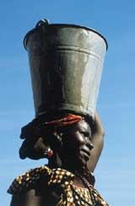 | Drinking Water: Traditionally rain water has been one of the few water sources known to usually be clean and safe to drink. Today water harvesters must be wary of pesticide contamination, high mineral levels, bacteria and other impurities in their runoff water. Filtering technologies have been used in the past and today to purify it by passing it through a series of rocks, gravels, and sands to scrub out contaminants. These methods have proven to be very effective.

Irrigation: Rainwater is the primary source of irrigation for crops around the world. Water harvesting techniques have been employed for thousands of years to get more water to the fields in order to improve crop production. This is the primary traditional use of rainwater harvesting. | 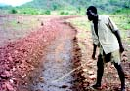

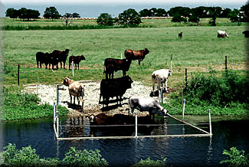 | Sustaining Animals: Because of animals’ higher tolerance for bacteria and other impurities, harvested rainwater is often used as the primary source of water for livestock. Since cattle and sheep are well adapted to drinking rainwater, safer groundwater is often saved for human drinking.
Groundwater Recharge: This is one of the more modern applications for water harvesting. Rain runoff from buildings, parking lots and other man-made structures is funneled into seepage ponds or deep wells in order to directly recharge aquifers.

Case Studies
The people of Jharbeda Mundatola, in the Sundergarh district of India, recently revived their ancient water harvesting tradition in light of a shrinking water supply. Years of dwindling streams and dried up water tables stirred memories of a technology used by their forebearers to control rainwater runoff from the hills above. In 1999 the village restored and reconstructed the local ghaghra, a sort of mountain water reservoir. Older members of the village remembered swimming and playing in the pond created behind the dam of stone and mud which collected rain runoff coming down the slope. The water is collected in behind one or more of these barriers, also known as bunds, and allowed down the hill at a steady rate. This provides the village with drinking, cooking and bathing water in addition to sustaining animals and watering terraced crops and lowland fields. The water gathered is enough to provide for the village even through the worst of dry season droughts. Most of the ghaghra disapeared when British colonial authorities frustrated or dismantled traditional water harvesting techniques by village institutions in order to take full control of their colony. This tribal public works project rescued not only their own village from drying out, but also revived streams and wells in fields and villages in the surrounding valley. More information at humanscapeindia.net
The Zuni Nation of the Colorado Plateau employed a system of water harvesting methods to survive in the dry climate. These people nestled their fields in vast valleys between enormous hills. The Native Americans would build a series of stone and mud walls between the hills to slow the movement of water through the valley. The walls did not hold standing water, but instead prevented soil erosion and slowed runoff long enough for it to permeate the dirt; creating moist rich soil in which to grow crops. This technique is also known as flood water harvesting, and has been used in traditional agriculture all over the world. Many decades of disrepair eventually lead to the total failure of this system and the eventual desertification of many of these valleys. Find out more about the Zuni at Arid Lands
“Zuni agriculture represents a long-term successful land conservation strategy with a 100-year hiatus. For over 1,000 years Zuni farmers utilized the exodus of eroded soil and water resources from pinyon-juniper uplands to grow food that sustained their people. As Zunis abandoned traditional farming methods to cope with repression and misguided development strategies of the recent century's dominant culture, the nutrient-laden waters that previously supported them have become an expensive liability.” (Jay B. Norton and Jonathan A. Sandor)
Agricultural water harvesting has come in many shapes and sizes. This Table, provided by the FOOD AND AGRICULTURE ORGANIZATION OF THE UNITED NATIONS gives examples of different agricultural water harvesting systems. They are all dependent on capturing water flowing down hill in what are called catchments. They move the water to the cultivated area and then allow it to permeate the earth.
 | Classification | Main Uses | Description | Where Appropriate | Limitations | Rough Diagram
negarim microcatchments | microcatchment (short slope catchment) technique | trees & grass | Closed grid of diamond shapes or open-ended "V" s formed by small earth ridges, with infiltration pits | For tree planting in situations where land is uneven or only a few tree are planted | Not easily mechanised therefore limited to small scale. Not easy to cultivate between tree lines | 
contour bunds | micro catchment (short slope catchment) technique | trees & grass | Earth bunds on contour spaced at 5-10 metres apart with furrow upslope and cross-ties | For tree planting on a large scale especially when mechanised | Not suitable for uneven terrain | 
semi circular bunds | micro catchment (short slope catchment) technique | rangeland & fodder(also trees) | Semi-circular shaped earth bunds with tips on contour. In a series with bunds in staggered formation | Useful for grass reseeding, fodder or tree planting in degraded rangeland | Cannot be mechanised therefore limited to areas with available hand labour | 
contour ridges | microcatchment (short slope catchment) technique | crops | Small earth ridges on contour at 1.5m -5m apart with furrow upslope and cross-ties Uncultivated catchment between ridges | For crop production in semi-arid areas especially where soil fertile and easy to work | Requires new technique of land preparation and planting, therefore may be problem with acceptance | 
trapezoidal bunds | external catchment (long slope catchment) technique | crops | Trapezoidal shaped earth bunds capturing runoff from external catchment and overflowing around wingtips | Widely suitable (in a variety of designs) for crop production in arid and semi-arid areas | Labour-intensive and uneven depth of runoff within plot. | 
contour stone bunds | external catchment (long slope catchment) technique | crops | Small stone bunds constructed on the contour at spacing of 15-35 metres apart slowing and filtering runoff | Versatile system for crop production in a wide variety of situations. Easily constructed by resouce-poor farmers | Only possible where abundant loose stone available | 
permeable rock dams | floodwater farming technique | crops | Long low rock dams across valleys slowing and spreading floodwater as well as healing gullies | Suitable for situation where gently sloping valleys are becoming gullies and better water spreading is required | Very site-specific and needs considerable stone as well as provision of transport | 
water spreading bunds | floodwater farming technique | crops & rangeland | Earth bunds set at a gradient, with a "dogleg" shape, spreading diverted floodwater | For arid areas where water is diverted from watercourse onto crop or fodder block | Does not impound much water and maintenance high in early stages after construction | 

Water Harvesting Today
Modernized versions of water harvesting are making a comeback in North America with some environmentally conscious individuals and businesses. Small companies are popping up, especially in the Pacific Northwest, which offers to install water harvesting system in your own home. These rainwater storage systems modify the rain gutters that are already on many homes. The gutters are led to a large storage tank where water is held for future use. Water from the tank is filtered first for large objects such as twigs, leaves, shingle dirt, and insects. Next it passes through two micron filters witch eliminate tiny contaminants down to the size of many bacteria. Finally it passes under an intense ultraviolet light to finish sterilizing it. Then the water is ready for almost any home use. The Ersson family in Portland, Oregon installed the water harvesting system shown above. They use reclaimed water for nearly all of their domestic needs. Showering, laundry, dishes, and cooking all use reclaimed water. They do not yet use it for drinking water, but speculate that they easily could in the near future.

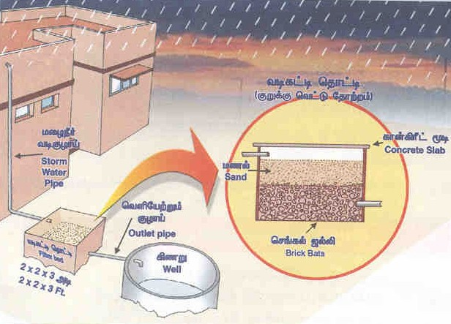
A second interesting modern use of water harvesting is known as harvesting for groundwater recharge. This system is similar to the previous system in that it gathers the water that would otherwise simply run off of your roof. It is different, however, in that instead of saving the water in a container it redirects back into the aquifer. This may sound overly simple or useless, but this is not just putting the water back onto the ground. Water that falls to the ground may make it into the undergroundwater reserves, but it will very likely be redirected downstream to a river or pond or (more likely in urban areas) enter the sewer system and be transported far away. Surface water is also much more likely to cause erosion as well as pick up runoff contaminants such as fertilizer and chemicals. The recharge process actually puts the water through a dirt and gravel filter with biological components to clean it and then directs the water down a deep well. This directly recharges the clean cool aquifers without the long delay it otherwise takes water to reach these depths. Water customers in arid and semi-arid climates are already being encouraged to use this technology. The Town of Panchayats Tennessee, for example, has provided the diagram above and encourages its citizens to use this technology.
The Future of Water Harvesting
Many communities in the past and present have effectively employed water harvesting to meet many of their water needs. Ancient technologies have shown themselves to be useful today, and modern water harvesting technologies are improving in leaps and bounds. If we are facing a future of increasing water demand, and possible water conflict, it may prove to be very wise to look to the past for a solution. All the water we need is out there. We simply need to cherish every drop, as our ancestors did.

Sources
For more information:
Rainwaterharvest.org
http://www.rainwaterharvesting.org/Rural/whim_tradi.htm
Arid Lands News Letter
http://ag.arizona.edu/OALS/ALN/ALNHome.html
Food And Agriculture Organization Of The United Nations
http://www.fao.org/docrep/U3160E/U3160E00.htm
Ersson family Water Harvesting Website
http://users.easystreet.com/ersson/rainwatr.htm
Official State Web Sight Of Tennessee
http://www.tn.gov.in/dtp/rainwater.htm

28. Alternate Policy Directions

Pat Soldan soldanps@uwec.edu

Water is life, but many people in the world do not have enough freshwater to survive. How can we combat this problem? How can we make it so that ll human beings have an ample supply of water? Many researchers are pondering this question and have come up with some interesting thoughts on alternative directions to take to help solve the world's freshwater shortages.
Policy Directions
Many water policy analysts have ideas on alternate directions that should be taken. The Canadian environmental activist Maude Barlow, in her book Blue Gold, gives her opinion on what steps she feels are necessary:
1. To deal with the global poverty gap, Barlow feels that there are some immediate actions that governments could take. They include:
a.) Canceling the Third World debt.
b.) Increasing foreign aid budgets to their previous standards. (0.7 percent of GDP)
c.) Implementing a "tobin tax" (small worldwide tariff) on financial speculation that would pay for water infrastructure and universal water services.
2. To deal with the issue of water as a human right, Barlow states that "countries must adopt constitutions such as that of South Africa, which guarantees water first for people, second for nature and third for the economy."
3. Barlow also asserts that in order to ensure ecosystem survival within any system of water pricing, "revenues raised must be used to protect the environment, restore watersheds, enforce clean water standards and repair faulty infrastructure which is currently the cause of great water wastage."
4. Finally, Barlow states that governments must focus on the greatest abusers of water: large industry and corporate farming. She feels that governments must implement a more just taxation system, to capture some of the billions in taxation that corporations are now evading. She further says that none of this will ever be possible unless water is controlled in the public interest, and that if water is allowed to be commercialized the profit principle will dominate.
Blue Gold (Maude Barlow)
In his book, Water Follies: Groundwater Pumping and the Fate of America’s Fresh Waters, Robert Glennon had a few ideas on what should be done to address the approaching water shortages:
1. Create legal water conservation standards. These standards must remain simple for ease of implementation and to ensure that they succeed.
2. Establish minimum stream flow. These minimum flows could become appropriations in the prior appropriations system, thus holding users accountable within the context of existing legislation.
3. Stop unregulated groundwater pumping. By banning the drilling of new wells within a certain distance of water sources, future withdrawals from and depletion of important water sources would be regulated.
4. Institute an extraction tax on water pumped near a water source. By establishing a minimum distance from important rivers, springs, and lakes for wells to be drilled, the state would discourage excessive groundwater pumping and make more ecologically sensitive pumping sites more economically attractive.
5. Commit to data collection on well locations and pumping. An organized effort to assemble a comprehensive understanding of where our water is coming from is an essential precursor to moving towards the wiser use of water resources.
6. Require new pumpers to mitigate for their impact on the environment. This is not to be confused with charging a fee for depleting a resource. Rather, the attitude must shift so that functioning water resources are being protected, and when water is needed, it is taken from the least impacted location.
7. Use financial incentives as a part of water policy. Individuals and businesses do not incur the true cost of water extraction, allowing them to waste water with little penalty to pay. Passing on the actual costs of water to consumers must become part of water policy.
8. Require that a small percentage of each water rights transfer be dedicated for environmental purposes. This must be done with moderation initially and with uniformity always so the allocation becomes a standard part of the transaction. Through this method, great environmental progress can be made in small pieces.
Water Follies
The Arab Center for Studies of Arid Zones and Drylands (ACSAD), Republic of Syria, and the Arabian Gulf University (AGU) also have a few ideas on what type of water policies should be implemented, and they discuss these ideas in their article, Alternative Policy Study: Water Resource Management in West Asia.
This study felt that there were economic considerations to taken into account, and that economic incentives could be effective for rationalizing water use as long as they do not go against other key economic factors. Some possible incentives are, "...water tariffs for domestic and industrial water supplies, charges for abstraction, irrigation, water wastage and pollution, and soft loans for modernizing equipment."
This study also felt that West Asia (the Middle East) must incorporate conservation programs into water resource management plans to cut down on water losses. There are three sectors one must take into account: agriculture, domestic, and industrial sectors. According to the Alternative Policy Study, one must approach each sector differently:
"In the agricultural sector this can be approached by:
• Reviewing the economics of irrigation and agricultural production and reappraising agricultural policies.
• Improving the efficiency of traditional irrigation systems, introducing appropriate modern irrigation technology and promoting water conservation techniques among farmers and other water users.
• Reviewing current irrigation incentives and tariffs, implementing the necessary legislation to enforce and update regulations on water use and strictly enforcing regulations.
• Improving extension services and programs for raising awareness among farmers and the public about the economic value of water as a precious, scarce and viable resource.
• Providing subsidies or soft loans to encourage the application of modern irrigation systems.
The domestic and industrial sectors may require:
• Restructured water pricing to reflect the true costs, including environmental costs, of maintaining and operating water supply works and desalination and wastewater treatment plants. Water tariffs in most countries of the Arabian Peninsula are too low to encourage rational water use.
• A review of water pricing mechanisms and the application of escalating tariffs for increasing water consumption.
• The installation of modern water saving technology for distribution systems and households.
• Improved leakage detection in water supply networks.
• Modified building codes to promote efficient use of wastewater for landscaping.
• The application of heavy pollution charges against industrial units violating regulations.
• The obligation for industrial units to treat water before recharging it into water courses, lakes and other water bodies, and the sea."
Finally, this study felt that there needs to be a council appointed whose members are responsible for, "...water resource development, management and utilization, to coordinate at the highest political level and formulate the overall water policy of the country." This committee needs to develop a plan for water sector development. This plan would include many stages, including:
• The collection and review of existing data and information.
• The review and evaluation of previous development studies.
• The review of current conditions of water resources, population growth, socio-economic conditions, land use, water utilization, and related legislation in force.
• The evaluation of the potential of water resources.
• Forecasting water demand.
• A water resources development planning framework.
• The assessment of water resources management, institutional reform and water facilities.
• Rough estimates of total cost.
• The evaluation of strategy formulation: financial, economic and social analyses
It would then be the committee's job (according to the evaluation result) to decide on alternatives for strategy formulation, water projects, tariffs, new technologies and legal institutional reform.
Alternative Policy Study: Water Resource Management in West Asia
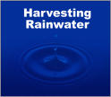Rainwater Harvesting
Rainwater Harvesting
Rainwater harvesting is an interesting technique that some people have thought to be an answer to our freshwater shortages. According to an article entitled Alternative Technologies For Freshwater:
"A rainwater harvesting system consists of three basic elements: a collection area, a conveyance system, and storage facilities. The collection area in most cases is the roof of a house or a building. The effective roof area and the material used in constructing the roof influence the efficiency of collection and the water quality.
A conveyance system usually consists of gutters or pipes that deliver rainwater falling on the rooftop to cisterns or other storage vessels. Both drainpipes and roof surfaces should be constructed of chemically inert materials such as wood, plastic, aluminum, or fiberglass, in order to avoid adverse effects on water quality.
The water ultimately is stored in a storage tank or cistern, which should also be constructed of an inert material. Reinforced concrete, fiberglass, or stainless steel are suitable materials. Storage tanks may be constructed as part of the building, or may be built as a separate unit located some distance away from the building."
Costs of rainwater harvesting vary widely. The cost of a 30m cistern (storage tank) in Brazil is estimated around $900-$1,000, while a 30-meter cistern in Paraguay has been reported to cost $2,000. The effectiveness of rainwater harvesting is great in areas of high rainfall. In areas such as the Caribbean islands, Brazil, etc., rainwater harvesting is the principle souce of water for residences.
Source Book of Alternative Technologies For Freshwater
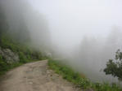Fog Harvesting
Topofusion News
Fog harvesting has the potential to provide freshwater to costal communities. According to the Source Book of Alternative Technologies For Freshwater (SBATFF) they can provide this freshwater through simple and low-cost fog collecting machines. These fog collecting machines are basically made of fine-mesh nylon or polypropylene netting, that are set up so that the fog will pass through them. As the fog passes through these "nets" it catches the small drops of water in the fog. As more and more fog passes through, the drops collectively get bigger and bigger. They then drop off of the net because of gravity into a gutter system that sends the water to a collection bin for storage. The SBATFF stated that"Chlorination of storage tanks may be necessary if the water is used for drinking or cooking purposes."
This technology has been investigated for over thirty years, and has apparently been successful in the mountain regions of Chile, Peru, Ecuador, and Mexico. The cost of fog harvesting really depends on where it is used. The SBATFF reported that, "Maintenance and operating costs are relatively low compared to other technologies. In the project in Antofagasta, Chile the operation and maintenance cost was estimated at $600/year." The effectiveness of fog harvesting depends entirely on the region. In areas of the world that have much fog, this is a viable resource, however setting up a fog harvesting system in an area that receives very little fog, would be inefficient.
The Source Book Of Alternative Technologies For Freshwater
Flood Diversion 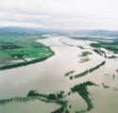
Disaster Monitoring
Flood diversion strategies is the method of diverting the excess water during floods and storing it for use during dry seasons. According to the Source Book of Alternative Technologies for Freshwater, there are three types of structures used during this situation:
- Transverse Dikes
- Homemade Diversion Structures (toroba)
- Water Traps
The cost of this strategy varies once again. The cost of a dike can be anywhere from $10,000 to millions of dollars depending on the size of the river and the dike. The SBATFF reported that a small water trap cost around $130-$170.
There are definitely some advantages as well as disadvantages to a systems like this:
Advantages:
- Being able to use the water that would normally be lost as run-off.
- The velocity of the water in the river channels can somewhat be controlled as well as the amount of erosion and destruction caused by this water.
- Keeping water on the ground increases soil fertility.
Disadvantages
- Building the diversion structures may cause a disruption in vegetation.
- If a storm is bigger than the holds of the diversion structures, the amount diverted may exceed capacities.
- May affect flora and fauna by changing patterns of flood regime.
Source Book for Alternative Technologies For Freshwater

Sources
For more information:
The Source Book for Alternative Technologies For Freshwater. http://www.oas.org/sp/prog/srcecont.htm
Desalting Benefits. http://www.usbr.gov/lc/yuma/desalting/benefits.htm
Putting Water on a Salt-Free Diet. http://www.grinningplanet.com/2004/02-17/desalination-eco.htm
Water Supply and Sanitation. http://www.worldbank.org/watsan/
Water Resources of the United States. http://water.usgs.gov
Blue Gold, by Maude Barlow.
Water Follies: Groundwater Pumping and the Fate of America’s Fresh Waters,by Robert Glennon http://www.tidepool.org/original_content.cfm?articleid=103994
Alternative Policy Study: Water Resource Management in West Asia. http://www.grida.no/geo2000/aps-wasia/#alternative

